Asplundh Golf Outing a picture-perfect benefit for the TREE Fund

Asplundh Tree Expert Co.’s 18th annual Golf Outing to benefit the TREE Fund, held August 12th at Portland’s Heron Lakes Golf Club, earned perfect scores for location, industry participation and fun.

75 golfers signed up to swing a club for the cause with Asplundh, and a record number of event sponsors helped to ensure that their every need was met. At day’s end the golf outing had raised more than $20,000 for research and education programs managed by the TREE Fund.

First-place honors went to the foursome of Tony Gann of Altec Industries, Matt Asplundh of Asplundh Tree Expert Co., and Ken Kinsey and Rusty Evans of Oncor Electric Delivery Co. LLC.

After 18 holes the group gathered for a hearty lunch, generous awards and expressions of thanks from Asplundh CEO Scott Asplundh and TREE Fund President/CEO Janet Bornancin.

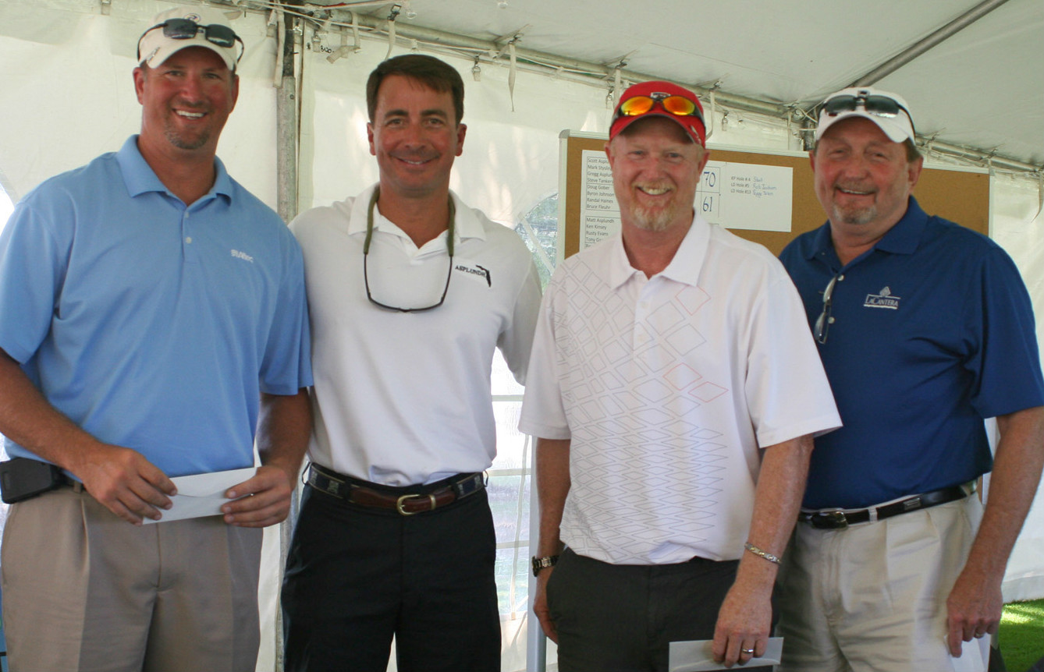
First place foursome: Tony Gann, Matt Asplundh, Ken Kinsey and Rusty Evans

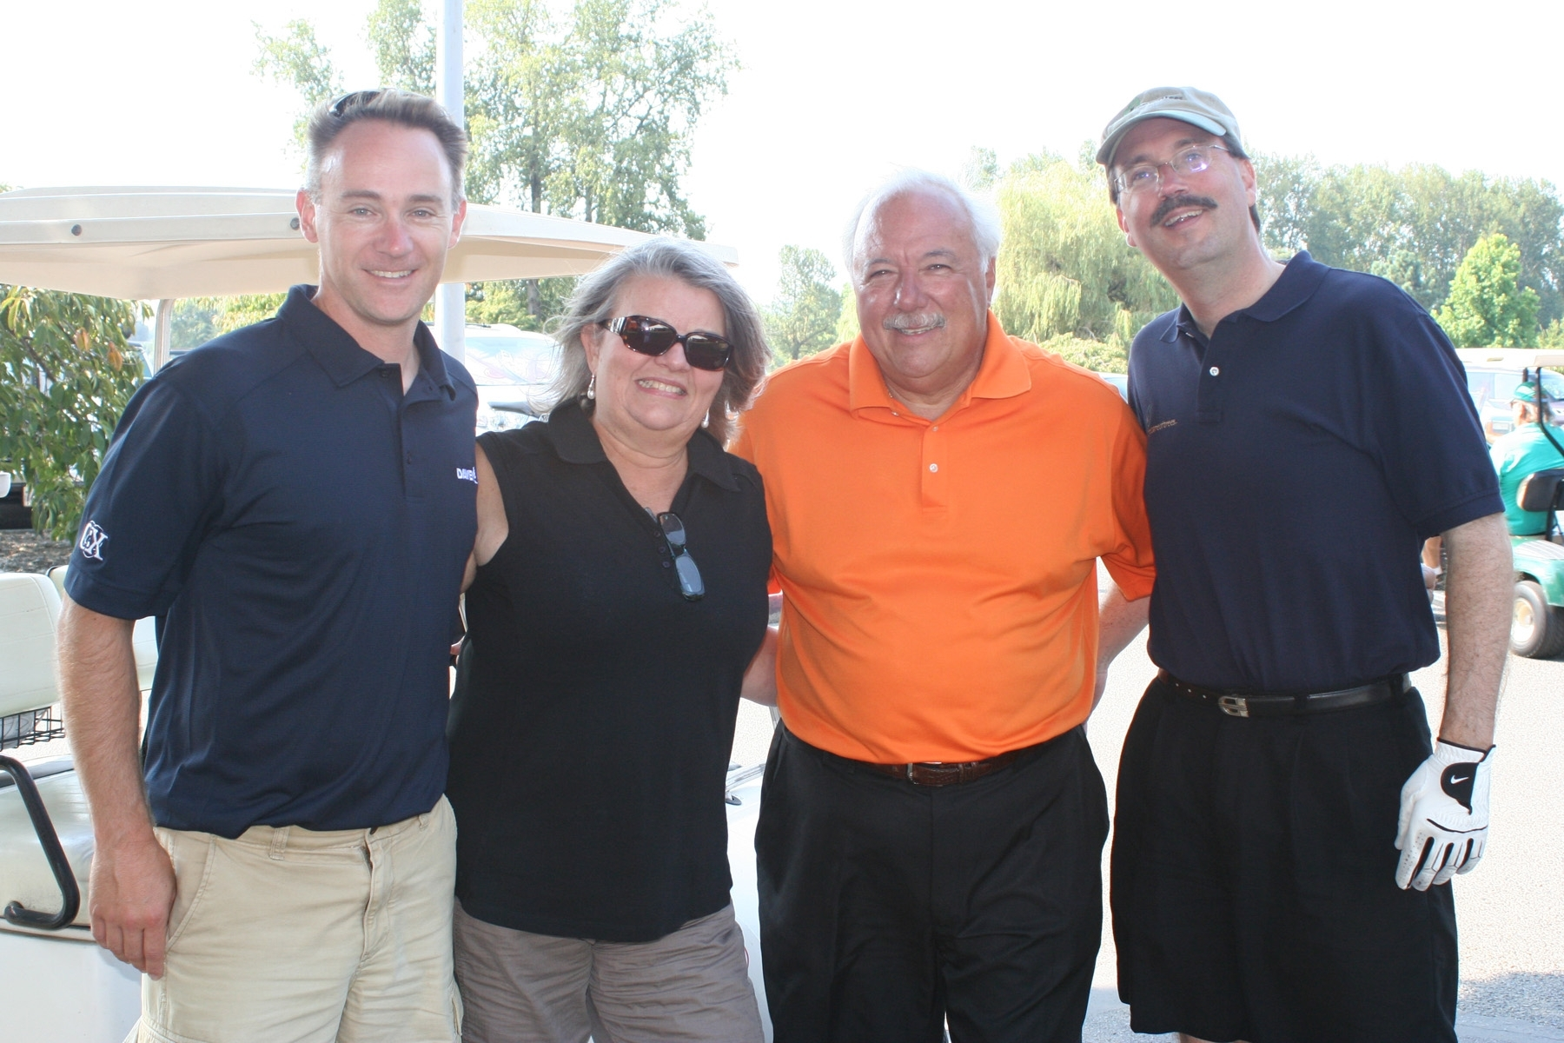
(below):Team TREE Fund: Jim Zwack, Janet and Denny Bornancin and “Skeet”

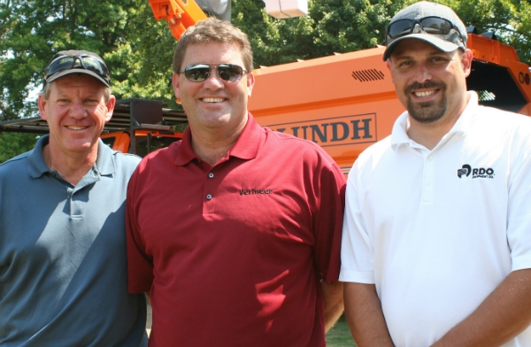

Team Vermeer: Sam Van Maanen,
Jerry Beyer and Dave Geiger

