ISA announces increase in annual support of the TREE Fund

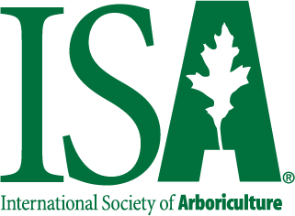
The International Society of Arboriculture will present a $50,000 gift to the TREE Fund, its largest-ever single gift to the foundation, at the ISA Leadership Conference in October. The gift inaugurates ISA’s commitment to increased annual support of the TREE Fund, and includes a previously announced pledge of $12,500 to the Safe Arborist Techniques Fund, plus $12,500 for the Bob Skiera Memorial Fund and an unrestricted gift of $25,000 to support tree research and education.

Thank you to these other recent donors to the TREE Fund Endowment and General Funds:

Wisconsin Arborists Association: $25,000 to the Bob Skiera Memorial Fund
Ameren Corporation: $15,000 to the Utility Arborist Research Fund
Husqvarna: $12,500 to the Safe Arborist Techniques Fund
Universal Utility Supply Co. (UUSCO): $10,000 to the General Fund
Gamma Tree Experts LLC: $5,000 to the Frank E. Gamma, Sr. Arboriculture Education Fund
Sacramento Municipal Utility District (SMUD): $5,000 to Utility Arborist Research Fund
Tree Care Industry Association: $5,000 to the Robert Felix Memorial Fund
West Coast Arborists: $5,000 to the General Fund

