Oregon delivers “epic” fundraisers for the TREE Fund

2012 STIHL Tour des Trees a record-breaker
ISA’s PNW Chapter partnered with the TREE Fund to host a blockbuster STIHL Tour des Trees this summer, a “bucket list” ride worthy of the 20th Anniversary of the Tour.

“PNW and Terrill Collier promised the TREE Fund an epic ride in Oregon, and they delivered,” said TREE Fund President/CEO Janet Bornancin. “We closed registration 6 weeks ahead of schedule because we’d reached capacity. We had a strong group of rookie riders and our veteran riders couldn’t wait to take on Oregon. Donations and sponsorships pushed this year’s revenues to $600,000, a new record for the event. This was a benchmark Tour from every perspective.”

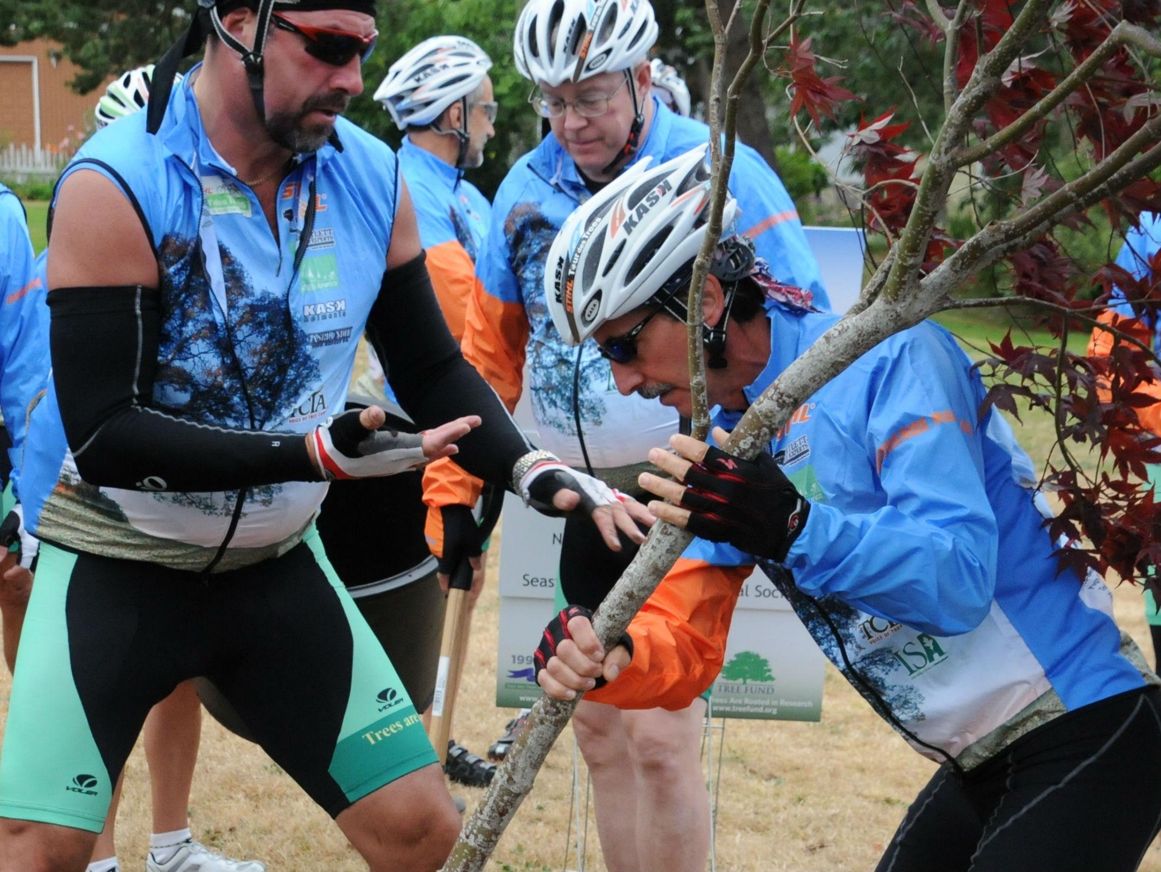
The cyclists launched in high spirits from tiny Banks, OR, after adding 20 trees to Banks’ new Educational Arboretum with support from STIHL Northwest and EF Nursery. An early-morning tree planting in Seaside the next day honored the legacy of Virginia arborist Bonnie Appleton, and the tribal drummers and children’s chorus of the Confederated Tribes of Grand Ronde welcomed the Tour to Oregon and paid tribute to its riders on Tuesday.

Frazer Pehmoeller and Tom Armstrong
plant a tree for Bonnie Appleton

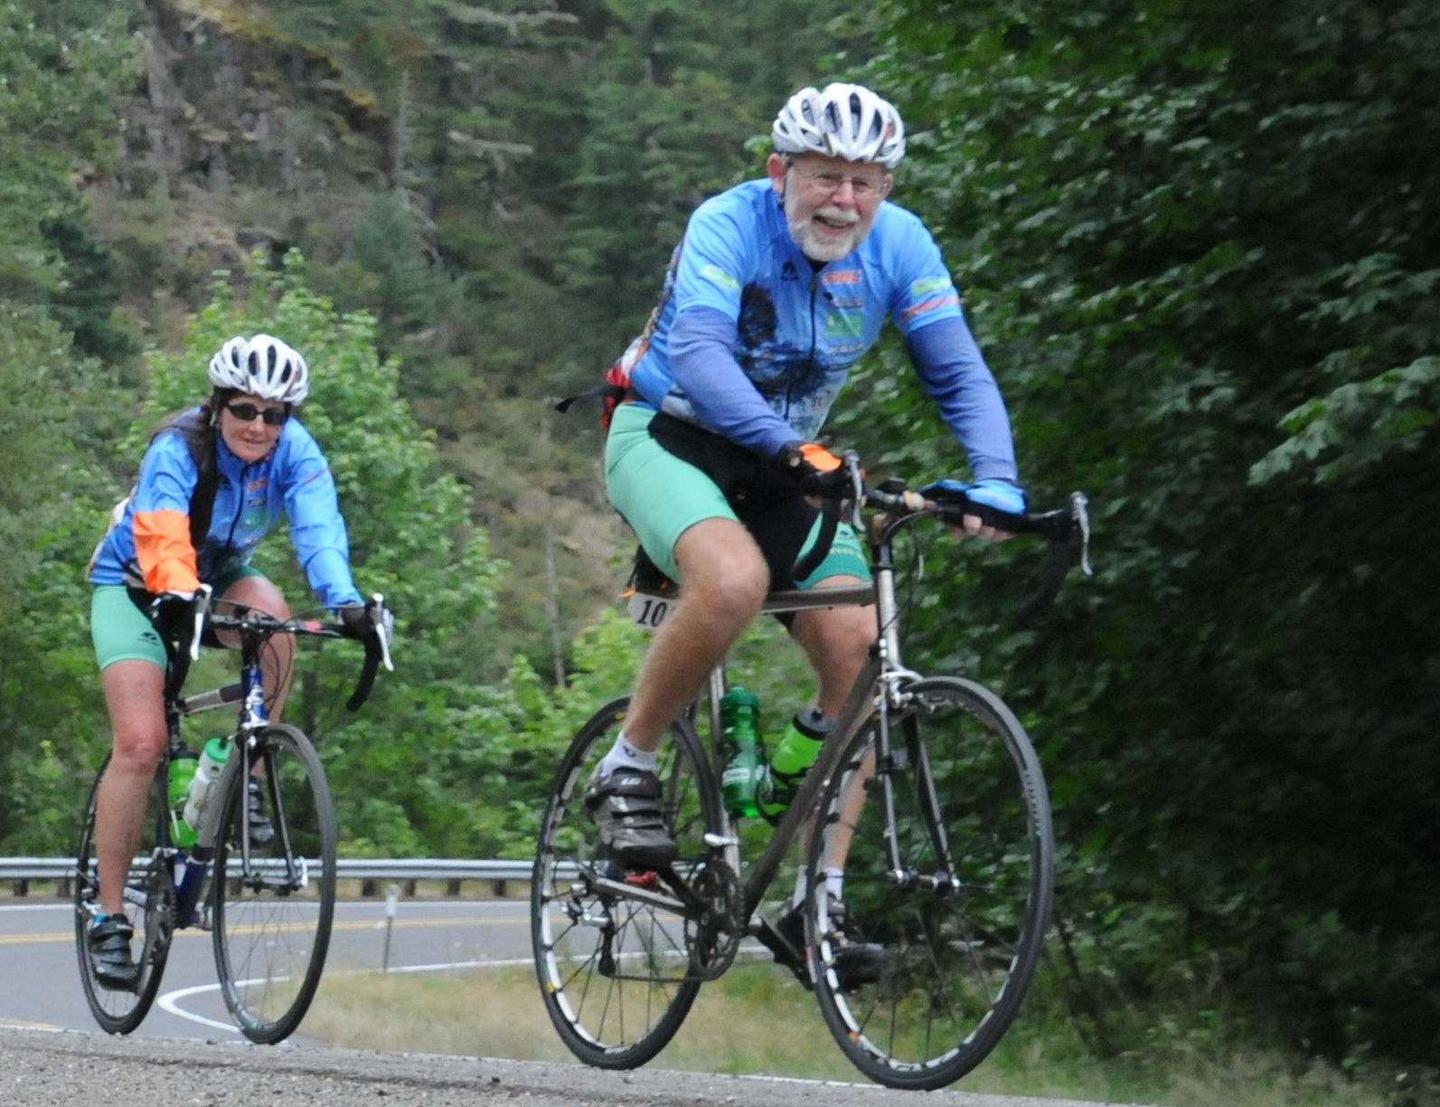
Tuesday’s sunset crowned a picturesque dinner at the home of Janet and Terrill Collier, and then it was on to the mountain. The winding roads and heavy forests obscured the cyclists’ view of Mt. Hood for much of Wednesday, but the relentless climbing left no doubt in anyone’s mind as to where they were headed. Thursday’s downhill run culminated in a trek through Oregon’s high desert on the way to Hood River and the windswept Columbia River Gorge.

Bartlett VP and first-time rider Scott Jamieson got the ride of his life in Oregon. “Nothing in the Midwest prepared me for
Oregon climbs, but the scenery was so spectacular I just kept Shirl McMayon and Harry
pedaling. And I couldn’t let my donors down. As tough as the Banker take on Mt. Hood
ride was though, the Tour isn’t about the bike. It’s about the
people, and the rider camaraderie was equal to none.”
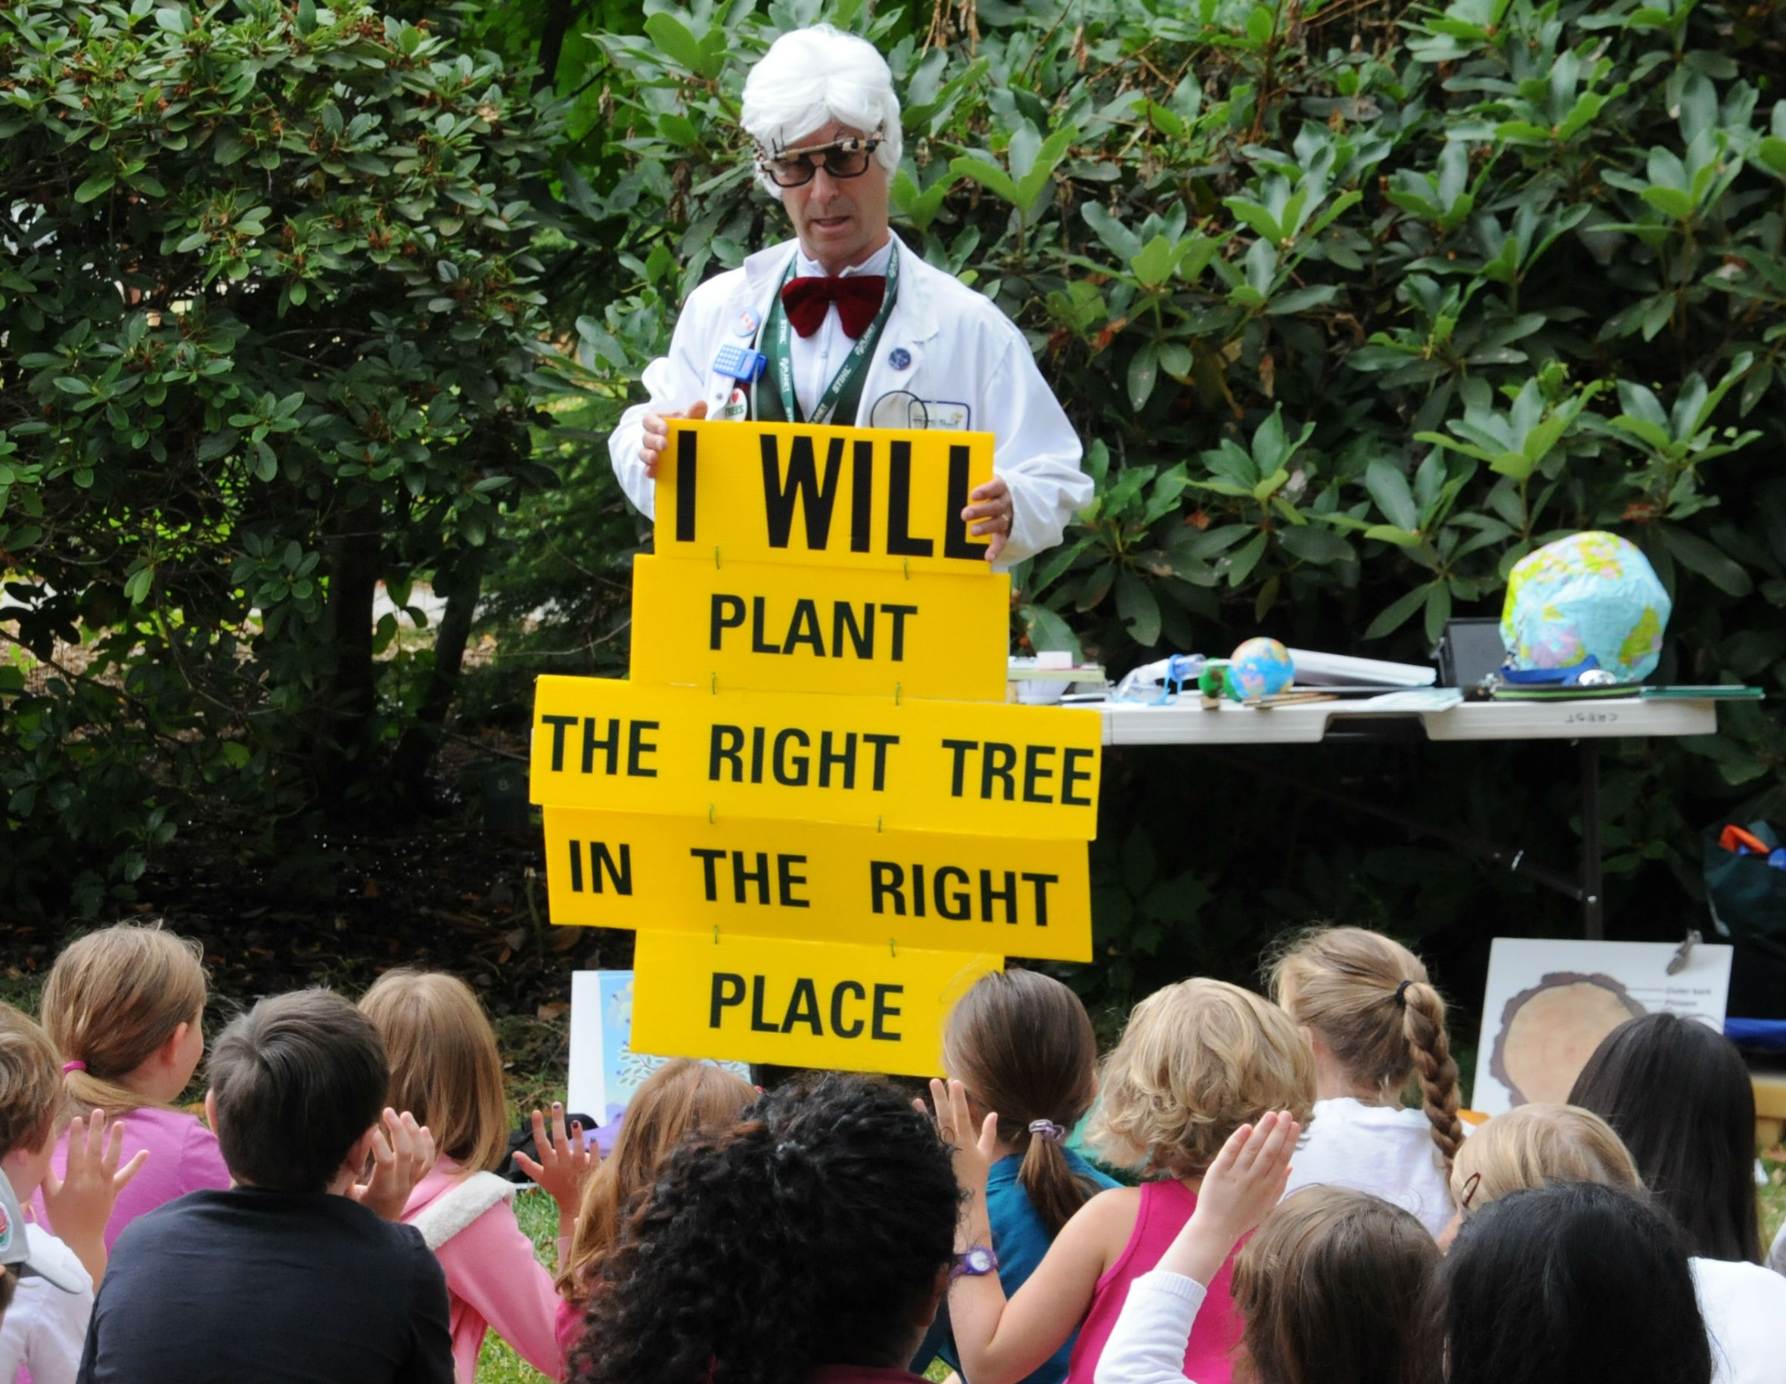
The Tour’s commitment to education and community outreach was embraced by Canadian arborist and veteran Tour rider Warren Hoselton, who traded his cycling jersey for a lab coat and a bad wig on five different occasions during the week. “Professor Pricklethorn” captivated the kids of Oregon with his interactive reenactment of photosynthesis, enlisting dozens of young recruits to his campaign to “give trees a chance”.

Professor Pricklethorn gets the word out in Oregon
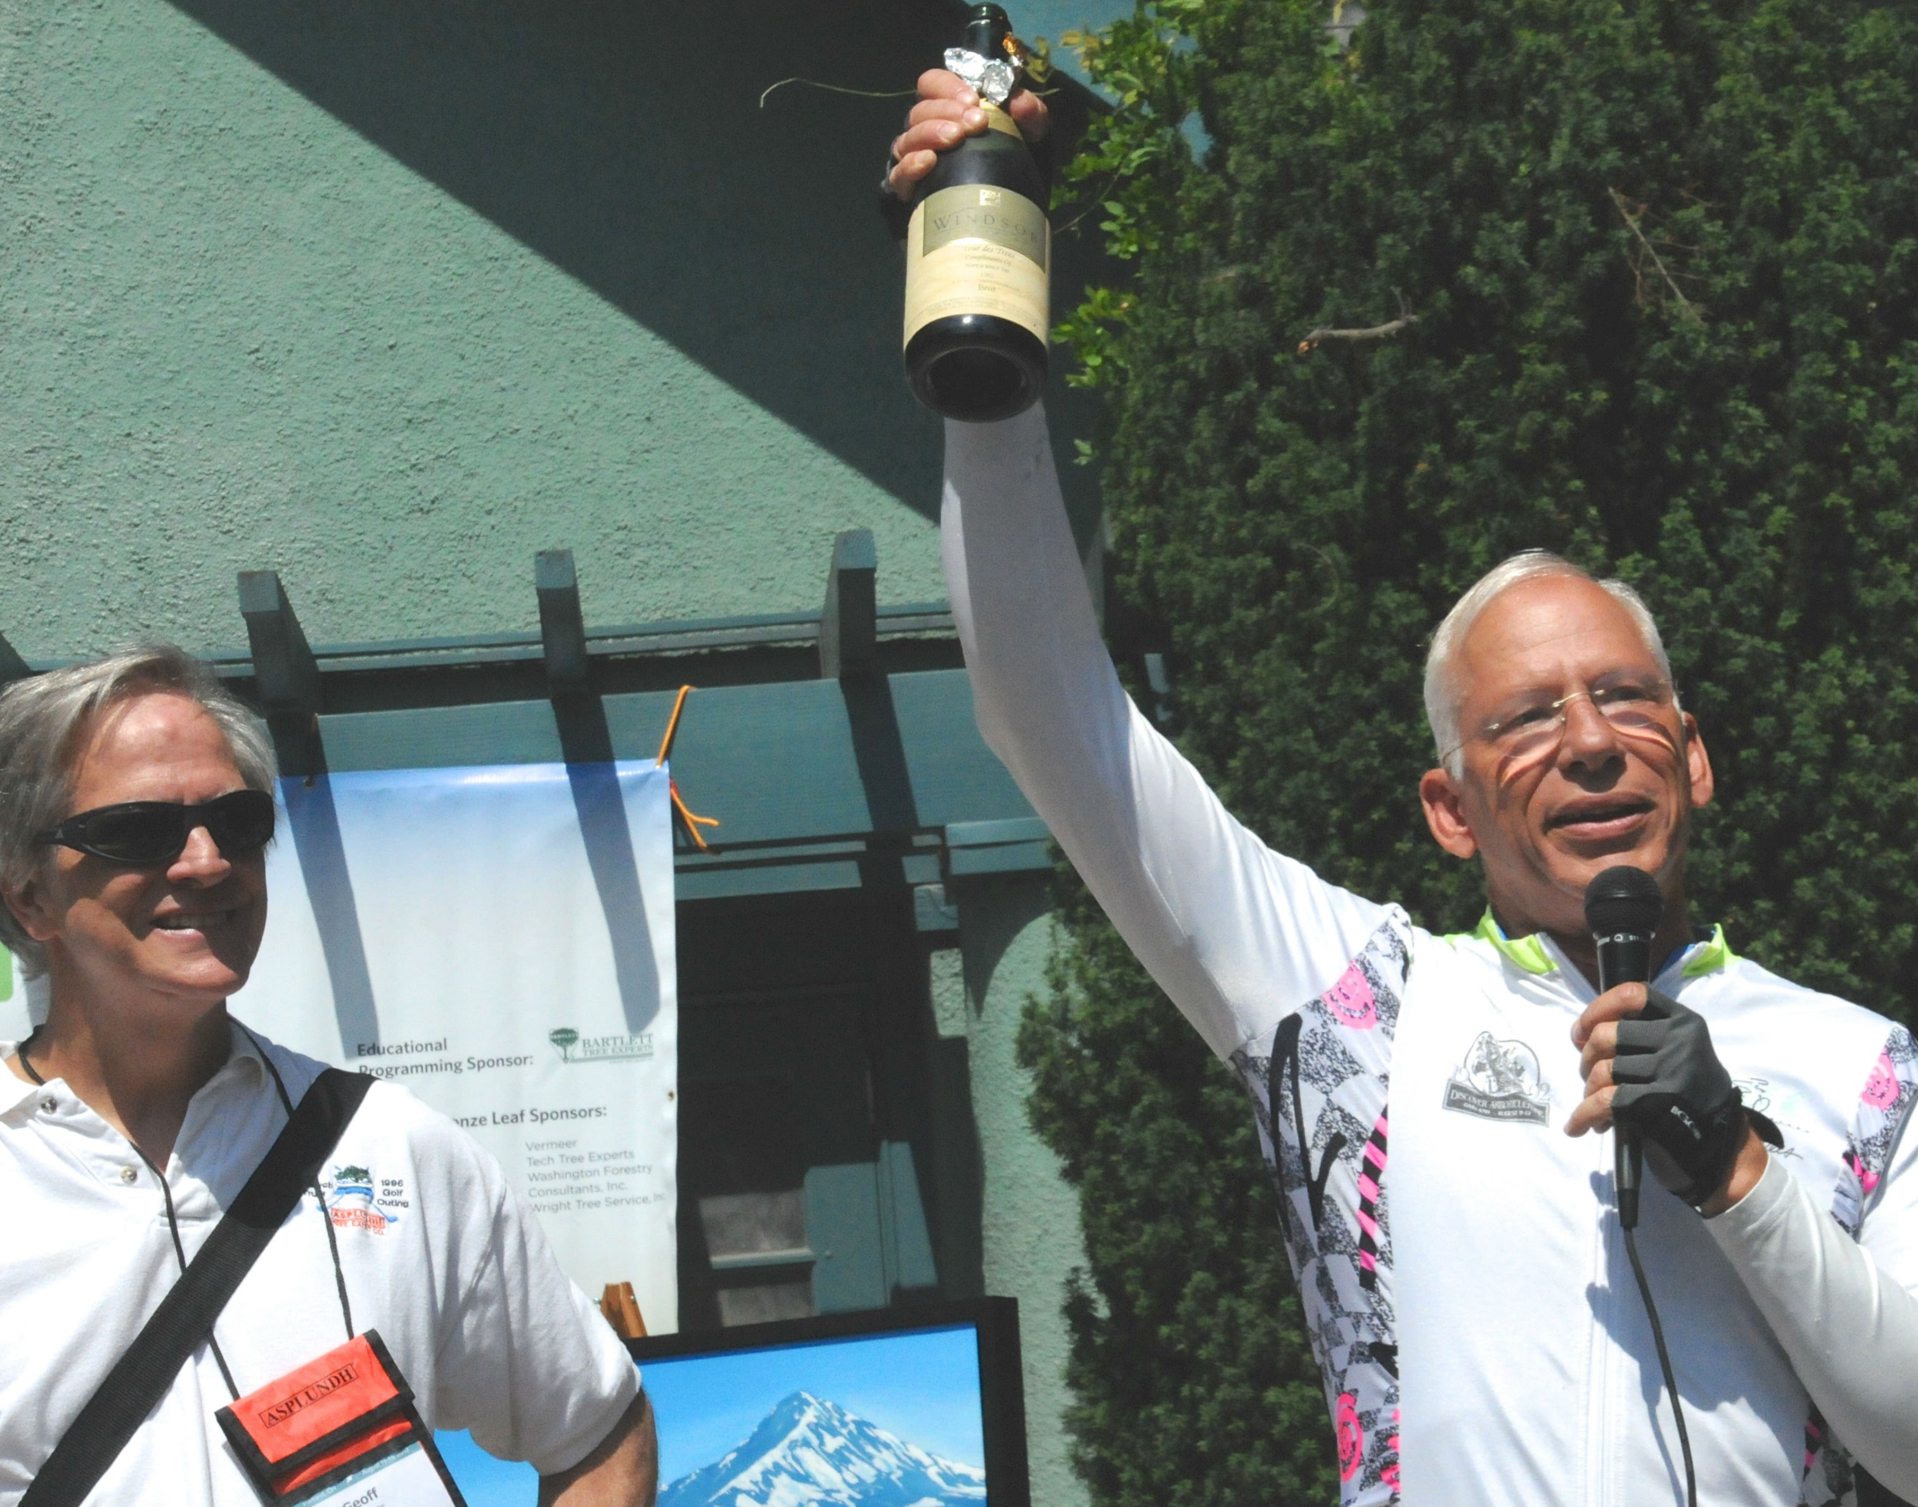
The 20th Anniversary Tour finished with an urban ride through Portland and a bottle of champagne from 1992’s inaugural Tour des Trees, saved for this occasion by Ward Peterson, veteran of the 1992 and 2012 Tours and several in between. “It was a bucket list ride, all right,” joked TREE Fund Chairman and Tour rider Mike Neal. “My bucket’s glad to be off that bike.”

1992 Tour rider Geoff Kempter and
1992/2012 Tour rider Ward Peterson
salute the Tour’s 20th Anniversary

