Viewpoint
By: Janet Bornancin, TREE Fund President/CEO

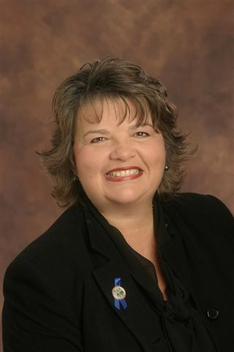
This issue of the TREE Fund Report spotlights four reliable engines of progress: imagination, collaboration, education and serendipity. All four played a role in bringing NASA scientists to The Morton Arboretum this fall, an unusual collaboration born of imagination and pure serendipity.

A NASA scientist hired a knowledgeable arborist to look at his trees. A backyard conversation revealed a shared interest in the physics of objects under stress (space shuttles, trees). What if…..tree researchers had access to NASA technology to measure the effects of load on trees? An idea took shape, a proposal was drafted, submitted, approved and funded, and biomechanics research took a leap forward.

Education is what makes any of this relevant. The results of the NASA project and September’s Tree Risk Assessment Symposium will be published in 2013, adding to our growing bank of knowledge on biomechanics. If the wait list for the Tree Risk Assessment Symposium was any indication, the demand for knowledge is strong (and Biomechanics Week 2013 won’t have many empty chairs). That’s what keeps us energized.

TREE Fund Trustee Mark Hoenigman was the arborist with imagination in the NASA scenario. Mark’s extensive knowledge of his industry and his willingness to listen and engage is typical of the volunteers who support our mission. TREE Fund loyalists are creative, dedicated and not afraid to lead (or fundraise). Quite a few of them also are formidable cyclists. We’re indebted to them for another record-breaking fundraising campaign in 2012, and we’re looking forward to welcoming our trustees and liaisons to Chicago in December to lay the groundwork for 2013.

I hope that what you read in this issue will inspire you to support the work that we do with a donation or an offer to lend a hand. We added “Cultivating Innovation” to our brand message this year, and we’re off to a strong start. It will require imagination and hard work in equal parts, and maybe a little serendipity. This is the future of tree care science. Let’s get started!

