Tree Research & Education Endowment Fund (TREE Fund)
2012 Annual Report

Our Mission: We support sustainable communities and environmental stewardship by funding research, scholarships and education programs essential to the discovery and dissemination of new knowledge in the fields of arboriculture and urban forestry.

“I believe in innovation and that the way you get innovation is you fund research
and you learn the basic facts. ” -Bill Gates

The Year in Review by M. Janet Bornancin, President/CEO

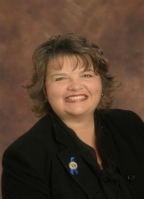
At the TREE Fund, we have always believed that innovation must be grounded in science if it is to have real and lasting value. In 2012 we ‘put it in writing’, integrating Cultivating Innovation into our brand message and logo. We followed through with a year of record-breaking fundraising and program growth fueled by the generosity of people like you: donors, sponsors, fundraisers and volunteers who share our conviction that investment in science is the first step toward safer, more effective and more efficient tree care.

We invested over $330,000 in 2012 to support arboriculture education programs, industry symposiums, scholarships for aspiring tree care professionals and new research projects in our priority areas of root and soil management, planting and establishment, risk assessment and arborist safety, and urban forestry.

In addition we continued to support the ongoing work of multi-year grant recipients. Dr. Brian Kane (Univ. of Mass. Amherst), recipient in 2009 of our first Dr. Mark McClure Research Fellowship, completed his investigation into “The Impact of Decay on the Structural Integrity of Trees” in 2012.

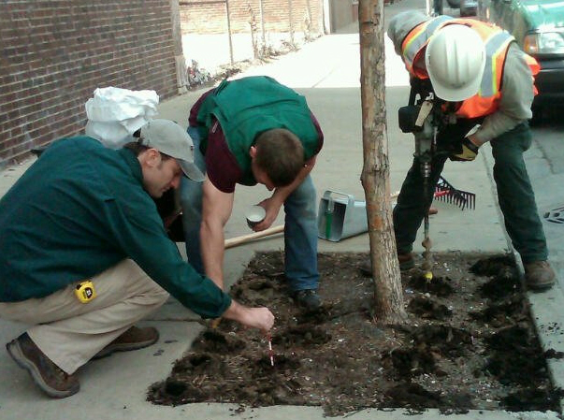
Drs. Bryant Scharenbroch (The Morton Arboretum) and Kelby Fite (Bartlett Tree Research Labs) continued their study, begun in 2010, of the merits of biochar as an urban soil amendment.

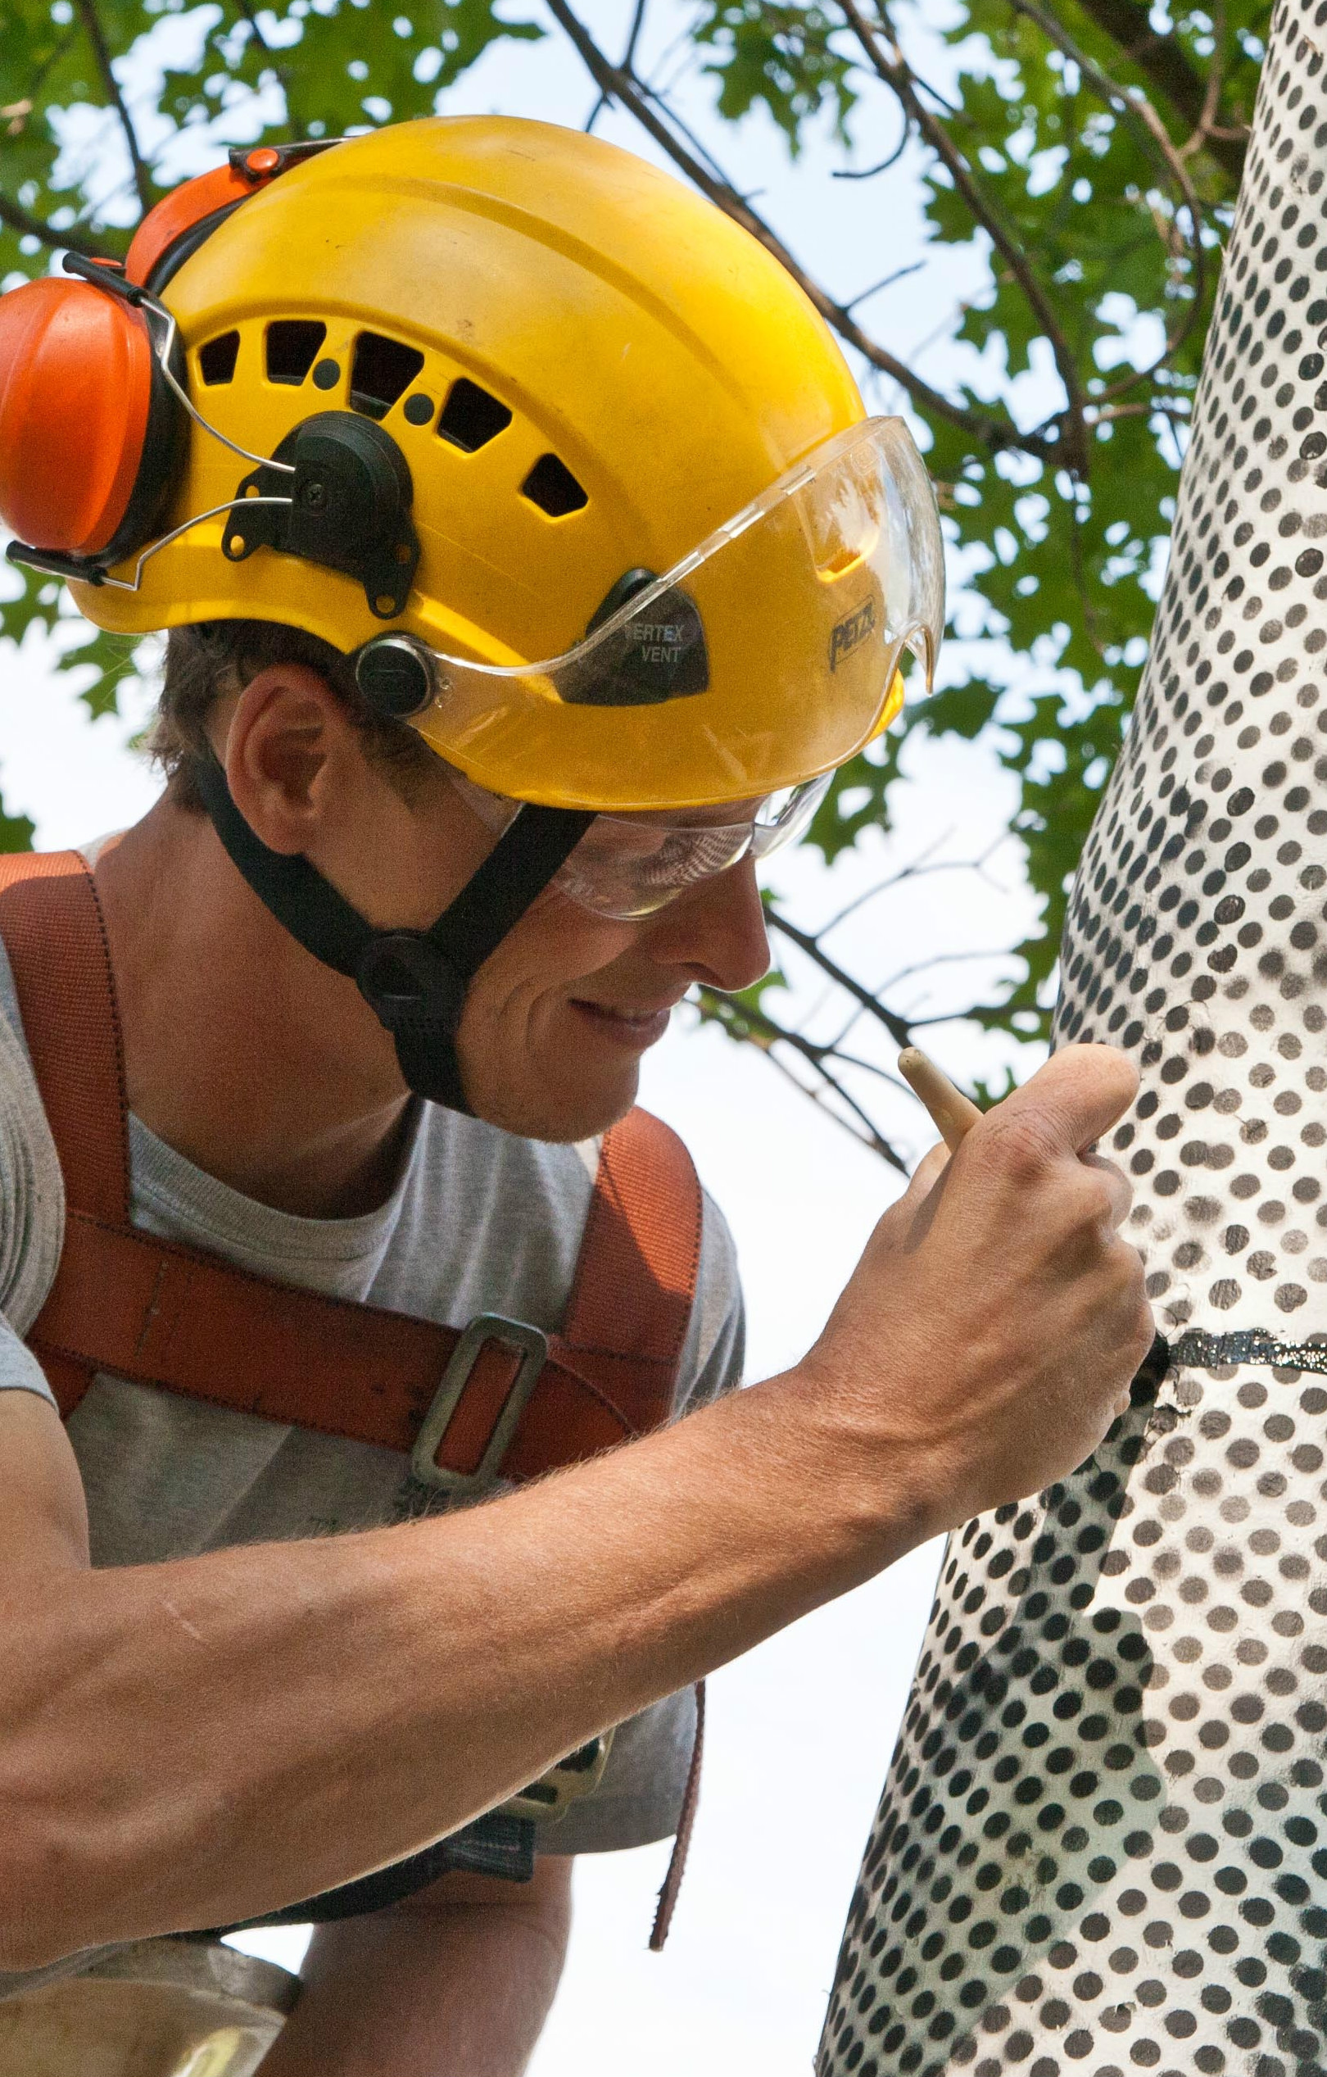
A grant awarded to Dr. Gary Watson (The Morton Arboretum) brought NASA engineers and an international team of tree scientists together to explore the applications of space age technology to tree biomechanics. Better understanding of how and why trees fail offers the best possible ROI in tree research—a safer workplace for tree care professionals. The project’s innovative application of NASA technology to tree care caught the attention of the Chicago media, garnering increased public awareness of the TREE Fund, The Morton Arboretum, and the relevance of research to the viability of trees in the public domain.

Another high point of our year was the announcement that veteran TREE Fund researcher Dr. Daniel Herms (Ohio State University) had leveraged his TREE Fund grants and received $1.5 million from USDA-APHIS to continue his study of apparent EAB resistance in ash trees. It’s thrilling when a researcher cultivates our ‘seed funding’ so successfully!

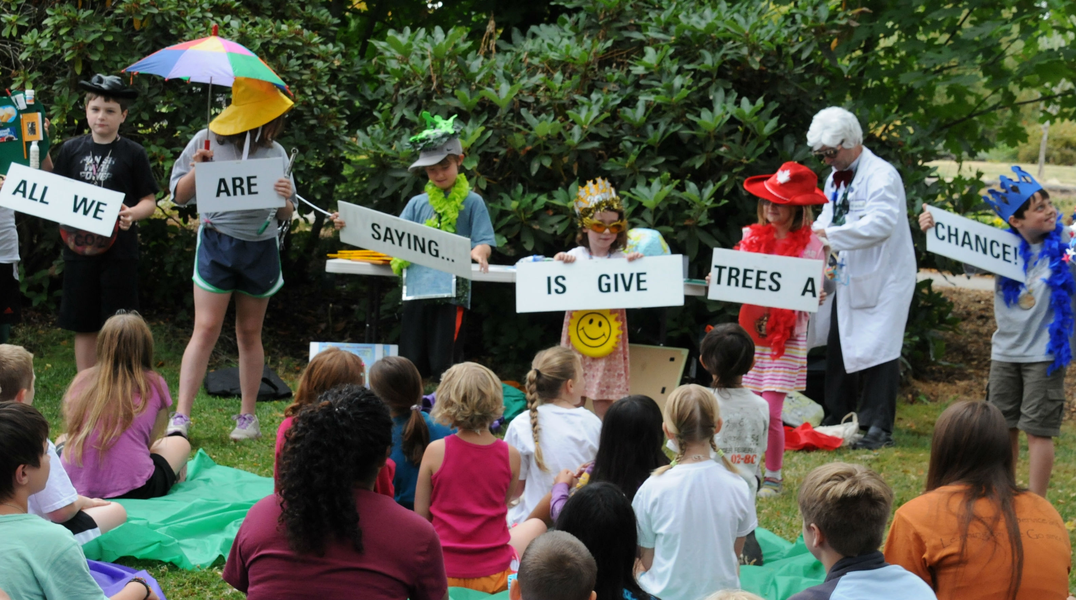
We’re equally proud of our expanding Arboriculture Education and scholarship programs. School children in Michigan, Oregon, Kansas and Uganda, (yes, Uganda, Africa) gained a new appreciation for the trees in their world in 2012, and the Ohio Chapter of ISA’s inaugural Arboriculture Education Grant supported improvements to Ohio State’s Secrest Arboretum, an important resource for Ohio researchers and tree enthusiasts . These awards, along with scholarships to students of arboriculture and related fields, personify our mission to identify and support programs which foster young people’s interest in nature and exploration of green careers.

The continued growth of our research and education program portfolio is a testament to the generosity and dedication of our donors and sponsors, STIHL Tour des Trees riders and volunteers. The 2012 Tour attracted 113 cyclists/fundraisers and the 2012 auction was a blast. Together they grossed $670,000 in revenue. Our Annual Appeal continued to evolve as a year-end fundraising and communications tool. The growth of our Endowment reflects the passion with which our fundraisers have championed support for the Safe Arborist Techniques Fund, the Bob Skiera Memorial Fund, the Utility Arborist Research Fund and other endowment funds. Gifts to the endowment edged us past the 2/3 mark in our progress toward a $3 million fundraising goal.

The TREE Fund laid the groundwork for sustained growth in 2013 and beyond. We implemented a comprehensive marketing and communications plan to help us cultivate new donors, volunteers and program applicants. We upgraded our grant management software to support more efficient interaction with our applicants and grantees and to allow us to be better stewards of your gifts.

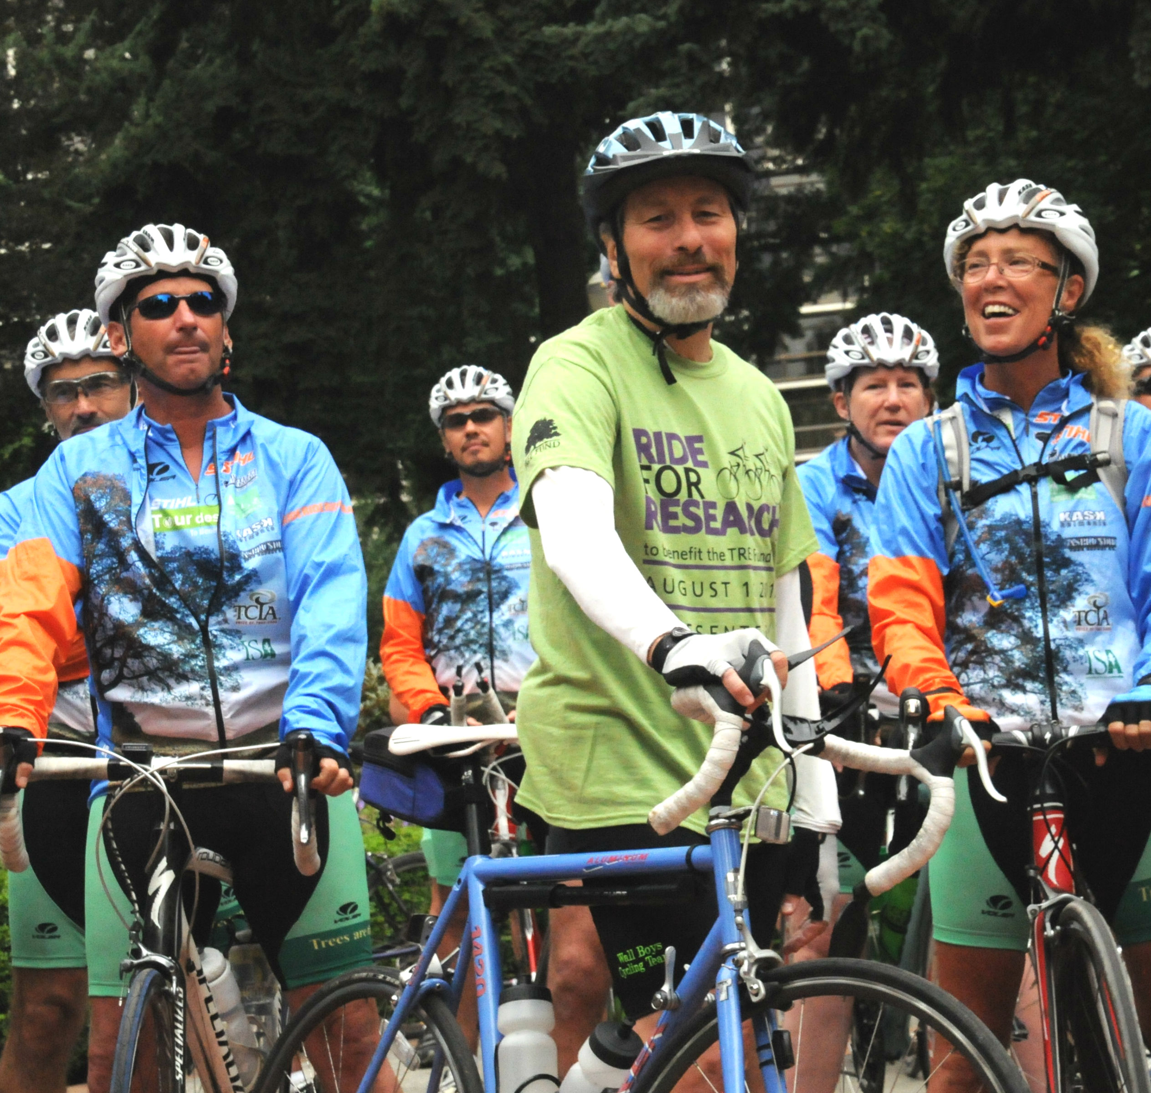
None of this would have been possible without the support of our most valuable resource – our volunteers! Our Board of Trustees brings an array of resources to the table, serving as ambassadors for the TREE Fund to their circles of influence. All of our trustees lead by example, giving generously of their time and personal resources. Three of them rode the 2012 STIHL Tour des Trees;

Knowledgeable, enthusiastic volunteers who share our passion for the urban forest and the research which sustains it powered our committees. Liaisons advocated year-round for research and education to their peers and beyond. Their energy, enthusiasm and dedication were the key to the success of our fundraising campaigns. Volunteers evaluated 81 grant applications, supported our communications and provided oversight of our financial and organizational processes.

There’s still much to be done. Insects, disease, pollution, development and inexpert tree care practices pose a constant threat to the canopies which shade our lives. The antidote is science: research to keep urban trees healthy and the tree care workforce safe, education and scholarships to inspire the next generation of tree stewards and arborists.
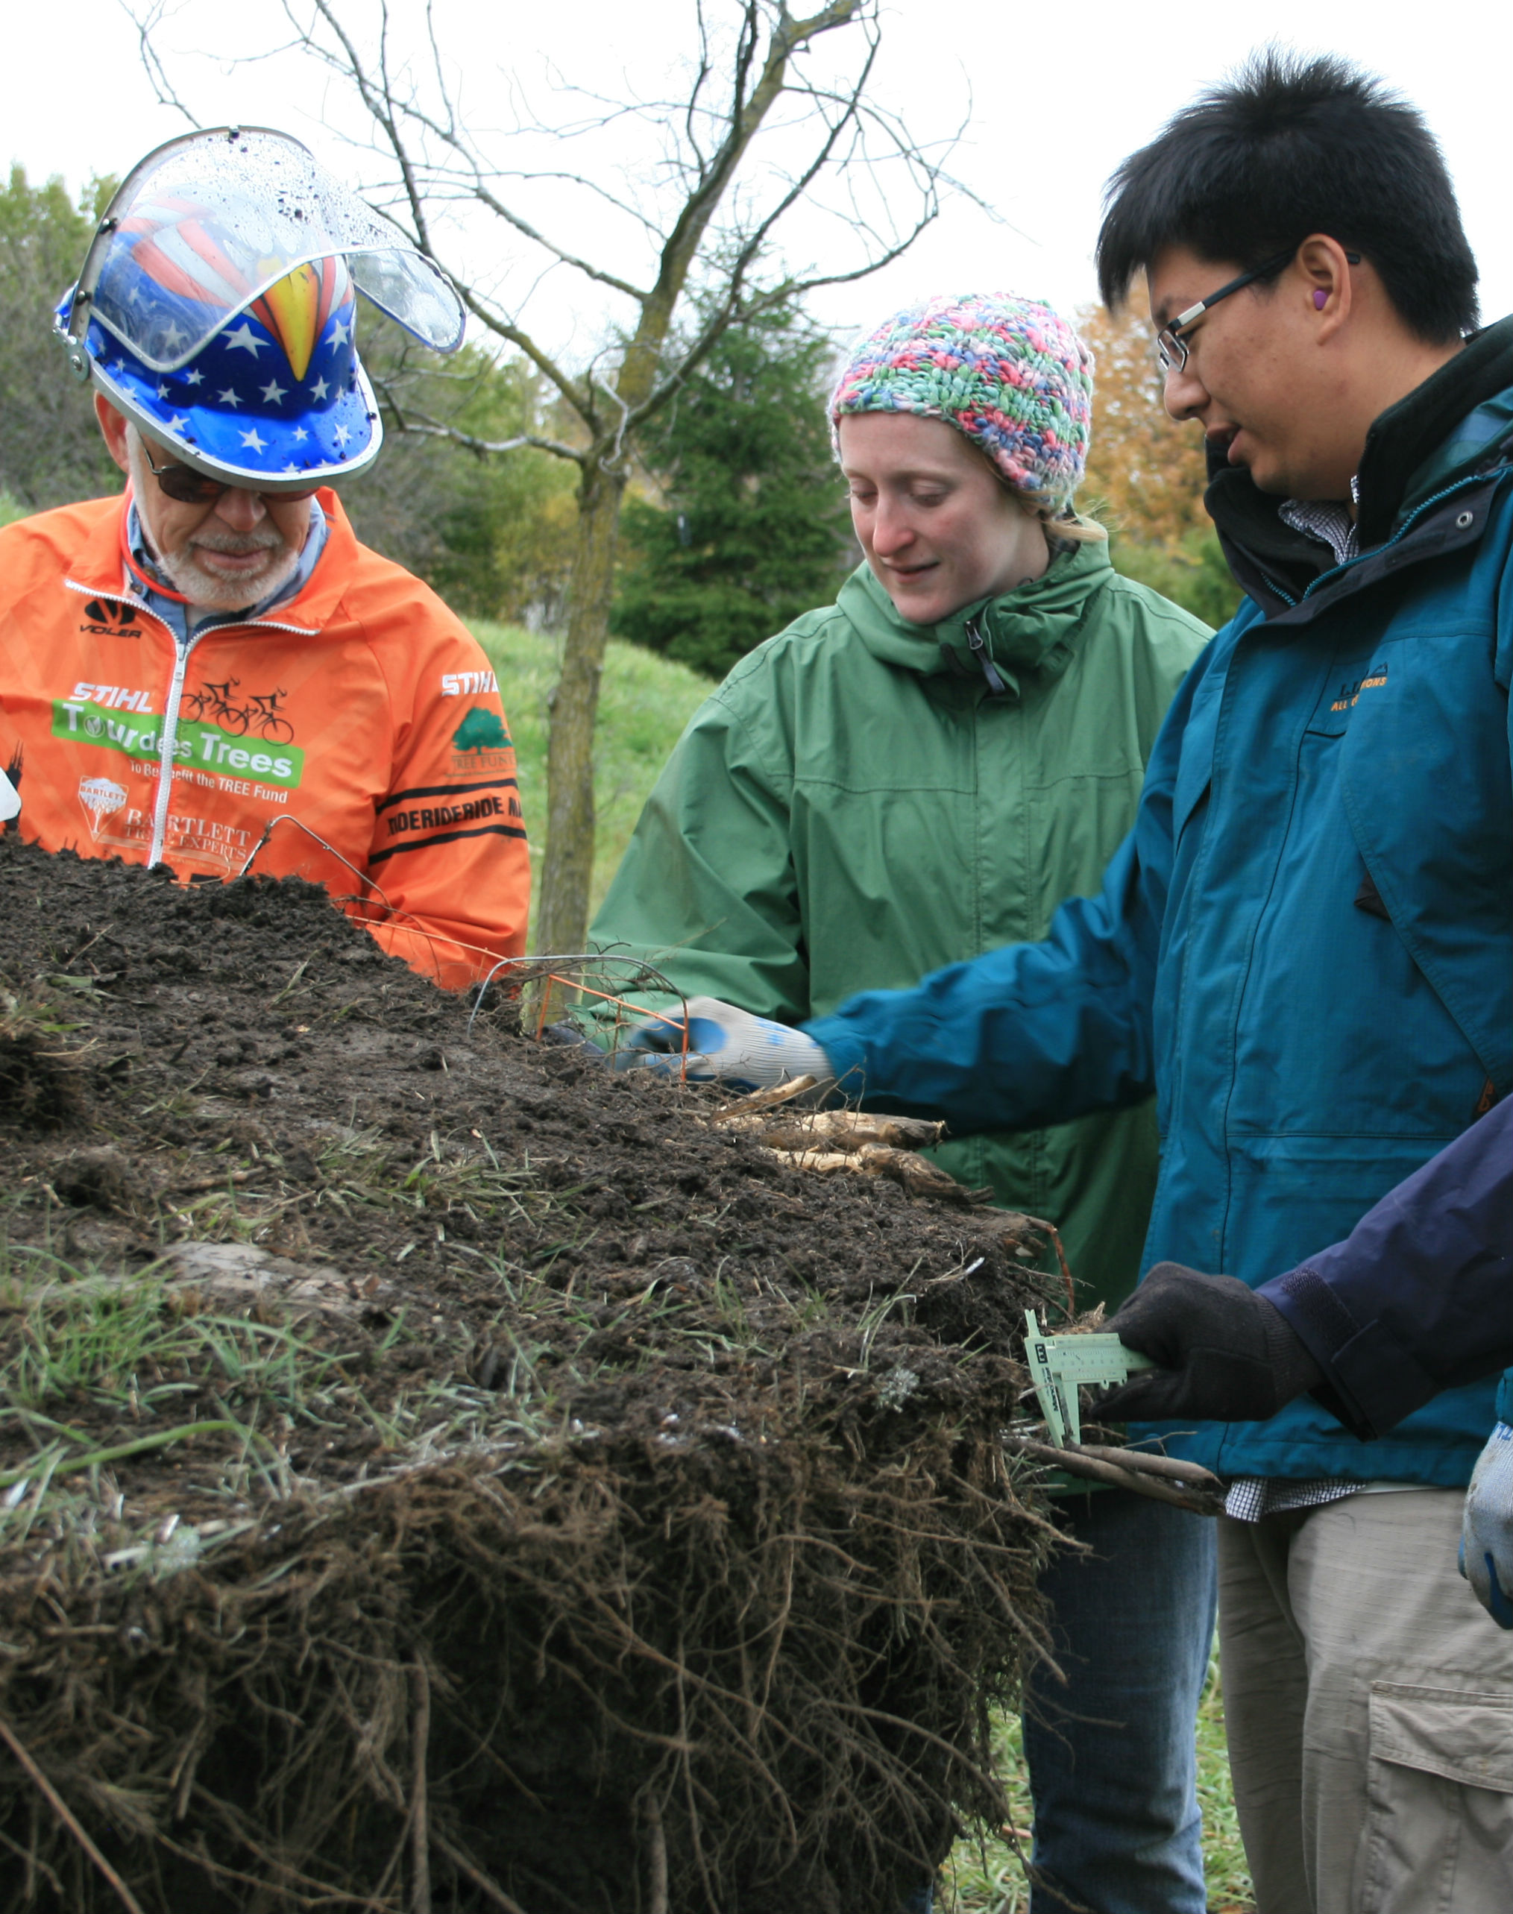
We invite you to learn more about the TREE Fund by subscribing to our newsletter at www.treefund.org, attending an arboriculture industry education program presented by a TREE Fund researcher, or volunteering for a committee or special event. Your continued financial support ensures that healthy trees will continue to grace our urban landscapes, and that the shade, beauty and environmental benefits they provide will sustain our communities for generations to come. Thank you for joining us in this important cause.

Our 2012 Board of Trustees

Mike Neal (Chairman)
Arizona Public Service, AZ

Jim Zwack (Chairman-Elect)
The Davey Tree Expert Company, MN

Randy Miller (Vice Chairman)
PacifiCorp, UT

John Hendricksen (Treasurer)
Retired from The Care of Trees, NM

Doug Anderson
Anderson Tree Care Specialists, Inc, CA

Jeffrey Carney
Liberty Utilities, NH

Hallie Dozier, Ph. D.
Louisiana State University, LA

Anita Gambill
STIHL Inc, VA

Doug Gober
Asplundh Tree Expert Co., PA
Mark Hoenigman
Busy Bee Services, Ltd., OH

Ed Macie
USDA Forest Service, GA

Michael J. Robinson
Bartlett Tree Experts, IL

Wendy Robinson
City of Bend, OR

Brian Sayers
The Tree Doctor, NY

Michael Weidner
ACRT, Inc., OH

Emeritus
John Lloyd
Tech Tree Experts, Inc., VA

Allan West
Retired from USDA Forest Service, CA

Janet Bornancin
(Ex-officio, President/CEO,
Executive Secretary to the Board)

Summary of 2012 Income and Expenses

Total Net Assets

 |  |  |  |  | 2012 |  |  | 2011
ASSETS
CURRENT ASSETS:
 | Cash and cash equivalents |  |  | $ | 288,953 |  | $ | 118,663
 | Pledges receivable |  |  |  | 48,400 |  |  | 91,000
 | Other contributions and grants receivable |  |  |  | 34,048 |  |  | 10,444
 | Investments held by Chicago Community Trust |  |  |  | 1,973,475 |  |  | 1,657,576
 | Prepaid expenses |  |  |  | 15,982 |  |  | 8,577
 |  | Total current assets |  |  | 2,360,858 |  |  | 1,886,260
PROPERTY AND EQUIPMENT, at cost:
 | Furniture and equipment |  |  |  | 30,120 |  |  | 30,120
 | Less - Accumulated depreciation |  |  |  | (30,120) |  |  | (27,946)
 |  | Net property and equipment |  |  | - |  |  | 2,174
OTHER ASSETS:
 | Pledges receivable, net of current maturities |  |  |  | 55,565 |  |  | 72,283
 |  |  |  | $ | 2,416,423 |  | $ | 1,960,717
LIABILITIES AND NET ASSETS
CURRENT LIABILITIES:
 | Accounts payable |  |  | $ | 12,038 |  | $ | 32,618
 | Grants payable |  |  |  | 157,533 |  |  | 95,447
 | Deferred revenue |  |  |  | 25,900 |  |  | 2,500
 | Accrued expenses |  |  |  | 5,701 |  |  | 2,837
 |  | Total liabilities |  |  | 201,172 |  |  | 133,402
NET ASSETS:
 | Unrestricted |  |  |  | 592,114 |  |  | 434,330
 | Temporarily restricted |  |  |  | 623,454 |  |  | 482,258
 | Permanently restricted |  |  |  | 999,683 |  |  | 910,727
 |  | Total net assets |  |  | 2,215,251 |  |  | 1,827,315
 |  |  |  | $ | 2,416,423 |  | $ | 1,960,717

TREE Fund Endowment Summary

