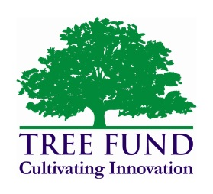**Trustee Profile**

**Name**: Jeff Wilson

**Employer:** Wachtel Tree Science

**Position:** President

**Education:** B.S. Biology

**Certifications:** ISA Certified Arborist

**Affiliations:** ISA, WAA, TCIA

**Skills:** Management, Leadership, Salesmanship, Career Development

**Why you are serving on TREE Fund board?** I am the TCIA board member representative to the Tree Fund

**TREE Fund Committees you chair/serve on:** TBD

**Biography**

President of Wachtel Tree Science & ISA Certified Arborist, I am a graduate of Northland College with a BS in Biology. 2015 is my 40th year in the tree care industry. Most of these years where spent at The Care of Trees (TCOT) and RW Hendricksen Company where I spent 12 years as a field worker. My last position at TCOT was Vive President. I became a co-owner of Wachtel Tree Science in 2007 and oversee Sales and Marketing for the company.

I have been or currently an advisor to the Forestry programs at UW Stevens Point, Milwaukee Area Technical College, and Mid-State Technical College, I enjoy watching young people enter the profession and grow into very talented tree care specialists. I take great pride in Wachtel's highly educated, friendly staff, and enjoy employing good honest people who are the very best at what they do.  My greatest area of satisfaction is watching young people become "great people helping great clients."

I am active in the International Society of Arboriculture, a former Wisconsin Arborist Association Board Member and entering my second term as a board member of the Tree Care Industry Association.

My favorite tree is the strong and mighty Kentucky Coffee tree.

I married my wife Linda in 1987 and have two children Maddie and Sam.