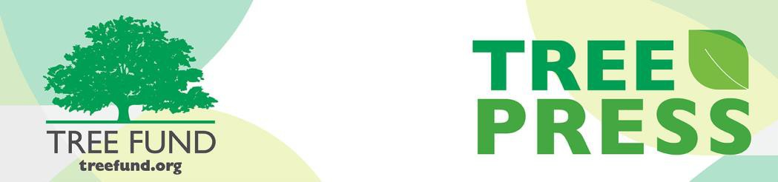

Tree Research and Education Endowment Fund Newsletter Vol. 2 No. 1 – January 2019

Crowning Achievements
Research on Fighting Tree Diseases with Non-Chemical Compounds
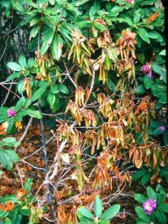
Urban trees are susceptible to various pathogenic fungi and bacteria that, if uncontrolled, can result in high mortality rates. Agrochemicals are primar- ily used to control these diseases, but present their own problems.
Systemic induced resistance (SIR) is a resistance mechanism in plants that is activated by exposure to a disease (same concept as a vaccine). SIR-

“Nature welcomes inquiry. Nature does not hide its work.
Just seek, and you will find.”

inducing compounds have been developed and
shown promise as a non-chemical disease
management strategy for trees. In the study,
Source: Missouri Botanical
Garden
- Alex L. Shigo

“Systemic induced resistance to control root and foliar diseases of urban trees” Dr. Glynn Percival (R.A Bartlett Tree Research Laboratory, University of Reading, U.K.) sought to evaluate the efficacy of a variety of these compounds and determine specifics such as timing, dosage, frequency, and duration of resistance.

In This Issue

- Crowning Achievements
- Leading Thoughts
- Spring Cycle Applications Open Soon
- Lead Donors
- Trees in Trouble Wins First Place
- Tour des Trees News
- Winning End to 2018
- Volunteer Spotlight
- Word on Webinars
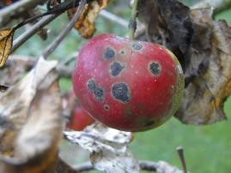
The research indicated that using a SIR product (provided that at least three spray applications were applied during the growing season) reduced disease severity by about 60%. Thus, application of an appropriate SIR compound may provide a

Source: Apsnet.org
useful addition to existing methods of foliar and root disease management in trees.

Dr. Percival has continued to explore using non-chemical methods and novel compounds to reduce tree disease severity and enhance resistance. Read more about his TREE-Fund supported projects in this area in the research archives of our website.

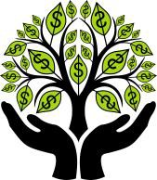
Leading Thoughts

Spring Cycle Applications Open Soon
Applications for the following TREE Fund grant and scholarship programs will be open January 15 through
March 15, 2019:

- $25,000 Hyland R. Johns Grant
- $ 5 0 , 0 0 0 U t i l i t y Arborist Research Fund Grant
- $5,000 Ohio Chapter ISA Education Grant
- A l l s c h o l a r s h i p s ($3,000 to $5,000)

Please note that a Letter of Inquiry is now part of the research grant application process, so we recommend starting the application process early. Get more details and instructions on the TREE Fund website.
By J. Eric Smith, TREE Fund President and CEO
It’s always an extra treat to travel when you’re a tree nerd, since you get to play “canopy compare and contrast” between your home turf and your destination(s) while you are abroad. My wife and I greeted 2019 with a trip to London and Paris, and my FitBit tells me we walked 160,000 steps (about 80 miles) over the course of the week, much of that time spent with me ooo-ing and ahh-ing at special street trees or historic park trees or “what the heck is that?” trees we passed as we ambled about.
I love London Planes (Platanus × acerifolia) anywhere I spot them, and it was particularly delightful to see so many mighty specimens at the heart of their namesake city, their dappled trunks striking in sun or shade, and their distinctive seed balls providing “winter interest” as you surveyed the streetscape. In Paris we strolled the Bois de Boulogne with its native and curated forests, and we admired the Tilias that abound throughout the city, and which lay people call lindens, or basswoods, or limes, depending on where they make their homes.
We spent a lot of time in airplanes getting to and from Europe, and also had a nice EuroStar train trip via the “Chunnel” between London and Paris. This gave me a hefty amount of quiet time to read (more than I normally have, anyway), and the tree nerd in me was happy with that prospect, too, as I read a most remarkable book about trees, and people, and people and trees called The Overstory by Richard Powers.
I have to assume that if you’re reading this article in the TREE Fund newsletter that you’re at least a little bit of a tree nerd yourself, too, and so I most heartily recommend this book to you. It’s a transcendent novel that twines the tales of a
half dozen wildly dissimilar humans into a single, solid, towering, powerful creative monument, with every step of the story given shape and substance by
trees. The New York Times perhaps captured this concept best in their review of the book, where they noted “humans are merely underbrush; the real protagonists are trees.”
While The Overstory clearly resonates with those who don’t necessarily love or know their trees (it was shortlisted for the prestigious Man Booker Prize, awarded to the best novel in the English language issued each year), it was positively electrifying to me given my professional avocation. It’s not every day that mycorrhizal networks pop up and play key roles in a work of fiction, after all, but they’re quiet superstars here.
Like all great novels, The Overstory leaves the reader with a lot to consider when it’s run its course, and while not everyone may agree with all of Powers’ implied or explicit lessons or morals, I can guarantee that his words, his stories, the magic of his prose, and most of all his trees will resonate with you all. Happy reading, and let me know what you think!

Lead Donors
We are grateful to the following people and organizations who contributed $2,500+ to TREE Fund in December 2018. See the full list of 2018 Lead Do- nors who make our work possi- ble on the donor page of our website. Thank you!
- ACRT
- Asplundh Tree Experts LLC
- James and Ann Barborinas
- Bartlett Tree Experts
- CN Utility Consulting
- Illinois Arborist Association, Inc.
- Mundy Wilson Piper and Winthrop Piper

Trees in Trouble Wins

First Place
Trees in Trouble, a documentary film supported in part by TREE Fund, won first prize at the International Film Festival of the Urban Forest held in Mantova, Italy, in late November 2018. The film festival was part of the World Forum on Urban Forestry international gathering attended by over 1,000 green industry stakeholders from around the world.
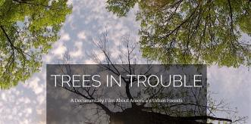
Read more about Trees in Trouble on our website.

Bikes, Banjos and Bluegrass: 2019 Tour News
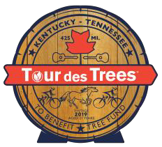
Watch your email on January 15 for the big announcement: the 2019 Tour des Trees route! Not signed up for Tour- related email? Subscribe today.
Registration for this year’s Tour opens February 1 on the Tour des Trees page of our website.

Winning End to 2018
With your generous support, TREE Fund’s Year End Appeal achieved its goal of raising $30,000. Thank you!
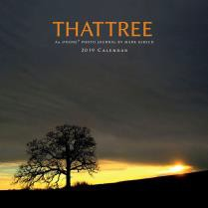
We are also pleased to announce the winners of the That Tree calendar fundraising incentive:
- Richard and Ellen Alt (NY)
- Anonymous (OH)
- Robyn Flakne (IL)
- Dennis McGlade (PA)
- E. Thomas Smiley (SC)
- Kristin Wild (PA)
Thank you for participating, and congratulations!

Volunteer Spotlight: Will Nutter
Please join us in celebrating Wilbur Nutter of Wright Tree Service as our outstanding volunteer in December. Will has been a TREE Fund Trustee since 2015 and is currently a very active member of our Audit and Finance Committee and Development Committee. Will is a true champion
of TREE Fund, long advocating for us within the tree care and vegetation management industries. He was instrumental in securing a ten-year partnership with Wright Tree Service, an important collaboration that helped endow the John Wright Memorial Scholarship Fund that supports a national annual scholarship for arboriculture students. Thank you, Will, for the many things you do for TREE Fund!
To suggest someone for the Spotlight, contact Karen Lindell.

The Word on Webinars
Register today for The Salt Dilemma: Growing Better Urban Trees in Northern Climates, featuring James Urban, FASLA (Urban Tree + Soil), Andrew Millward, PhD (Ryerson University), and Adam Nicklin (PUBLIC WORK).
Can urban trees and city winter weather protocols peacefully co-exist? Join us for a discussion of the latest research findings related to success- fully growing trees under these conditions.
- February 5 at 12:00 p.m. (Mountain)
- Pre-registration is highly recommended (translate to your time zone)
- Earn 1.0 CEU from ISA, SAF, NALP or LACES for the live broadcast.
Visit the webinar page of our website to get more information, see upcoming webinars, and watch past broadcasts.
Contact Us TREE Fund
552 S. Washington Street Suite 109
Naperville, IL 60540
(630) 369-8300
treefund@treefund.org

Visit us online at treefund.org.

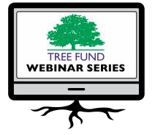

TREE Fund is a 501(c)3 nonprofit whose mission is to support scientific discovery and dissemination of new knowledge in the
fields of arboriculture and urban forestry.

TREE Fund

PLACE STAMP HERE
552 S. Washington St., Ste. 109
Naperville, IL 60540

