

**Tree Research and Education Endowment Fund Newsletter Vol. 2 No. 2 – February 2019**

# Crowning Achievements

#### Research on Tree Risk Perceptions

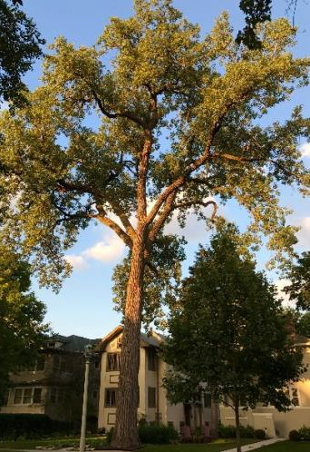Trees give us immense benefits, and tree owners and property managers must weigh them against potential risk to life and property.

Ideally, tree risk evaluation balances a strong understanding of any defects in the specimen, and the people or items in the tree’s range (target). In the three- year, 2013 study, **“ U r b a n T r e e R i s k Assessment – Perceptions, Reality, and Reliability,”** partially funded by TREE Fund’s Jack Kimmel International Grant, Dr. Andrew Koeser

PHOTO CREDIT: T. RECCHIA

##### “Nature welcomes inquiry.

*Nature does not hide its work.*

*Just seek,*

*and you will find.”*

*- Alex L. Shigo*

(University of Florida) examined factors driving homeowner and

**In This Issue**

* Crowning Achievements
* Leading Thoughts
* Spring Cycle Grant Applications Open
* Lead Donors
* TREE Fund Research Impact
* Tour des Trees 2019

Registration Open

* Fall Cycle Grant Awards
* Volunteer Spotlight
* The Word on Webinars

professional risk perceptions, the impact an individual arborist has on common risk assessment method outcomes, and the assessment of target ratings. His study found that up to 55% of arborists’ risk rating decisions are based on the severity of the defect they see in the tree, while as little as 24% are based on an informed assessment of the target; that is, focusing on the defects when the target should be considered as well.

Read about Dr. Koeser’s [research](https://treefund.org/archives/7484) and other studies on tree risk

assessment and more at TREE Fund’s website.

# Leading Thoughts

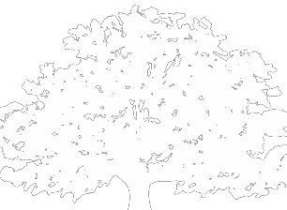

**Spring Cycle Grant Applications**

Applications for the following TREE Fund grant and scholarship programs are open through March 15, 2019:

**$25,000**

**Hyland R. Johns Grant**

**$50,000**

**Utility Arborist**

**Research Fund Grant**

**$5,000**

**Ohio Chapter ISA Education Grant**

**$3,000 - $5,000**

**All Scholarships**

Please note that a Letter of Inquiry is part of the application process and is due by March 1, 2019.

Get more application details and instructions on TREE Fund’s [website.](https://treefund.org/)

*By J. Eric Smith, TREE Fund President and CEO*

Last summer, I wrote a Leading Thoughts column on “trees as inspiration,” sharing my affection for a wonderful work-in-progress book about ginkgos by Jimmy Shen, a professional botanic photographer based in east China. Last month, my column focused on another book, *The Overstory* by Richard Powers, a powerful novel about the ways that trees can shape our lives, from birth to death, and maybe beyond.

I received more feedback on those two columns than I did from any of the others I’ve written here, I think because those of us who count ourselves as “tree people” generally don’t leave our interest in trees at our work sites but are also awed and moved by them in our personal lives as well. We look for and admire great trees in the cities, fields and forests where we work, live and travel, and then we also seek out opportunities to celebrate trees in books, art, music, and in all of the other myriad of creative arts.

On one of our recent snow days, I bundled up and walked over to the Art Institute of Chicago – my favorite place in my favorite city, hands down – and wandered around the various galleries there as I often do. In the 19th Century European Art collection, I saw a wonderful painting that I’d not noticed before by Albert Bierstadt, depicting a glorious stand of birches around a rocky waterfall, and I shared a photo of it in on the TREE Fund Twitter feed.

And then I decided to have a full tree day at the museum, walking through every gallery, seeking out great trees in the collection. It was a wonderful way to re-experience galleries that I’ve seen more times than I can count, looking through a different lens at paintings, decorative arts, sculptures, and more. I found abstract trees, photographic trees, and impressionist trees. I was awed by the ways that artists were inspired by trees over centuries and around the world. I shared my findings on social media, and they were widely liked, commented on, and retweeted.

A couple of weeks later, I was home again and the song “The Trees” by the BritPop band Pulp came up on my stereo. Once again, thinking about trees, I decided to have a tree music day, going through the 14,000+ songs that I have on my computer, looking for great ones about trees, woods, forests, and more. I posted my 25 favorite tree songs on my personal [website](https://jericsmith.com/2019/01/19/tree-songs/) and once again got loads of comments, feedback, and response from others about their favorite tree songs. People just love tree art, in all of its forms.

I recommend you have your own museum tree day, or make a tree song playlist, or look at some other creative idiom through tree lenses. It’s truly rewarding to actively consider how the trees we care for professionally enhance our lives beyond their scientific and landscape value.

## Lead Donors

We are extremely grateful to the following people and organizations who contributed **$2,500+** to TREE Fund in January 2019:

### MICHAEL GRIMM

**SERVICES, INC.**

**~ • ~**

**MICHAEL R.AND KAREN ROOT GRIMM**



See the full list of Lead Donors who make our vital work possible on our [website.](https://www.treefund.org/about/our-donors)

## Bikes, Banjos and Bluegrass

#### 2019 Tour des Trees Registration Is Now Open!

Join us September 16-20, 2019, for five days of cycling 450 miles through the beautiful rolling terrain of northern Tennessee and western Kentucky, starting and ending in Nashville. Get details and register to ride or participate virtually on the Tour des Trees page of our [website.](https://treefund.org/tourdestrees)

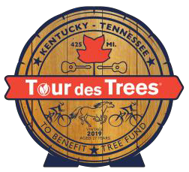

## Fall Cycle Grant Awards

TREE Fund has awarded $95,000 for urban tree research in its Fall 2018 grant-making season. With these new awards, we have provided nearly $4.0 million in grants and scholarships since our inception in 2002! Learn more about our Fall Cycle Grant Award recipients [here.](https://treefund.org/?p=16704&amp;preview=true)

## 2018 TREE Fund

**Volunteer Spotlight**

***Tree and Soil Research Fund Committee***

Please join us in celebrating the Tree and Soil Research Fund (TSRF) Committee members! Chaired by **Paul Josey**, members of the committee include: **Joe Chambers, Guy Champin, David Gorden, Allison Harvey, Susan Hatchell, Adam Nicklin, John Royster, Hardy Stecker,** and **Jim Urban**.

This group met over the course of seven months to help us define the communication message of the TSRF and the best approach for reaching the landscape architecture community. Based on the input from this committee, TREE Fund’s February webinar had record-breaking attendance. We are extremely grateful for their advice, passion, and willingness to support and share the importance of the Tree and Soil Research Fund.

Thank you all for being TREE Fund champions!

*To suggest someone for the Volunteer Spotlight, contact* [*Teresa Recchia.*](mailto:trecchia@treefund.org)

**Research Impact**

TREE Fund research provides new knowledge that helps tree professionals better care for the urban forest. In 2018, there were **32** publications or presentations stemming from TREE Fund projects, on topics ranging from planting stock size to soil management practices.

Access this new knowledge along with all of the research TREE Fund has supported since 2004 by visiting our [Research Archives.](https://treefund.org/researcharchive)

# The Word on Webinars

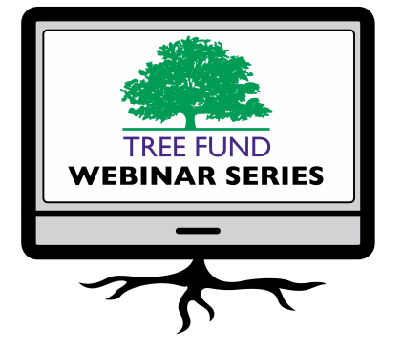

If you missed February’s terrific webinar, ***The Salt Dilemma: Growing Better Urban Trees in Northern Climates***, presented by Jim Urban, FASLA (Urban Trees + Soils), Andrew Millward, PhD (Ryerson University) and Adam Nicklin (PUBLIC WORK), it’s now available for viewing via our [webinar page.](https://treefund.org/webinars)

And while you’re there, be sure to mark your calendar for all

the other great webinars we have coming up in 2019!

###### May 29, 2019 at 12 pm (Central)

Dr. Richard Hauer, University of Florida

Dr. Andrew Koeser, University of Wisconsin Topic: Impact of TREE Fund Research Since 2003

###### June 11, 2019 at 12 pm (Mountain)

Dr. Nina Bassuk, Cornell University

Topic: Follow Up to *Reducing Tree (and Soil!) Damage During Construction* Webinar

**August 29, 2019 at 12 pm (Central)** Dr. Glynn Percival, Bartlett Tree Experts Research Laboratory, UK

*Can We Vaccinate Trees to Protect Against Diseases?*

**November 19, 2019 at 12 pm (Mountain)** Dr. Kathleen Wolf, University of Washington *Health Benefits of City Trees: Research Evidence and Economic Values*

These one-hour programs are **FREE** and offer **1.0 CEU** credit from the International Society of Arboriculture, the Society of American Foresters, and if relevant the National Association of Landscape Professionals and the Landscape Architecture Continuing Education System. See webinar descriptions for specifics.

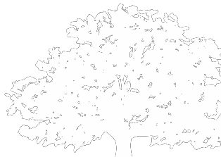

**Connect with us online at treefund.org**

and on social media:

@TREEFund @TREE_Fund @TREEFund

**Contact Us TREE Fund**

552 S. Washington Street Suite 109

Naperville, IL 60540

(630) 369-8300

[treefund@treefund.org](mailto:treefund@treefund.org)

TREE FUND IS A 501(C)3 NONPROFIT WHOSE MISSION IS TO SUPPORT SCIENTIFIC DISCOVERY AND DISSEMINATION OF NEW KNOWLEDGE IN THE FIELDS OF ARBORICULTURE AND URBAN FORESTRY