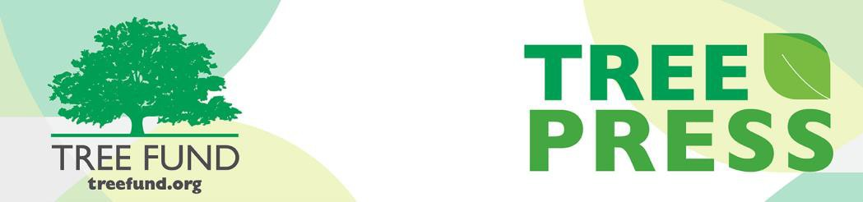

Tree Research and Education Endowment Fund Newsletter Vol. 2 No. 3 – March 2019

Crowning Achievements

Effect of Tree Species on Cooling Complex Urban Environments
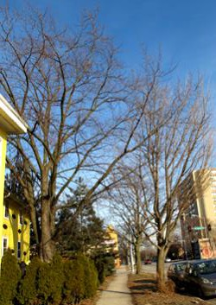
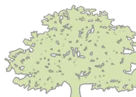In crowded urban settings, planting the right tree in the right place means more than just avoiding power lines and other targets. To Dr. Henrik Sjöman, Swedish University of Agricultural Science (Gothenburg Botanic Garden), it also means knowing the beneficial qualities of individual tree species on the environment. In his research project, “The Role of Tree Species in Cooling the Urban Climate – Application in Tree

In This Issue
- Crowning Achievements
- Leading Thoughts
- TREE Fund
After Hours Bash
- Lead Donors
- 2019 Tour des Trees
- Volunteer Spotlight
- The Word on Webinars

“Nature welcomes inquiry.
Nature does not hide its work.
Just seek,
and you will find.”

- Alex L. Shigo

PHOTO CREDIT: T. RECCHIA
Planting and Landscape Architecture,”

funded by TREE Fund’s Jack Kimmel International Grant, Dr. Sjöman examined how different species of trees influence what humans experience and feel in terms of both real and perceived temperature comfort in complex urban environments in both summer and winter. By recording them into the microclimate model ENVI-met, Dr. Sjöman studied the impact of 62 tree species and genotypes in solitary areas such as pocket parks, residential areas, parking lots, along streets and more.
The data Dr. Sjöman acquired will supply tree planters and landscape architects with a tangible understanding of how tree species differ significantly when it comes to mitigating urban temperatures and thermal stress in the environment, providing them with even more justification for why and where a particular tree is required for a particular location. Learn more about the impact of individual tree species on the climate here.

Leading Thoughts

You are invited to the
TREE Fund After Hours Bash!

Ken Ottman Outstanding Volunteer Award
WINNER ANNOUNCED

Support your favorite Tour des Trees Teams and Riders!

Free Appetizers and Two Drink Tickets

BRING YOUR FRIENDS AND JOIN THE FUN!
August 13, 2019
6:00 – 7:00 pm
followed by Toast with the Host

Jackson Terminal 205 W Jackson Ave Knoxville, TN

Please register for this FREE event when you complete your ISA Conference registration

By J. Eric Smith, TREE Fund President and CEO
“Research” is the word that we use to define a set of protocols designed to help people turn subjective assumptions into (more) objective conclusions. It can take many forms, but the requirements of good research generally include:
- Intellectual rigor in seeking out and considering credible sources beyond those easily available in the public domain, even when they are not in alignment with the researcher’s presumptions;
- An ability and a willingness to compile and analyze qualitative and/or quantitative data using generally accepted statistical and scientific methods;
- A clearly-defined method for testing those data against a hypothesis, followed by a willingness to allow results to be re-tested by others;
- Independent affirmation of data and conclusions by peers in the field of research; and
- The recognition of the research’s utility, via cites and references from other
researchers in the field of study, or wide-spread adoption of findings.
That list may be a bit academic, and perhaps it’s worth flipping the definition and
asking: So, what isn’t high quality research, really? Some red flags:
- Using non-scientific public web sites (e.g. Wikipedia) as primary sources, since none of those sites index the countless proprietary resources that require library assistance to access;
- Throwing out entire sectors of the printed and online media worlds because they do not cover certain topics in ways that the researcher may wish to see them covered;
- Working in a vacuum, without the intellectual testing that comes from the healthy give-and-take of collegial debate and discourse;
- Reaching conclusions that are only cited or referenced by other individuals who enter the realm of research with the same viewpoint as the researcher; and
- Using shock tactics or logical fallacies to make pre-determined points.
When you compare those two lists, one point should become readily apparent: people can do the “bad research” list without many resources, where the “good research” list is far more dependent on the availability of skilled human, laboratory, field and/or financial resources. Which, of course, is where TREE
Fund comes in: we’re one of a small number of funding sources for tree research projects, and we play a key role in developing rigorous findings that practitioners can trust, rather than depending on hearsay, half-baked experiments, gut feelings, or professional folklore.
Our next grant will push us over the $4.0 million mark in total funds expended to advance scientific discovery and disseminate new knowledge in our field. It’s an important milestone for our community, even as we look forward to empowering the next research project to answer the next burning question that faces us. Our grant-making processes are designed to inspire trust in our outcomes, and when you, our readers and supporters, are making professional tree care decisions with significant property impacts associated with them, you should expect – and demand – nothing less.

Lead Donors
We are extremely grateful to the following people and organizations who contributed over $2,500 to TREE Fund in February 2019:

BANDIT INDUSTRIES, INC.
~ • ~
STEVEN GEIST
~ • ~ INTERNATIONAL SOCIETY OF ARBORICULTURE

See the full list of Lead Donors who make our vital work possible on our website.
To Be Determined
2019 Tour des Trees
Register to Ride Today!
Join us this September for five days and 450 miles of cycling through the rolling terrain of northern Tennessee and western Kentucky, starting and ending in Nashville. Not a cyclist or unable to join us this year? Do a Virtual Tour instead. Either way, you won’t want to miss this year’s ride! Complete details
on the 2019 Tour des Trees can be found here.
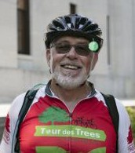Already registered? Be sure to follow the discussion and stay involved by joining our Facebook event and Strava Club!
Volunteer Spotlight
Dave Leonard
Dave Leonard is a 17-time Tour des Trees rider and a long-term TREE Fund Liaison representing the “small but mighty” Kentucky Chapter of ISA. As we prepare to visit Dave’s home state this year for the first time on the Tour des Trees, he’s been hard at work recruiting his fellow
Kentuckians, raising funds (he ran the raffle at the Chapter’s recent annual conference), and serving as an all-around champion for TREE Fund and its work. Our staff team regularly travels the country as part of our community engagement efforts, and it’s not unusual that we will run into Dave, typically wearing his Tour des Trees jersey or jacket, at conferences and symposia, continuing his own education to be the best possible arborist that his customers and colleagues could ever wish to hire or recommend. Dave also has a key companion in his support for TREE Fund, as his wife Nancy has designed custom jewelry for sale at the TREE Fund booth at various industry events over the years, with proceeds benefiting our charitable mission.
Dave and Nancy are a great team with great passion for TREE Fund’s work and the industry that we serve, and we are proud to acknowledge them this month in our Volunteer Spotlight.

To suggest someone for the Spotlight, contact Teresa Recchia.

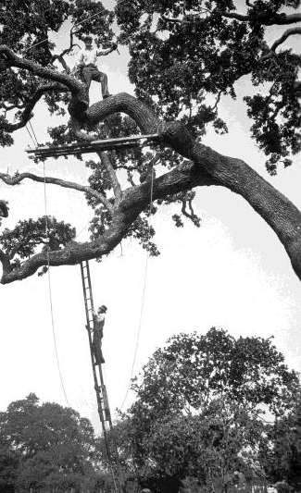
HEALTHY
are
ROOTED
in
RESEARCH
TREES
Visit our Research Archives to do some safe research of your own!

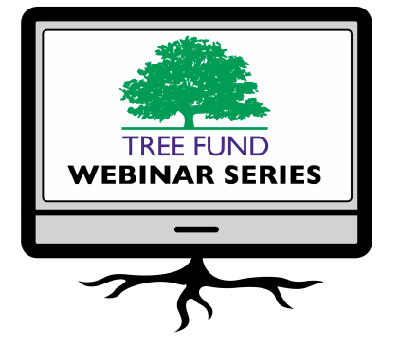The Word on Webinars
If you missed February’s “The Salt Dilemma: Growing Better Urban Trees in Northern Climates” webinar or any of our previous webinars, did you know you can watch recordings of them anytime by visiting our website?
Also, please mark your calendars for all of our upcoming webinars. Registration opens approximately one month before the program date. Space is limited so be sure to sign up early!

May 29, 2019 at 12 pm (Central)
Dr. Andrew Koeser, University of Wisconsin Dr. Richard Hauer, University of Florida
Topic: Impact of TREE Fund Research Since 1992

June 11, 2019 at 12 pm (Mountain) Dr. Nina Bassuk, Cornell University Remediating Compacted Soils Compromised by Urban Construction
August 29, 2019 at 12 pm (Central) Dr. Glynn Percival, Bartlett Tree Experts Research Laboratory, UK

Can We Vaccinate Trees to Protect Against Diseases?

November 19, 2019 at 12 pm (Mountain) Dr. Kathleen Wolf, University of Washington Health Benefits of City Trees: Research Evidence and Economic Values

These one-hour programs are FREE and offer 1.0 CEU credit from the International Society of Arboriculture, the Society of American Foresters, and sometimes the National Association of Landscape Professionals and the Landscape Architecture Continuing Education System. See webinar descriptions for specifics.

Connect with us online at treefund.org
and on social media:

@TREEFund @TREE_Fund

Contact Us
TREE Fund | Cultivating Innovation
552 S. Washington Street Suite 109
Naperville, IL 60540
(630) 369-8300
treefund@treefund.org

TREE FUND IS A 501(C)3 NONPROFIT WHOSE MISSION IS TO SUPPORT SCIENTIFIC DISCOVERY AND DISSEMINATION OF NEW KNOWLEDGE IN THE FIELDS OF ARBORICULTURE AND URBAN FORESTRY

