

**Tree Research and Education Endowment Fund Newsletter Vol. 2 No. 4 – April 2019**

# Crowning Achievements

## *Cultivating Innovation – Documenting 15 Years* of TREE Fund Research Impact

### TREE Fund’s charitable mission is to support scientific discovery and dissemination of new knowledge in the fields of arboriculture and urban forestry. Our work is made possible through partnership with thousands of individuals and organizations that share our belief that research is fundamental when it comes to sustaining and enhancing our urban canopies, making them safer for the skilled professionals who care for them, and healthier for the communities that reap their benefits. Toward this end, we have awarded just under $4.0 million in grants and scholarships since our establishment in 2002; for perspective on the scale of this investment, consider that the ISA Research Trust distributed $460,000 in the 15 years prior to its merger with the National Arborist Foundation that created TREE Fund.

One of the most frequent questions we hear is “So what did all that money buy?” It’s a tough one to answer, since tree research can be slow, findings can be incremental, and outcomes and findings are often disseminated in ways and places outside of TREE Fund’s purview. To help better answer this important and valid inquiry, TREE Fund’s Board of Trustees issued a competitive request for proposals in 2017 under our Directed Grants Program to complete a comprehensive evaluation of impacts, outputs, outcomes and returns on investment from all of our research grants since 2003. The grant was awarded to Drs. Andrew Koeser (University of Florida, Gulf Coast Research and Education Center) and Richard Hauer (University of Wisconsin, Stevens Point) and presented to TREE Fund’s Trustees, who accepted its findings in late 2018.

In summary, Drs. Koeser and Hauer concluded that TREE Fund sponsored research has been instrumental in the evolution of tree care industry standards and practices. We invite you to read their complete report – “A 2018 Assessment of TREE Fund’s Research Grant Program: Research Outputs, Outcomes & Impacts” – on our [website](https://treefund.org/archives/15010) and join their webinar on May 29, 2019 (*see The Word on Webinars for more details*). We are deeply grateful for your support which continues to make our work possible.

“Nature welcomes inquiry.

Nature does not hide its work.

Just seek,

and you will find.”

- Alex L. Shigo

**In This Issue**

* Crowning Achievements
* Leading Thoughts
* TREE Fund After Hours
* Lead Donors
* Website Update
* 2018 Annual Report
* 2019 Tour des Trees
* Volunteer Spotlight
* The Word on Webinars

**Leading Thoughts**



*You are invited to*

**TREE Fund After Hours!**

**Ken Ottman Outstanding Volunteer Award**

**WINNER ANNOUNCED**

**Support your favorite Tour des Trees Teams and Riders!**

**Free Appetizers and Two Drink Tickets**

**BRING YOUR FRIENDS AND JOIN THE FUN!**

**August 13, 2019**

**6:00 – 7:00 pm**

***followed by Toast with the Host***

**Jackson Terminal 205 W Jackson Ave Knoxville, TN**

Please register for this **FREE** event when you complete your ISA Conference registration

#### *By J. Eric Smith, TREE Fund President and CEO*

I have spent over a quarter-century in leadership roles in the nonprofit sector, and you know what? I still don’t like asking people for money. Like all of my professional peers, I am continually researching prospects, cultivating donors, crafting appeals, making cases, and asking for gifts – and despite all of that effort, more often than not, the answer is still “no.”

Being a fundraiser is analogous to being a baseball batter in that regard: if you’re *really* good at your job, you can pull a .300 average (i.e. 30% success rate), but more than two-thirds of the time you’re going to strike out, get tagged out, or hit what looks like a glorious stroke into deep center field, only to see it snatched away against the wall. But those of us who make careers in this field learn to shake off those bad at-bats, take some practice swings, and step up to the plate again, with the never-flagging confidence that the next at- bat just might be a highlight reel game winner.

One of the nicest things about being CEO of TREE Fund is that a sizable percentage of our annual gift solicitations are handled by volunteers, most especially our ISA Chapter Liaisons and our Tour des Trees riders. People rightly marvel at the physical challenges of the Tour (I ride it, so I know how hard it is), but as a professional fundraiser, I’m honestly more awed by the fact that our riders are willing and able, year after year, to solicit friends, family

members, coworkers, colleagues, strangers, whoever it takes, to raise *a lot* of money for our research programs. Wow!

That extraordinary level of volunteer commitment allows our staff team to focus more on business partnerships, direct mail solicitations, and other forms of giving that either defray the expenses associated with the Tour, underwrite operations, or enhance our endowment to ensure our long-term viability. Another area where we focus staff attention, though a bit more behind-the- scenes, is on planned giving. Unlike annual giving – where a donor makes a contribution to a charity as an outlay of current assets or income – planned gifts are current decisions to make future gifts, most often from an estate via bequests, insurance policies, or retirement plan distributions.

For individuals and families who wish to make legacy gifts that are guaranteed to support their philanthropic interests in perpetuity, planned gifts may provide the most effective ways of achieving such goals. We have an amazing group of supporters called [The Heritage Oak Society](https://treefund.org/plannedgiving) who have already established such legacy commitments. We’re going to be making a formal appeal for The Heritage Oak Society this summer, so you’ll hear more from me on this topic then – unless, of course, you decide to give a grateful fundraiser an intentional walk to first base by reaching out to express your interest before I ask.

I’ll be over [here](mailto:jesmith@treefund.org) in the dugout if you’d like to share some sunflower seeds and talk it over. It could be a winning proposition for you, for me, and best of all, for TREE Fund.

**2019 Tour des Trees**

|  |  |  |
| --- | --- | --- |
| **Lead Donors**  We are extremely grateful to the following people and organizations who contributed **over $2,500** to TREE Fund in March 2019:  **ALTEC/STYSLINGER FOUNDATION**  **~ • ~**  **THE DAVEY TREE EXPERT COMPANY**  **~ • ~ WISCONSIN ARBORIST ASSOCIATION**  See the full list of Lead Donors who make our vital work possible on our [website.](https://www.treefund.org/about/our-donors) | |  |
| **Website Update** |  |
| Our transition from old to new website is complete! [TREEFund.org](https://treefund.org/) is now fully phone/tablet compatible, with a streamlined theme and more intuitive navigation.  Take a look, kick the tires, and please do not hesitate to [let us know](mailto:trecchia@treefund.org) if you see anything glitchy! |  |  |
| **2018 Annual Report**  2018 was a very successful year for TREE Fund. Read all the details online in our [Annual Report.](https://treefund.org/wp-content/uploads/2019/04/2018-Annual-Report.pdf) | |

***Register to Ride Today!***

Registration for the 2019 Tour des Trees in Tennessee and Kentucky has been so fast and

furious that we are getting close to our maximum rider capacity. To maintain our road support safety standards and due to lodging limitations, we will close registration when we get to 85 full-time riders or 90 total riders, whichever comes first. So if you want a

guaranteed spot in the peloton, register [here](https://treefund.org/tourdestrees) now!

*Attention Registered Tour des Trees Riders: Be sure to follow the discussion and stay involved by joining our* [*Facebook Event*](https://www.facebook.com/events/1134592420048663/) *and* [*Strava*](https://www.strava.com/clubs/TREE_Fund_TdT2019)[*Club,*](https://www.strava.com/clubs/TREE_Fund_TdT2019) *and don’t forget to check your monthly Ride Guide emails to stay up-to-date on the latest fundraising promotions and opportunities.*

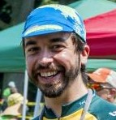

**Volunteer Spotlight**

***Kevin Jones***

We are happy to feature Kevin Jones, Business Development Manager with ACRT, in this month’s Volunteer Spotlight! The 2019 Tour des Trees will be Kevin’s 10th time participating in the event. Kevin has become an

expected face at this annual reunion of tree lovers and cycling enthusiasts, and he truly embodies what it means to be a Tour rider and a TREE Fund supporter. Most recently, Kevin organized multiple fundraising efforts at the 2019 Ohio Chapter ISA conference, including a silent auction and a spirited “Heads or Tails” competition. Conference members couldn’t help but catch the TREE Fund bug after just one conversation with Kevin, discussing the beauty of trees and the importance of research with a sincerity that only he can portray (and exude).

The 2018 Tour des Trees proudly rode its course through Kevin’s home state of Ohio, where he was able to show off the state’s hilly terrain and local urban canopy coverage. The Tour des Trees riders planted a *Nyssa sylvatica* tree in honor of ACRT founder, Dick Abbott, and Kevin was highlighted in a feature [video clip](https://vimeo.com/283517601) commemorating the event. We are privileged to call Kevin Jones part of our TREE Fund Family, and we are honored to recognize him in this month’s volunteer spotlight!

*To suggest someone for the Spotlight, contact* [*Teresa Recchia.*](mailto:trecchia@treefund.org)

**The Word on Webinars**

Join Drs. Koeser and Hauer at our next webinar where they will share highlights of their [report,](https://treefund.org/archives/15010) “A 2018 Assessment of TREE Fund’s Research Grant Program: Research Outputs, Outcomes & Impacts” – from facts and figures to more personal accounts from industry leaders on how TREE Fund has impacted their professional lives. You may be surprised to learn what commonly accepted practices trace their origins to TREE Fund research projects! Registration opens April 29, 2019.

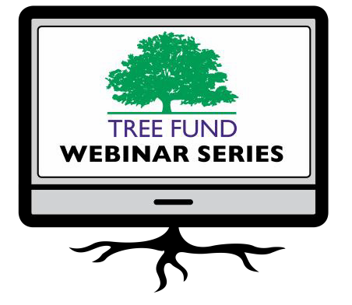

Missed a webinar? Watch it anytime on our [website!](https://treefund.org/webinars)

**May 29, 2019 at 12 pm (Central)**

Dr. Andrew Koeser, University of Wisconsin Dr. Richard Hauer, University of Florida

*Cultivating Innovation – Documenting 15 years of Tree Fund Research Impact*

**June 11, 2019 at 12 pm (Mountain)** Dr. Nina Bassuk, Cornell University *Remediating Compacted Soils Compromised by Urban Construction*

**August 29, 2019 at 12 pm (Central)** Dr. Glynn Percival, Bartlett Tree Experts Research Laboratory, UK

#### *Can We Vaccinate Trees to Protect Against Diseases?*

**November 19, 2019 at 12 pm (Mountain)** Dr. Kathleen Wolf, University of Washington *Health Benefits of City Trees: Research Evidence and Economic Values*

### These one-hour programs are **FREE** and offer **1.0 CEU** credit from the International Society of Arboriculture, the Society of American Foresters, and sometimes the National Association of Landscape Professionals and the Landscape Architecture Continuing Education System. See webinar descriptions for specifics.

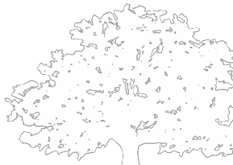

**Connect with us online at** [**treefund.org**](https://treefund.org/)

and on social media:

@TREEFund @TREE_Fund

**Contact Us**

[**TREE Fund | *Cultivating Innovation***](https://treefund.org/)

552 S. Washington Street Suite 109

Naperville, IL 60540

(630) 369-8300

[treefund@treefund.org](mailto:treefund@treefund.org)

TREE FUND IS A 501(C)3 NONPROFIT WHOSE MISSION IS TO SUPPORT SCIENTIFIC DISCOVERY AND DISSEMINATION OF NEW KNOWLEDGE IN THE FIELDS OF ARBORICULTURE AND URBAN FORESTRY

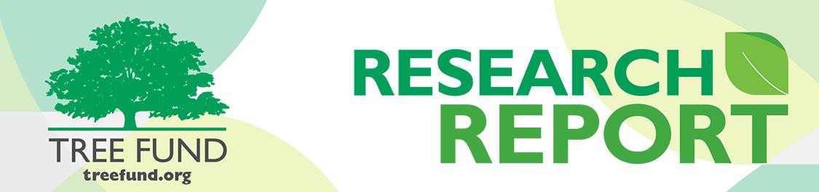

**C U L T I V A T I N G I N N O V A T I O N**

**Tree Research and Education Endowment Fund Vol. 2 No. 1 – April 2019**

**A Site Index for Urban Trees**

**by Bryant Scharenbroch, Ph.D.**

Site and soil assessment is a critical component of urban tree and forest management. Urban sites and soils are extremely variable. Current urban soil maps are often not available, and even if they are, they do not tell us about the suitability of the site for an urban tree or forest. Consequently, arborists and urban foresters must be able to assess sites and soils for the trees they manage. A practical and accurate approach for site assessment is needed for arboriculture and urban forestry.

An urban site index will help to increase urban forest diversity and urban tree health. Site quality identification will facilitate better matching of sites with species. Low quality sites should be planted with tough trees. High quality sites should be planted with new species introductions to the urban forest or trees with relatively weak resistance to urban site stress. An urban site index will also improve our management of individual urban trees. Site assessment will identify those poor quality soils in need of some management for urban trees. Additionally, site assessment will allow us to detect whether our management actions are effective at improving soil quality.

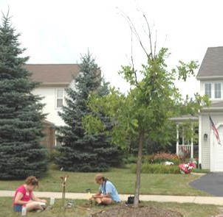

*Michelle Catania and Marlene Hahn performing an urban site assessment, Baker Hill subdivision, Glen Ellyn, Illinois*

For the past ten years, we have been working on developing a practical and accurate site assessment approach for arborists and urban foresters (Scharenbroch and Catania, 2012; Scharenbroch et al., 2017). We have two goals with the project: (1) develop an index that can be used for assessing sites for urban trees and (2) increase awareness and education on urban soils (i.e., teach arborists and urban foresters about soils and how to assess them).

Our first step in this process of developing the urban site index was to examine all possible soil and site properties that might be useful in predicting urban tree growth and health. We surveyed the literature, made a list of important properties, and then measured these ~50 properties in urban landscapes with trees. We developed some predictive models and found that the most important soil properties for urban tree growth and health were: soil texture, density, aggregate stability, pH, electrical

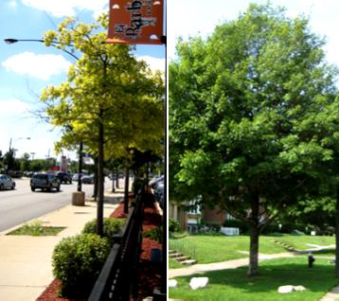conductivity, total organic matter, and labile organic matter. We concluded that these properties are important for urban tree health, and that we need to develop field assessment techniques for these properties to be included in our site assessment model.

The second step in this process was to develop a model and approach for assessing these properties (Scharenbroch et al., 2017). The model we developed and then tested included 15 site and soil properties. Each of these properties are measured in the field and then scored (0-3). The total score is summed up and divided by the total maximum possible points to return a site index score of 0-100. This model was tested in urban landscapes and the scores were correlated to urban tree health and growth. We concluded that this approach was somewhat accurate and practical for urban site assessment. The site assessment requires minimal equipment, time (~5 to

Quercus rubra *in a low quality urban site in Chicago, Illinois (left).* Tilia cordata *in a high quality planting site in Cleveland, Ohio (right).*

10 minutes), and expertise. Further evaluation of the model has led us to conclude that the accuracy of the model can be improved when the approach is modified to recognize variability within cities (manuscript in preparation).

**A Site Index for Urban Trees** *(continued from front)*

The third step, which we are currently working on, is to collaborate with individual arborists and urban foresters to tailor the model and approach to improve its accuracy for specific users. The process is summarized below:

1. Identify sites to assess
2. Determine the potential limitations that are present on these sites
3. Identify the site properties related to these limitations
4. Develop scoring functions for those site properties
5. Create a tailored site index model for these sites
6. Assess sites using the model
7. Utilize the site index scores

This research would not have been possible without the generous support of TREE Fund. The researchers would like to thank

TREE Fund and all of its partners and donors.

If you are interested in learning more about the site index approach or would like to develop and test your own site index, p lease contact Bryant Scharenbroch at [bryant.scharenbroch@uwsp.edu.](mailto:bryant.scharenbroch@uwsp.edu)

**References**

Scharenbroch, B.C. and Catania, M. 2012. Soil quality attributes as indicators of urban tree performance. Arboriculture and Urban Forestry 38:214-228.

Scharenbroch, B.C., Carter, D., Bialecki, M., Fahey, R., Scheberl, L., Catania, M., Roman, L.A., Bassuk, N., Harper, R.W., Werner, L. Siewert, A., Miller, S., Huytra, L., and Raciti, S. 2017. A rapid urban site index for assessing the quality of street tree p lanting sites. Urban Forestry and Urban Greening 27:279-286.

**Behind the Research: Meet Dr. Bryant Scharenbroch**

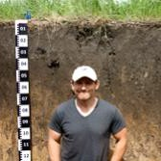

Dr. Bryant Scharenbroch was born in Manitowoc, Wisconsin and spent his childhood living in and exploring the central Lake Michigan coastal region of the state. His childhood love of being outdoors propelled him to seek degrees in urban forestry, plant science, and soil science and a career in natural resources. Bryant is currently an Assistant Professor of Soil and Waste Resources at an alma mater of his, the University of Wisconsin - Stevens Point (UWSP), and a Research Fellow at The Morton Arboretum in Lisle, IL (both January 2015 to present).

Before joining the faculty at UWSP, Bryant worked as a soil scientist at The Morton Arboretum and he was engaged in many research projects there. Despite the wide reach of the arboretum, Bryant knew he could have more impact on the vital, neglected study of urban trees and soils by joining the faculty at UWSP. Soil is an underrated resource for our rapidly expanding urban ecosystems, and the world needs more people who care for the degraded soils sustaining urban trees. Teaching and research go hand in hand for Bryant, and he was able to continue his research projects at the arboretum by becoming a Research Fellow there.

Bryant is not immune to some soil problems of his own; he is currently working on improving the low fertility and low water weight capacity of the sandy soil on his own property by applying a heavy, two-foot thick layer of organic material and allowing it to sit on top of his soil for a year. A bonus? It also kills weeds! After this, he is planning to install raised beds and plant several fruit trees in his backyard. These trees will join a small woodland area he is developing on his property and the two oak trees he planted in front of his house courtesy of seedlings he received at an ISA conference.

When Bryant is not busy improving soils at home and abroad (the most interesting soil he ever studied was in Moscow, Russia), he can be found caring for his three children and sharing his passion for the great outdoors with them.

Read about more about his TREE Fund supported research and watch his webinar at [www.treefund.org.](https://treefund.org/)

**TREE FUND IS A 501(C)3 NONPROFIT WHOSE MISSION IS TO SUPPORT SCIENTIFIC DISCOVERY AND DISSEMINATION OF NEW KNOWLEDGE IN THE FIELDS OF ARBORICULTURE AND URBAN FORESTRY**