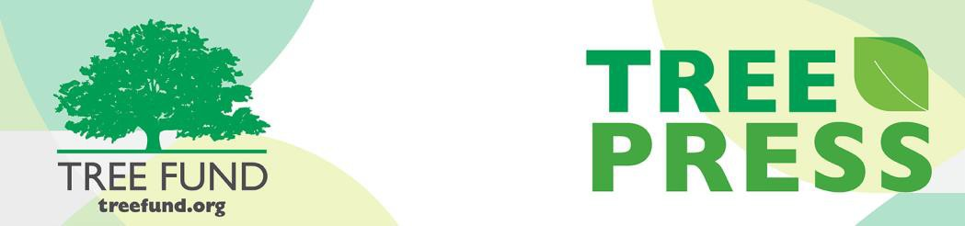

Tree Research and Education Endowment Fund Newsletter Vol. 2 No. 5 – May 2019

Crowning Achievements

Cooling Effectiveness of Urban Street Trees
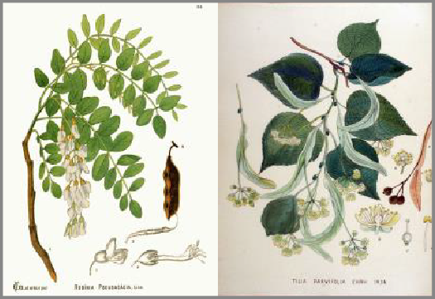
Last time we checked in with Dr. Mohammad Asrafur Rahman, he was busy working on his study, “Quantifying the cooling effectiveness of urban street trees in relation to their growth,” funded in part by a Jack Kimmel International Grant,
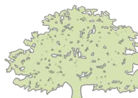awarded in partnership with Canadian TREE Fund. At that time he discovered large differences in the cooling potential between two extremely common but contrasting urban tree species with respect to eco-physiology and morphology. Specifically, Robinia pseudoacacia L. and Tilia cordata Mill. His data also uncovered that water use efficiency is more strongly related to cooling potential than growth rate.

In This Issue
- Crowning Achievements
- Leading Thoughts
- TREE Fund After Hours
- Lead Donors
- 2019 Tour des Trees
- Volunteer Spotlight
- The Word on Webinars
Since then, Dr. Rahman and his team from the Technical University of Munich, Germany have continued to study these two contrasting tree species, focusing more recently on the temperatures below their canopies. Dr. Rahman was able to measure the effect of leaf size on the evaporation of water from plant leaves and the impact that larger leaf area indexes have on temperatures outside and inside tree canopies. This new branch of investigation also revealed that on extremely hot days, even grass can act like concrete when it comes to cooling the environment, making deep shading from urban tree canopies even more essential.
Get additional details on Dr. Rahman’s research and read more about the impact of tree species on urban climates in the Research Archives of TREE Fund’s website.
“Nature welcomes inquiry.
Nature does not hide its work.
Just seek,
and you will find.”

- Alex L. Shigo

Leading Thoughts

You are invited to
TREE Fund After Hours!

Ken Ottman Outstanding Volunteer Award
WINNER ANNOUNCED

Support your favorite Tour des Trees Teams and Riders!

Free Appetizers and Two Drink Tickets

BRING YOUR
FRIENDS AND JOIN THE FUN!
August 13, 2019
6:00 – 7:00 pm
followed by Toast with the Host

Jackson Terminal 205 W Jackson Ave Knoxville, TN
Please register for this FREE event when you complete your ISA Conference registration
By J. Eric Smith, TREE Fund President and CEO

When I was a kid, the woods were my second home. My friends and I would come home from school every day, get handed a snack, and then get thrown out of the house until dinner time, expected to entertain ourselves in ways that didn’t bother any grownups. Most days, we’d trot down the well-worn trails into the woods behind our neighborhood, where we’d climb trees, build forts, splash about in creeks, investigate the detritus dumped in the woods, and otherwise have unstructured fun beneath the untended wild canopy that’s fairly typical of most suburban communities.
Years later, when I lived near Albany, New York, I kept on exploring my local woods, eventually creating a photo essay series called, “Hidden in Suburbia.” The premise behind this project was that I did regular deep dives into the woods around my community, never going more than five miles from my home, essentially recreating those childhood days of walking into the woods and being receptive to whatever I found there. Given the deep history of that part of Upstate New York, there were truly some amazing, forgotten finds back in those woods, which I was always happy to share.
Fast forward to 2019: I moved back to Des Moines, Iowa, a couple of months ago. My daughter (mostly raised in New York) and her boyfriend (a Des Moines native) live here, so it’s been wonderful to be close to them again. Last week, on one of the rare nice days we’ve had here this spring, my daughter’s boyfriend and I decided to go on a trek through the woods where he spent his own time as a kid. We had a great day, slogging across creeks, pushing through brambles, scaling post-industrial escarpments created by generations of landfill dumping, investigating all sorts of illicit detritus left in the woods, trekking across a meadow that generations have used for dirt bike riding, quietly tiptoeing away from a homeless camp we found, and just generally enjoying being in the moment, there in the woods. It was a full, rich day.
But you know what we didn’t see while we loped about in the woods? Young people, nor even any signs that they’d been there. We saw no tree forts, no
stones placed to facilitate creek crossings, no cairns, nor any other evidence
that these woods were routinely accessed by the kids who live around them. That seems sad to me, on some plane. Yes, I know that today’s children have opportunities for all sorts of global engagement via their televisions and phones and tablets, but still, I can’t help but think that climbing trees and damming creeks and building forts gave me more meaningful, resonant life skills than anything I’ve ever accessed on a computer, and what a loss it is if kids don’t get to have such experiences anymore.
Do you have a young person in your life? If so, here’s hoping you have some woods near your home, and that you can take them out for an unstructured adventure therein. I guarantee they will love it, and 50 years hence, they may be writing about it as I am today!

Lead Donors
We are extremely grateful to the following people and organizations who contributed over $2,500 to TREE Fund in April 2019:

ASPLUNDH TREE EXPERT, LLC

BARTLETT TREE EXPERTS

CORTEVA AGRISCIENCE, AGRICULTURE DIVISION OF DOWDUPONT

ECI FIRSTENERGY CORP.
PECO ENERGY (AN EXELON COMPANY)

J. ERIC SMITH AND
MARCIA BROM SMITH

TREE CARE INDUSTRY ASSOCIATION, INC.

WRIGHT TREE SERVICE

See the full list of Lead Donors who make our vital tree research and education work possible at treefund.org.
2019 Tour des Trees
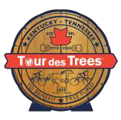
Attention Riders!
For each $50 Tour donation you raise between May 15 and May 31, your donor earns a chance to
win a $100 prepaid VISA card and you earn a chance to win a Black Bear Adventures (BBA) cycling gift pack! You will be the envy of the Tour with your BBA-branded gear. Many thanks to Tour Director Paul Wood and Black Bear Adventures for making this fundraising promotion possible!
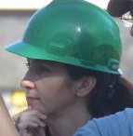Be sure to follow the discussion and stay involved with the 2019 Tour by joining our Facebook Event and Strava Club, and don’t forget to check your monthly Ride Guide emails to stay up-to-date on all the latest fundraising promotions and opportunities.
Volunteer Spotlight
Rebecca Johnson
This month we are pleased to point the Volunteer Spotlight at Rebecca Johnson (Arborholic, LLC). Rebecca is our newest TREE Fund Liaison, representing ISA's highly- influential Texas Chapter. She has been an
active member of TREE Fund's Communications Committee since its inception in 2017, and we have been very fortunate to have Rebecca's expertise and astute perspectives as we have worked through website updates, social media roll-outs, and a re-launch of our monthly newsletter, TREE Press, and its quarterly supplement, Research Reports, over the past 18 months. In both of her TREE Fund roles, Rebecca has used her sharp social media skills to regularly promote the work of TREE Fund, not only to her ISA Texas Chapter members, but also to the international audience that TREE Fund serves and supports. Beyond her TREE Fund connections, she is an avid and enthusiastic champion for our professional arborists and urban foresters, recognizing, celebrating, and sharing her wisdom and perspective on their effort and impacts, locally and globally. We applaud Rebecca for her energy, acuity, and faithful support of TREE Fund’s mission, and we are proud to count her as a regular and irreplaceable contributor to our efforts.
To suggest someone for the Spotlight, contact Teresa Recchia.

The Word on Webinars
Earn CEU Credit in May AND June!
Registration is now open for Drs. Koeser and Hauer’s May 29th webinar on TREE Fund supported research. You may be surprised to learn what commonly accepted practices trace their origins to TREE Fund research projects. Space is limited, so register now!
Learn more about how to improve degraded soils by joining Dr. Nina Bassuk on June 11 for her webinar on the subject. Registration for Dr. Bassuk’s webinar opens on May 11, 2019.

May 29, 2019 at 12 pm (Central)
Dr. Andrew Koeser, University of Florida Dr. Richard Hauer, University of Wisconsin
Cultivating Innovation – Documenting 15 years of TREE Fund Research Impact
June 11, 2019 at 12 pm (Mountain) Dr. Nina Bassuk, Cornell University Remediating Compacted Soils Compromised by Urban Construction

August 29, 2019 at 12 pm (Central) Dr. Glynn Percival, Bartlett Tree Experts Research Laboratory, UK
Can We Vaccinate Trees to Protect Against Diseases?

November 19, 2019 at 12 pm (Mountain) Dr. Kathleen Wolf, University of Washington Health Benefits of City Trees: Research Evidence and Economic Values

These one-hour programs are FREE and offer 1.0 CEU credit for live broadcast from the International Society of Arboriculture, the Society of American Foresters, and sometimes the National Association of Landscape Professionals and the Landscape Architecture Continuing Education System. See webinar descriptions for specifics. Missed a webinar? Watch it anytime on the webinar page of our website!

Connect with us online at treefund.org
and on social media:

@TREEFund

@TREE_Fund

#treefund

Contact Us
TREE Fund | Cultivating Innovation
552 S. Washington Street Suite 109
Naperville, IL 60540
(630) 369-8300
treefund@treefund.org

TREE FUND IS A 501(C)3 NONPROFIT WHOSE MISSION IS TO SUPPORT SCIENTIFIC DISCOVERY AND DISSEMINATION OF NEW KNOWLEDGE IN THE FIELDS OF ARBORICULTURE AND URBAN FORESTRY

