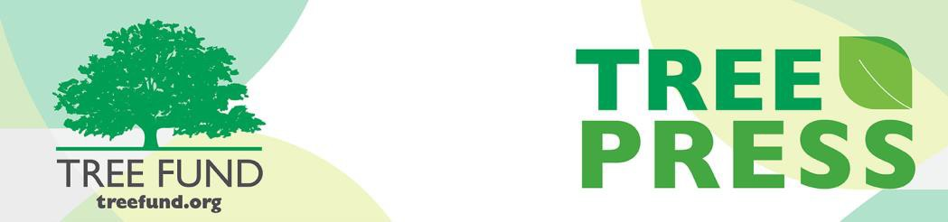

**Tree Research and Education Endowment Fund Newsletter Vol. 2 No. 6 – June 2019**

# Crowning Achievements

***Spring 2019 Research and Education Awards***

TREE Fund has awarded $234,000 for urban tree research and education in its spring 2019 grant-making season. With these new awards, we have provided over $4.2 million in grants and scholarships since our inception in 2002! Read more details about our spring research and education awards on our [website.](https://treefund.org/?p=17946&amp;preview=true)

### 2019 TREE Fund Research Grant Recipients

**Hyland R. Johns Research Grant** Robert Fahey, PhD University of Connecticut

*Monitoring and modeling changes in street tree communities over time*

“Nature welcomes inquiry.

Nature does not hide its work.

Just seek,

and you will find.”

- Alex L. Shigo

### Utility Arborist Research Fund Grant

Phil Chen

CN Utility Consulting

*Cost of deferred maintenance*

**Sponsored Grant** Carolyn G. Mahan, PhD Penn State Altoona

*Long term effects of electrical right- of-way vegetation management on floral and faunal communities*

### 2019 TREE Fund Education Grant Recipients

**Frank E. Gamma, Sr. Arboriculture Education Fund** TCIA Foundation

*Arborist Safety Training Institute*

### Ohio Chapter ISA Education Grant

Holden Forests and Gardens

*Cleveland Neighborhood Tree Walks*

### 2019 TREE Fund Scholarship Recipients

**Bonnie Appleton Memorial Scholarship** Alexandra Love

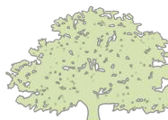

**In This Issue**

* Crowning Achievements
* Leading Thoughts
* TREE Fund After Hours
* Tour des Trees 2019
* Volunteer Spotlight
* Lead Donors
* The Word on Webinars

Michigan State University

**Robert Felix Memorial Scholarship** Maraea Harris

Northern Virginia Community College

Kasandra Hernandez Cuyahoga Community College

Harrison Sopp

Paul Smith’s College

**John Wright Memorial Scholarship** Robert Hammond University of Cincinnati

### Horace M. Thayer Scholarship

Steven Constable Penn State

# Leading Thoughts



*You are invited to*

**TREE Fund After Hours!**

**Ken Ottman Outstanding Volunteer Award**

**WINNER ANNOUNCED**

**Support your favorite Tour des Trees Teams and Riders!**

**Free Appetizers and Two Drink Tickets**

**BRING YOUR**

**FRIENDS AND JOIN THE FUN!**

**August 13, 2019**

**6:00 – 7:00 pm**

***followed by Toast with the Host***

**Jackson Terminal 205 W Jackson Ave Knoxville, TN**

Please register for this **FREE** event when you complete your ISA Conference registration

*By J. Eric Smith, TREE Fund President and CEO*

As I write this column, there are about 100 days left until the Tour des Trees rolls out from Nashville, Tennessee for five days of community engagement and fundraising on behalf of our research programs. I woke up this morning planning to get a good training ride in, but, Ugh! Rain! And more rain! And floods! And wind! And cold! It’s been just awful for cycling in Chicago and in Des Moines all spring, in fact, and the forecast for the next week is much more of the same. How am I going to get ready for the Tour if this continues? And what a bummer to have to spend another spring day indoors, harrumph!

I was muttering and grumbling to myself about this unfortunate personal inconvenience with a warm cup of tea in my hand, looking out from the window of my new apartment building, feeling very self-aggrieved, when I happened to glance downward, and I saw a crew of half-a-dozen workers who were putting in new trees, irrigation systems, sod, mulch and gravel around our building, out in the cold and the rain. Looking further upward and outward, I noted a utility truck on the other side of the Des Moines River, lights flashing, crews out of the street directing traffic, likely engaged in water or power management activities as the river continues to rise here.

They had no warm tea. They had no nice bikes. Nor did they have an option to call it a day and hang out indoors instead of getting a good ride in. My grievances about the weather suddenly felt very petty and small. Don’t get me wrong: training and fundraising for and riding the Tour des Trees is hard work, and I am extraordinarily grateful to the amazing volunteers who take the time off to do it, while I’m getting paid to be with them. But it was a timely and important reminder to me to also always remember that the people we ride for – our working arborists, our urban foresters, our ground crews, our utility lines people, our landscapers, our municipal managers, and so many others – work even harder, all the time, all year long, in jobs that actually become more intense and urgent when the weather is at its worst, after storms, ice, floods, etc.

As Tour des Trees riders, we get a lot of kudos and compliments around the country at the various industry events we attend, and those are all fine and deserved and appreciated. But the *real* heroes in our industry are the men and women who are usually sitting in the chairs watching us being feted without comment or remark, taking the time from their own busy schedules to make themselves as professionally effective, efficient, and safe as they can be in often crushingly challenging and difficult work settings. I’m an office worker at bottom line, while they are doing the heavy lifting that truly makes a difference. I use my column space this month to say “thank you” to them all, and hope you’ll join me in sharing your own appreciation, publicly, whenever and however you are able.

# Tour des Trees 2019

Congratulations to Stanley Zuba of Stanley Tree Service, Inc. and his supported rider, Paul Sellers, for being selected as the winners of our May fundraising promotion! Thanks again to Black Bear Adventures for making this promotion possible, and thank you to all who participated. Together you raised over

$10,000 for the Tour des Trees campaign between May 15 and 31! Tour registration closes on July 1 and there are only a few rider slots left, so sign up soon.

**Important Note:** Riding in Tour des Trees 2019? Be proactive in your planning! Make sure you [**order your jersey**,](https://www.voler.com/custom/ordering/li/26838)

[**set up your fundraising page**,](http://tour-des-trees-2019.everydayhero.do/) and [**make your**](https://treefund.org/wp-content/uploads/2019/04/Travel-Logistics.pdf) **travel arrangements**. We also encourage you to join the [**Facebook Event Page**](https://www.facebook.com/events/1134592420048663/) and [**Strava Club**](https://www.strava.com/clubs/TREE_Fund_TdT2019)to help you stay in-the-know and prepare as the big week approaches!

# Volunteer Spotlight

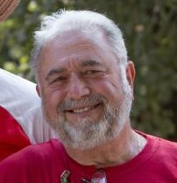

***Peter Andre***

This month’s volunteer spotlight honors Peter Andre. Tour des Trees 2019 will be Peter’s fifth year volunteering with the Tour, and his face and character have become deep-rooted in the Tour des Trees family dynamic. His first exposure to the Tour was in 2014 when

he served as a volunteer with the Lions Club. It was then that he caught the Tour bug and never recovered.

Peter’s passion for supporting the Tour and the industry are deeply connected to his personal interests and work on Wisconsin land that was passed down to him from his father. On this land he and his wife, Gayle, manage over 20 acres of tallgrass prairie where they host prescribed burns and educational opportunities for locals. In addition to this prairie, the duo also manages many more acres of woodland.

Peter not only supports Tour riders during event week, he goes above and beyond during the planning stages of the event, utilizing his connections through the Lions Club to help secure local volunteers and accommodations for the ride in advance of our arrival. Peter’s level head and sense of humor drive the riders to keep pedaling forward throughout the week of the Tour, even on the longest of days. You will never catch him without a smile. Tree cheers for Peter!

*To suggest someone for the Spotlight, contact* [***Teresa Recchia****.*](mailto:trecchia@treefund.org)

# Lead Donors

We are extremely grateful to the following people and organizations who contributed **over $2,500** to TREE Fund in May 2019:

## FORD MOTOR COMPANY

**BRETT HEINRICH**

**IOWA ARBORIST ASSOCIATION**

**LEWIS TREE SERVICE**

**TEXAS CHAPTER ISA**

**VEACH CHARITABLE FOUNDATION**

See the full list of Lead Donors who make our vital tree research and education work possible at [**treefund.org**.](https://www.treefund.org/about/our-donors)

**The Word on Webinars**

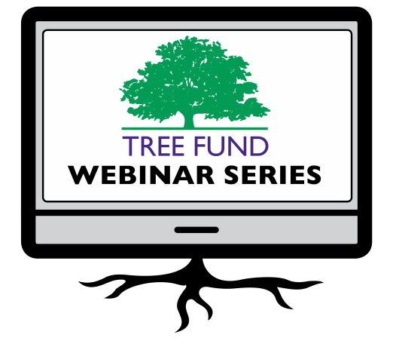

**August 29, 2019 at 12 pm (Central)** Dr. Glynn Percival, Bartlett Tree Experts Research Laboratory, UK

*Can We Vaccinate Trees to Protect Against Diseases?*

**November 19, 2019 at 12 pm (Mountain)** Dr. Kathleen Wolf, University of Washington *Health Benefits of City Trees: Research Evidence and Economic Values*

Did you miss our May webinar, “Cultivating Innovation—Documenting 15 years of TREE Fund Research Impact” or our June webinar, “Remediating Compacted Soils Compromised by Urban Construction” or any of our previous webinars? Then you will be pleased to know that all TREE Fund webinars are generally archived within one week of broadcast and you can watch them anytime on our website’s [**webinar page**!](https://treefund.org/webinars)

TREE Fund’s one-hour webinars are **FREE** and offer **1.0 CEU** credit for live broadcast from the International Society of Arboriculture, the Society of American Foresters, the National Association of Landscape Professionals and sometimes the Landscape Architecture Continuing Education System. See webinar descriptions for specifics.

Be sure to mark your calendar for our August and November webinars, too! Registration opens and more detailed CEU credit information becomes available one month before webinar date.

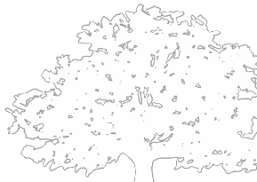

**Connect with us online at** [**treefund.org**](https://treefund.org/) **and on social media:**

**#treefund**

@TREEFund

@TREE_Fund

**Contact Us**

[**TREE Fund | *Cultivating Innovation***](https://treefund.org/)

552 S. Washington Street Suite 109

Naperville, IL 60540

(630) 369-8300

[treefund@treefund.org](mailto:treefund@treefund.org)

TREE FUND IS A 501(C)3 NONPROFIT WHOSE MISSION IS TO SUPPORT SCIENTIFIC DISCOVERY AND DISSEMINATION OF NEW KNOWLEDGE IN THE FIELDS OF ARBORICULTURE AND URBAN FORESTRY