Tree Research and Education Endowment Fund Newsletter Vol. 2 No. 7– July 2019

Crowning Achievements
Tree Care Volunteers
What does your community ask you to do for the trees you live with? How does this information effect decision making by municipalities when it comes to sustainable urban forestry programs? Dr. Richard Hauer, University of Wisconsin – Stevens Point, answers these questions in his latest TREE Fund supported research on volunteers and their involvement in municipal tree care activities as part of his Hyland R. Johns grant, “Sustainable Urban Forestry Planning Models and Decision- Making Dashboard”.
Overall, volunteers completed nearly 5% of tree care activities in the municipalities surveyed for this study. While this is by no means a replacement for municipal staff or contracted services, volunteer assistance cannot be discounted when challenging fiscal decisions are being made. Many strong municipal forestry programs across the United States involve volunteers, and developing community outreach and training programs are a proven way to increase the involvement of community members in tree care. While tree planting is the most common activity, it is important to point out that volunteers also have impact on tree awareness and education, fundraising and policy development – as well as in helping trees reach maturity through watering and pruning. Volunteers are a resource whose value can be maximized if they are properly integrated into project planning.
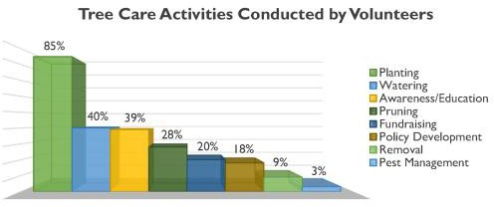

We are proud to support Dr. Hauer’s continued development of his dashboard. As more functionalities are added, its value as a tool for municipalities will continue to grow. Access more vital learnings from Dr. Hauer’s research on volunteers, among many other topics, on our website at www.treefund.org.

“Nature welcomes inquiry.
Nature does not hide its work.
Just seek,
and you will find.”

- Alex L. Shigo

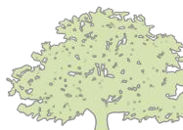
In This Issue
- Crowning Achievements
- Leading Thoughts
- TREE Fund After Hours
- Lead Donors
- 2019 ISA International Conference
- Tour des Trees 2019
- Volunteer Spotlight
- The Word on Webinars

Leading Thoughts

You are invited to
TREE Fund After Hours!

Ken Ottman Outstanding Volunteer Award
WINNER ANNOUNCED

Support your favorite Tour des Trees Teams and Riders!

Free Appetizers and Two Drink Tickets

BRING YOUR
FRIENDS AND JOIN THE FUN!
August 13, 2019
6:00 – 7:00 pm
followed by Toast with the Host

Jackson Terminal 205 W Jackson Ave Knoxville, TN
Please register for this FREE event when you complete your ISA Conference registration
By J. Eric Smith, TREE Fund President and CEO

After TREE Fund was organized in 2002 via the merger of the ISA Research Trust (ISART) and the National Arborist Foundation, our very first research awards were made under the Hyland Johns Grant Program, originally established by ISART. This grant program’s namesake was, and remains, one of the great innovators and leaders in scientific utility arboriculture, and he was
onsite in 1952 at the very beginning of the legendary “Bramble and Byrnes”
research test plots in Pennsylvania, which TREE Fund now administers.
Over the years, TREE Fund has awarded ~$1.5 million in Hyland Johns Grants, and some of our most influential findings and outcomes have emerged from under this program’s auspices. But unlike the majority of our other grant programs, these awards have always been made on a “pay as we go” basis, rather than being secured by a permanent endowment fund that generates revenue annually. As we have often observed, trees are slow-growing, long-lived organisms. Permanent endowments are the best possible ways to ensure that our often equally long-term and slow-moving research programs can continue with confidence that funding will be in place to see them through to fruition.
Two months ago, TREE Fund’s Board of Trustees recognized that our signature program needed such long-term security, and unanimously voted to establish the Hyland Johns Endowment Fund. This new endowment will immediately become an important part of our investment and grant-making portfolio. It will further reduce our dependence on labor-intensive, transactional, retail fundraising to support our scientific mission.
Named endowments and grant programs are often established via memorial gifts, so that their honorees do not actually have the opportunity to see and appreciate the work done in their names. That’s not the case here, as Hyland Johns has been – and remains – an ardent, regular TREE Fund supporter, a great source of wisdom and historical perspective for us, and a mover, shaker,
collaborator and networker par excellence within the greater tree care
community. It’s always a privilege to let Hyland know what we’re doing in his name, and it’s always a treat when he contacts us to share his thoughts on and reactions to our work.
In addition to being an inspiration and leader on the scientific side of our endeavors, Hyland was also a trend-setter as one of the earliest members of our
Heritage Oak Society, treefund.org/plannedgiving, which honors supporters who have included TREE Fund in their estate plans. There is literally no better
way to support endowment funds than by making legacy gifts, which will outlive all of us, continuing the work we care about in perpetuity. The last time Hyland and I spoke, he let me know that he would be honored to direct part of his own legacy gift to the new Hyland Johns Endowment Fund – a perfect, fitting alignment of past, present, and future, a great life’s work now extended and amplified through the generosity of his estate gift.
Endowments and estate gifts are essential to TREE Fund’s long-term success. I hope others may be inspired by the example of Hyland Johns, and join him as members of the Heritage Oak Society.

Lead Donors
We are extremely grateful to the following people and organizations who contributed over $2,500 to TREE Fund in June 2019:

ASPLUNDH TREE EXPERT, LLC
JARRAFF INDUSTRIES, INC.
MINNESOTA SOCIETY OF ARBORICULTURE
URBAN TREES + SOILS VERMEER CORPORATION

See the full list of Lead Donors who make our vital tree research and educat ion work possible a t treefund.org.
Tour des Trees 2019
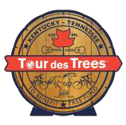
Registration for Tour des Trees 2019 has ended! We have 85 riders, and we couldn’t be more excited about this year’s lineup. If you are
interested in viewing the roster, supporting a rider or signing up to be a Virtual Participant, please visit our website.
Attention Riders: Topless riding is prohibited, so please order your jersey before July 22! Also, make sure you have set up your fundraising page and made your travel arrangements. Remember, ISA Chapter contributions are due to riders and teams by August 23, and rider fundraising minimums are due by September 3. Happy training, happy fundraising and see you in Nashville, TN this September!

TREE Fund Symposium at ISA International Conference
Volunteer Spotlight
Marina Mattingly and the Carol Stream
Rotary Club
Every year TREE Fund is fortunate to receive support from organizations that choose to highlight and support us for our work to improve urban forests. We are happy to recognize Marina Mattingly, President Elect of the Carol Stream Illinois Rotary Club, and the entire Carol Stream Illinois Rotary Club in our Volunteer Spotlight this month. The Club recently held their annual Chili Open Golf
Outing and auction. This year, they renamed the sold out event the Joe Kramer Chili Open Golf Outing, in memory of Joe Kramer. Joe was a long time member of the Rotary Club, the owner of Kramer Tree Services and a dedicated TREE Fund supporter. The outing attracted over 150 golfers and they and their spouses also participated in a celebratory dinner and auction. Committed to supporting healthy communities, and in honor of Joe Kramer and his lifelong dedication to urban tree care, the Rotary Club of Carol Stream donated a portion of the event’s proceeds to TREE Fund. We are grateful to them for their generosity and for inviting us to join their golf outing and weekly meeting to share the work and mission of TREE Fund with the Rotarians.
To suggest someone for the Spotlight, contact Teresa Recchia.
On August 13, 2019 in the Knoxville Convention Center, Dr. Richard Hauer, Dr. Andrew Koeser, Dr. Arnold “Beau” Brodbeck and TREE Fund Chairman Steve Geist, RCA, BCMA, will present an interactive symposium called, “Looking Backward and Forward Through TREE Fund Research: Impacts, Practical Research Outcomes and You.” All ISA International Conference attendees are invited to attend what should be a lively discussion, moderated by TREE Fund President and CEO, J. Eric Smith. See you there!

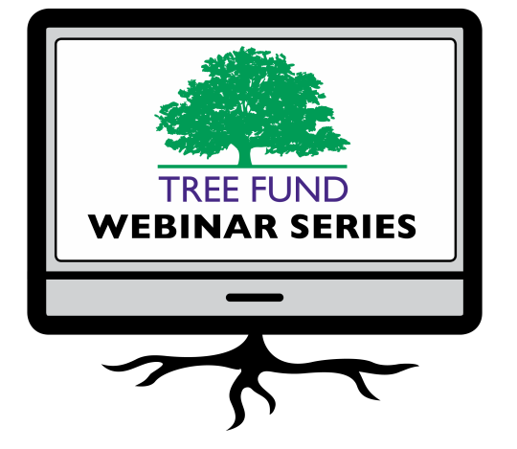The Word on Webinars

August 29, 2019 at 12 pm (Central) Dr. Glynn Percival, Bartlett Tree Experts Research Laboratory, UK
Can We Vaccinate Trees to Protect Against Diseases?

September 10, 2019 at 12 pm (Mountain)
James Urban, Urban Trees + Soils, and
Paul Josey, Wolf Josey Landscape Architects The Landscape Architect in the Nursey: Selecting Trees and Enforcing Specifications

November 19, 2019 at 12 pm (Mountain) Dr. Kathleen Wolf, University of Washington Health Benefits of City Trees: Research Evidence and Economic Values
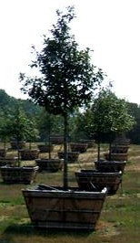TREE Fund is excited to announce a new webinar for 2019! Please join James Urban, Urban Trees + Soils, and Paul Josey, Wolf Josey Landscape Architects, for “The Landscape Architect in the Nursery:
Selecting Trees and
Enforcing Specifications,” at noon on September 10. Also, be sure to mark Dr. Glynn Percival’s August 29 webinar on your calendar! Registration for his presentation, “Can We Vaccinate Trees to Protect Against Diseases?” is opening at the end of this month.
TREE Fund’s one-hour webinars are FREE and offer 1.0 CEU credit for live broadcast from the International Society of Arboriculture, the Society of American Foresters, the National Association of Landscape Professionals and sometimes the Landscape Architecture Continuing Education System. Registration opens and more detailed CEU credit information becomes available on our website one month before webinar date. Missed a webinar? Watch it anytime on our website’s webinar archive page.

Connect with us online at treefund.org and on social media:
#treefund

@TREEFund

@TREE_Fund

Contact Us
TREE Fund
552 S. Washington Street Suite 109
Naperville, IL 60540
(630) 369-8300
treefund@treefund.org

TREE FUND IS A 501(C)3 NONPROFIT WHOSE MISSION IS TO SUPPORT SCIENTIFIC DISCOVERY AND DISSEMINATION OF NEW KNOWLEDGE IN THE FIELDS OF ARBORICULTURE AND URBAN FORESTRY

