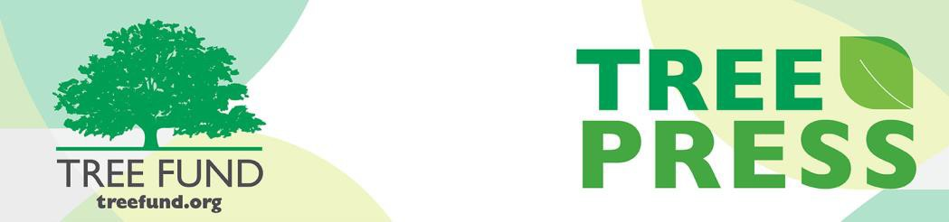

Tree Research and Education Endowment Fund Newsletter Vol. 2 No. 9 – September 2019

Crowning Achievements
Effect of topping on microclimate conditions and human comfort
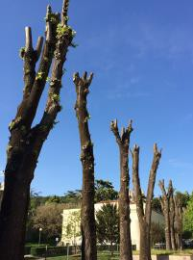
The painful sight of mangled trees due to tree topping is, unfortunately, still common to the present day. Though extreme pruning and crown restructuring may be required for safety reasons, such an intervention cannot be continued forever and it is detrimental to tree life. We know that topping trees depresses tree health, but we didn’t know until now the effect it had on microclimate conditions and human comfort in urban environments.
With his Jack Kimmel International Grant, “Effect of Topping on Microclimate Condition and Human Comfort,” Dr. Francesco Ferrini, ISA’s 2019 Award of Merit Winner (see page 2), University of Florence, Italy, studied the effect tree topping had on two common tree genera, maple (Acer spp.) and linden (Tilia spp.) through (1) phenological phases (budbreak date, leaf yellowing and leaf fall), (2) biometric data (shoot length, trunk diameter, crown width, leaf area), (3) ecophysiology (leaf gas exchange, A/Cc curves), (4) SPAD values, (5) thermal imaging, and
In This Issue
- Crowning Achievements
- Leading Thoughts
- 2019 ISA International Conference Awards of Distinction
- August Lead Donors
- Tour des Trees 2019
- 2019 Ken Ottman Volunteer Award Winner
- The Word on Webinars
(6) climate data. Dr. Ferrini found significant temperature differences between the plots with topped trees and unpruned trees. He estimates that tree topping results in an annual increased cost of between $250 to
$490 in additional air conditioning required to lower indoor room temperatures in surrounding buildings. He also found that phenological phases were delayed in topped trees such that both budbreak and leaf fall were later than in trees with no topping.
Dig deeper into Dr. Ferrini’s study on the negative effects of tree topping on microclimate conditions, human comfort, tree physiology and tree morphology by visiting our website, treefund.org.

“Nature welcomes inquiry.
Nature does not hide its work.
Just seek,
and you will find.”

- Alex L. Shigo

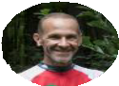
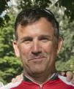Leading Thoughts
recognizes non-ISA members who have demonstrated continued interest and outstanding service in the advancement of arboriculture through research, field practice, promotion, i nvention or literature. Paul Wood is the owner/operator of Black Bear Adventures, an adventure cycling firm based in Charlotte, NC. He has served for 15 years as the road manager and director for the Tour des Trees to Benefit T R E E F u n d , p l a y i n g a n indispensable role in our success. He has gained a deep understanding and appreciation for ISA and its members, and he serves as a champion for the arboricultural community around the country. He is widely known and respected by countless arborists throughout dozens of ISA components.

Two TREE Fund researchers also received awards this year: Dr. Francesco Ferrini took home the highest honor the ISA bestows, the Award of Merit. This award recognizes a career of outstanding, meritorious service in advancing the principles, ideals, and practices of arboriculture. Dr. Daniel Herms received the L.C. Chadwick Award for Arboricultural Research which is granted to individuals in recognition of research that has contributed valuable information to arboriculture. Congratulations, Drs. Ferrini and Herms!
award
This
Membership recognition at this y e a r ’ s I S A I n t e r n a t i o n a l Conference!
H o n o r a r y
TREE Fund’s very own Paul Wood on being chosen for I S A
2019 ISA International Conference Awards
of Distinction
Congratulations to
By J. Eric Smith, TREE Fund President and CEO
If you were to create a word cloud of every document, article, letter, and email I’ve written during my four-plus years as President and CEO of TREE Fund, I suspect that after the obvious mission-related words — tree, forest, research, endowment, education, arborist, etc. — the word that would show up most frequently would be “community.” I use it all the time, referring to the Tour des Trees as our primary community engagement event, discussing how our work helps the global tree care community, noting that our work focuses on the
importance of urban and community forests by promoting research
designed to benefit whole communities of trees and related organisms (including humans), rather than individual specimens or species.
If you ran that same word cloud for the four years before I arrived at TREE Fund, I suspect you would not see “community” ranked so highly in our communications. We used to refer to the Tour des Trees as our
primary fundraising event, and we discussed how our work benefited
the tree care industry, and how our efforts advanced arboriculture, with much of our research focused on individual plant response, rather than forests as a whole. This change in language was not necessarily an organizational shift driven by some strategic planning decision, nor was it a modification to what we do and how we do it directed by our Board or emergent outside forces. It was frankly just me shaping the narrative about the organization I lead, and I how I want it to be perceived.
Calling the Tour des Trees just a “fundraising event,” for example, misses the critical component of how we interact with people as we roll on our way throughout the week, providing education and outreach to help people understand our work and how it benefits them. Saying that we work only for the “tree care industry” seems somehow antiseptic to me, implying that the businesses are more important than the community of people they employ, who collectively engage in the hands-on work of caring for trees. “Urban and community forests” is a helpful rubric in expressing the full scope of our focus,
evoking and including big city park spaces, street trees, yard trees and
trees along utility rights of way in suburbs, exurbs, and rural spaces. And thinking more about communities of trees, rather than individual
plants, helps us better understand and communicate the exciting, emergent science exploring the ways that trees have evolved as communal organisms, and not just as disconnected individuals.
I think my focus on the word “community” is indicative of its deep
importance to me, personally and professionally. My desire over the past four years, and hopefully into the future, is that TREE Fund acts and is perceived as part of something bigger and more connected than our relatively small physical, financial and personnel structure might otherwise dictate. I have been awed, truly, by the immense generosity, enthusiasm, wisdom and diligence of the global tree care community, and it has been an honor for me to be a small member of that great collective body, which works wonders, and makes a difference.

Lead Donors
We are extremely grateful to the following people and organizations who contributed over $2,500 to TREE Fund in August 2019:

JIM AND ANNIE BARBORINAS
CANADIAN TREE FUND

STEPHEN FARRENS FLORIDA CHAPTER ISA
HAMILTON TREE AND LANDSCAPE
PAMELA HENDRICKSEN
ILLINOIS ARBORIST ASSOCIATION
INDIANA ARBORIST ASSOCIATION
ISA SOUTHERN CHAPTER
KENTUCKY ARBORIST ASSOCIATION
MAC- ISA
NEW YORK STATE ARBORISTS, ISA CHAPTER, INC.
OHIO CHAPTER ISA DAVID WHITE

See the full list of Lead Donors who make our vital tree research and educat ion work possible a t treefund.org.
TREE Fund Tour des Trees 2019
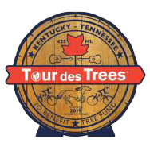
We may be only a few days away from our rollout in Nashville, but you can still help your favorite rider climb the fundraising leaderboard and support the research mission by visiting the Tour des Trees page on our website through October 1. TREE Fund’s Tour des Trees riders
have worked hard to achieve and exceed their 2019 fundraising
goals, but it isn’t too late to show them even more support.

Follow us on Facebook or Instagram at @TREEFund or on Twitter at @TREE_Fund and join us on this year’s ride for tree research and education through Tennessee and Kentucky.

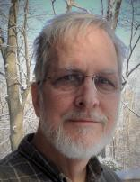TREE Fund Awards 2019 Ken Ottman Volunteer Award to Geoff Kempter!
After a terrific day at the 2019 ISA Annual International Conference and Trade Show in Knoxville, TN, TREE Fund President and CEO, J. Eric Smith, bestowed the 2019 Ken Ottman Volunteer Award upon Mr. Geoffrey Kempter, Technical Services Manager for Asplundh Tree Expert, LLC., at TREE Fund
After Hours on August 13, 2019. The Ken Ottman Volunteer Award is the highest public service award offered by TREE Fund and is named for the legendary Ken Ottman, an unparalleled champion for the work of TREE Fund and its predecessor organizations, the ISA's Research Trust and the National Arborist Foundation. The Ottman Award honors sustained, high
-impact support for TREE Fund and its mission, and the awards committee could not think of anyone more deserving of this award than Geoff. A founding Trustee of TREE Fund, he was a rider in our very first Tour des Trees in 1992. He has been a regular participant in countless TREE Fund activities over the years, and whenever he speaks at conferences, he always includes TREE Fund in his remarks and enthusiastically encourages support for us. Geoff is an inspirational champion, the embodiment of everything TREE Fund stands for: giving skilled tree care professionals the very best information and tools available, so they can work as effectively, efficiently, and safely as possible. Congratulations, Geoff, on being selected the winner of this year’s Ken Ottman Volunteer Award!

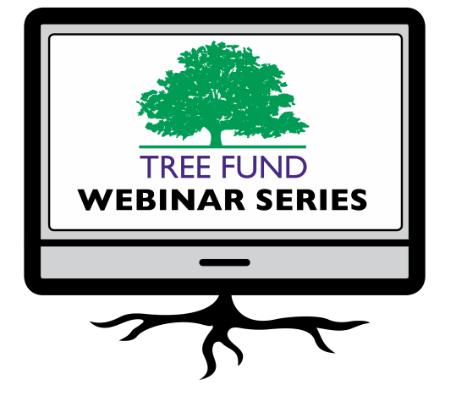The Word on Webinars

November 19, 2019 at 12 pm (Mountain) Dr. Kathleen Wolf, University of Washington Health Benefits of City Trees: Research Evidence and Economic Values

January 14, 2020 at 12 pm (Mountain)
Dr. Bryant Scharenbroch, University of Wisconsin - Stevens Point
Soil Assessment for Urban Trees
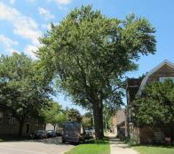
TREE Fund is pleased to announce our first webinar for 2020. You won’t want to miss Dr. Bryant Scharenbroch’s w e b i n a r , “ S o i l
Assessment for Urban Trees,” on January 14,
2020, so mark your calendar now.

Didn’t have time for our recent webinars on tree vaccination and selecting trees in the nursery? No problem! Visit the webinar archive page on our website to watch either of them anytime and access webinar supporting materials while you are there.
TREE Fund’s one-hour webinars are FREE and offer 1.0 CEU credit for live broadcast from the International Society of Arboriculture, the Society of American Foresters, the National Association of Landscape Professionals and sometimes the Landscape Architecture Continuing Education System. Registration and more detailed CEU credit information becomes available on our website approximately one month before webinar date.

Connect with us online at treefund.org and on social media:
#treefund

@TREEFund

@TREE_Fund

Contact Us
TREE Fund
552 S. Washington Street Suite 109
Naperville, IL 60540
(630) 369-8300
treefund@treefund.org

TREE FUND IS A 501(C)3 NONPROFIT WHOSE MISSION IS TO SUPPORT SCIENTIFIC DISCOVERY AND DISSEMINATION OF NEW KNOWLEDGE IN THE FIELDS OF ARBORICULTURE AND URBAN FORESTRY

