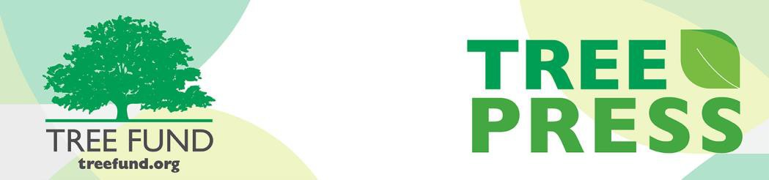

Tree Research and Education Endowment Fund Newsletter Vol. 2 No. 10 – October 2019

Crowning Achievements
Helping Trees and Soil Cope with Construction
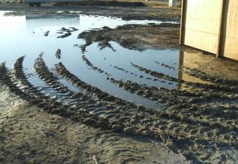
Nobody wants their trees and soil to suffer during a construction project, but not all take special measures to protect them from the damage done by trenching, vehicles, equipment and building materials. Most tree roots reside in the top three feet of
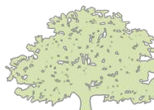soil and are easily damaged; and soil, once compacted, becomes impenetrable to water, oxygen and plant roots. In Dr. Nina Bassuk’s most recent TREE Fund webinars, “Reducing Tree (and Soil!) Damage During Construction” (Dec. 2018) and “Remediating Compacted Soils Compromised by Urban Construction” (June 2019), Dr. Bassuk demonstrates proven tree and soil preservation tactics to deploy whether you are planning a new construction project or trying to mitigate the harm done when such planning has been overlooked. These include such items as her Tree Protection Plan – an essential tool to ensure good communication throughout construction project development and execution – as well as an in depth look into radial trenching and her “Scoop and Dump” methods of soil remediation.
In This Issue
- Crowning Achievements
- Leading Thoughts
- Lead Donors
- Tour des Trees 2019
- The Word on Webinars
- 25th Annual Asplundh Golf Outing to Benefit TREE Fund
Damaged or dead trees can always be replaced, and compacted soils can be recovered, but both come at a great price to ecosystem services. Proper precautions should always be taken to safeguard
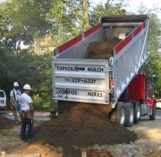
existing trees and soil quality when construction occurs. Please visit TREE Fund’s Webinar Archive at www.treefund.org to dig deeper into Dr. Bassuk’s research as she continues to build upon her 2007 Hyland R. Johns research grant, “Strategies and Techniques to Remediate Compacted, Poorly Draining Soils.”
“Nature welcomes inquiry.
Nature does not hide its work.
Just seek,
and you will find.”

- Alex L. Shigo

Leading Thoughts
Lead Donors
We are extremely grateful to the following people and organizations who contributed over $2,500 to TREE Fund in September 2019:

BRIGHTVIEW
CONNICK TREE CARE
DAVID AND GRETCHEN CRARY
NAN JERNIGAN DANFORTH
INTERNATIONAL SOCIETY OF ARBORICULTURE
ISA ROCKY MOUNTAIN CHAPTER
ALISON KEIR
RICK MOWBRAY
NEW JERSEY ARBORISTS
OHIO CHAPTER ISA
PENN-DEL CHAPTER ISA
STANLEY TREE SERVICE
WESTERN CHAPTER ISA

See the full list of Lead Donors who make our vital tree research and education work possible at treefund.org.
By J. Eric Smith, TREE Fund President and CEO

So here it is, my final “Leading Thoughts” column for TREE Press, three weeks before I retire as the organization’s President and CEO. As I type, we are in the final steps of the search process to find my successor, and barring something unexpected, next month’s TREE Press should feature an introduction of the new leader for our enterprise. We have outstanding candidates in the mix, and I am confident that the next President and CEO will be able to build on the successes we have
experienced over the past four years. I look forward to cheering him or her on, and to continue supporting TREE Fund as a donor, Tour des Trees rider, and advocate.
I will be pleased and proud to continue my personal and professional associations with the amazing community of arborists, urban foresters, landscape architects and other green industry experts who I’ve come to know and respect during my time at TREE Fund. I’ve noted in earlier TREE Press columns that, after some travel, I intend to return to the freelance writing and consulting work that occupied much of my time and talent when I lived in Upstate New York for the better part of 20 years. If you see an opportunity where I may be able to help you, your business, your ISA Chapter, or your clients, I’d be happy to discuss that further. You can always reach me at my website, jericsmith.com, for professional inquiries, to read whatever I might be writing for my own
entertainment, or just to say “howdy.” The connections and friendships I’ve made over the past four years are precious to me, and I am happy to continue them.
In my final remarks at this year’s ISA International Conference in Knoxville, I noted that when I reflect on my time at TREE Fund, the thing that I am most proud of is that I believe I have shifted our organizational focus and messaging away from “What should you do for
TREE Fund?” toward “What can TREE Fund do for you?” Your
continued support is, of course, crucial, but we only earn it by providing you with useful scientific research and education, and by sharing those mission-based products as widely as we possibly can. I believe we have achieved that with our improved website, newsletter and social media efforts, our wildly popular and successful webinar series, and a shift in emphasis for the Tour des Trees to make the focus on community engagement just as strong as the focus on fundraising. We are also putting our money where our mouths are: this year, we expect to break
$400,000 in new grant awards for the first time in our history, pushing our total awards since inception over $4.4 million. With $385,000 raised by this year’s Tour, next year’s number should build on that further. It is satisfying to me to leave that strong base behind for my successor.
And with that, I doff my cap to you all, grateful for our time together. Your work makes a difference, and it moves me. Thank you for the opportunity to have served.

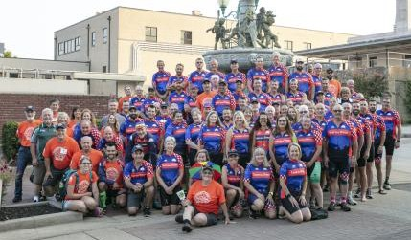Tour des Trees 2019
Congratulations and thank you to everyone who made the 2019 Tour des Trees to Benefit TREE Fund a roaring success! This year’s Tour found 80 riders and 20 support staff cycling over 440 miles in five days through the rolling hills of Tennessee and Kentucky in mid-September. During this celebration-filled week of trees, cycling and comradery, we also met with municipal leaders, local businesses and volunteer groups, and engaged with as many as 450 elementary school students through Professor Elwood Pricklethorn’s PEP Rallies, fostering knowledge and a love of
trees with our young people and their teachers. The Professor’s mission of cultivating a healthy future for urban forests is a vital component of the Tour, and we are honored to have him and his agent, Team Canada rider Warren Hoselton, on the road with us each year.
Along with the amazing cycling and educational feats of the 2019 Tour, we are also happy to report on our fundraising successes! The Tour des Trees 2019 fundraising campaign closed on October 1st with a total of
$385,201 raised to advance TREE Fund’s mission of supporting scientific discovery and dissemination of new knowledge in arboriculture and urban forestry. Approximately $15,000 of that funding arrived at our offices after the Tour’s closing breakfast, and with these gifts factored in, we are proud and grateful to present our final 2019 Fundraising Leader Board:

- Dick Rideout (Team Wisconsin) $13,929
- Randy Miller (Team Utah) $11,794
- Mike Neal (Team Western) $8,748
- Tom Wolf (Team Southern) $8,544
- David Gorden (Team ASLA) $8,384
- Jacques Brunswick (Team New York) $8,285
- Steve Geist (Team Rocky Mountain) $8,271
- J. Eric Smith (Team Iowa) $7,743
- Clem Desjardins (Team New York) $7,631
- Peter Sortwell (Team Western) $7,270

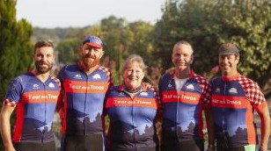
Team Southern (left to right): Matt Searels, Beau Brodbeck, Hallie Dozier, Brian Maxson, and Todd Nedorostek. Not pictured: Tom Wolf and Derrick Wells
ISA Southern Chapter (one of our two hosts, along with Kentucky Arborist Association) was our top fundraising team this year, collectively raising a total of $33,283 and earning the privilege of presenting the “big check” to TREE Fund at our closing breakfast.
Fresh off the success of this year’s Tour des Trees to Benefit TREE Fund, we are excited to get the ball rolling as we prepare for Tour des Trees 2020 in Colorado. Stay tuned as more information becomes available, and see you again next year!

Jeffery Iles John Saylor
Dave Staats Tom Wolf Paul Wood
Dave Leonard Laurie Skul
Cindy Schwab
Jeff Iles
Warren Hoselton Don Roppolo
Laurie Skul
J. Eric Smith Dave Staats Tom Wolf Paul Wood
WELCOMING COMMITTEE
PLANNING COMMITTEE
Beau Brodbeck Dave Leonard David Gorden Danny Lippi Maggie Harthoorn John Morris Brett Heinrich Jonathan Perkins Warren Hoselton Don Roppolo
Thank you Tour des Trees Planning and Welcoming Committee Members!

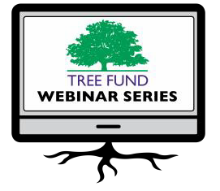The Word on Webinars

November 19, 2019 at 12 pm (Mountain) Dr. Kathleen Wolf, University of Washington Health Benefits of City Trees: Research Evidence and Economic Values

January 14, 2020 at 12 pm (Mountain) Dr. Bryant Scharenbroch, University of Wisconsin, Stevens Point
Soil Assessment for Urban Trees

March 26, 2020 at 12 pm (Central) Dr. Greg Dahle, West Virginia University Why Do Tree Branches Fail?
TREE Fund is pleased to announce we have added a second webinar to the calendar for 2020. Mark yours now for Dr. Greg Dahle’s webinar, “Why Do Tree Branches Fail?” scheduled to take place at noon (Central) on March 26, 2020.
TREE Fund’s one-hour webinars are FREE and offer 1.0 CEU credit for live broadcast from the International Society of Arboriculture, the Society of American Foresters, the National Association of Landscape Professionals and sometimes the Landscape Architecture Continuing Education System. Registration and more detailed CEU credit information becomes available on our website approximately one month before webinar date.
Missed a webinar? Watch it anytime on our
website’s webinar archive page.

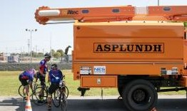
TREE Fund wishes to thank Asplundh CEO and Chairman of the Board, Scott Asplundh, his staff and the 60 golfers who signed up for the 25th Annual Asplundh Golf Outing to Benefit TREE Fund on September 9, 2019. Together these golfers raised a total of $15,690 for tree research and education that advances utility arboriculture. Thank you so much!

Connect with us online at treefund.org and on social media:
#treefund

@TREEFund

@TREE_Fund

Contact Us
TREE Fund
552 S. Washington Street Suite 109
Naperville, IL 60540
(630) 369-8300
treefund@treefund.org

TREE FUND IS A 501(C)3 NONPROFIT WHOSE MISSION IS TO SUPPORT SCIENTIFIC DISCOVERY AND DISSEMINATION OF NEW KNOWLEDGE IN THE FIELDS OF ARBORICULTURE AND URBAN FORESTRY

