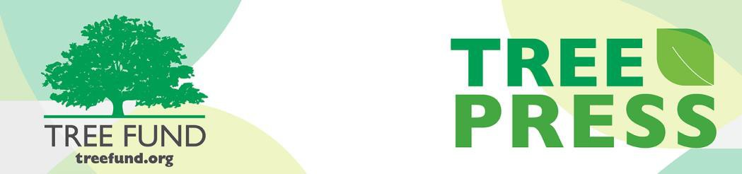

**Tree Research and Education Endowment Fund Newsletter Vol. 2 No. 11 – November 2019**

# Crowning Achievements

***TREE Fund names Russell King as its new President and Chief Executive Officer***

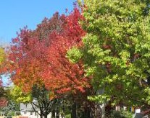TREE Fund is pleased to welcome its new president and CEO, Russell King, who began service Oct. 28. Russell’s hire followed an extensive national search to replace J. Eric Smith, who has retired as president and CEO after four years’ service to the organization.

Russell is a seasoned nonprofit executive with over 25 years’ experience in the public sector, including multiple chief executive roles. He has a Bachelor of Science degree from San Diego State University, an MBA from LaSalle University, and is a graduate of the University of Delaware’s Institute for Organization Management. He is the author of four books, a long-time contributor to numerous online and traditional print media outlets, and has an extensive community service resume, including election to the Verona (Wisconsin) Area Board of Education.

“We are truly delighted to have hired Russell to serve as our new president and CEO,” says TREE Fund Board Chair Steven D. Geist, BCMA, RCA. “He is a deeply experienced nonprofit executive, with formidable leadership, development, communications and financial skills. Russell has a proven track record of leading growth and transformation in the nonprofit sector, and the search committee truly admired his deep hands-on, mission-driven, servant leadership experiences throughout his career. We are confident that he will sustain and build on our recent successes under Eric’s administration, and we look forward to working together to benefit our urban and community forests and the skilled professionals who care for them.”

“Communication, collaboration, diversity, and servant leadership have been, and remain, the keys to my success with those I serve, whether staff, board members, donors, or the communities we support,” Russell said. “Although the depth and breadth of my experience and education may have uniquely qualified me for this role, what most defines me is the passion with which I immerse myself in a worthy cause. When I take on a mission, it becomes my driving force, my *raison d’être*. I now look forward to putting my abilities to work on behalf of TREE Fund.”

“Nature welcomes inquiry.

Nature does not hide its work.

Just seek,

and you will find.”

- Alex L. Shigo

**In This Issue**

* Crowning Achievements
* Leading Thoughts
* TREE Fund Year-End Appeal Appearing in Mailboxes Soon
* Lead Donors
* Tour des Trees 2020
* Volunteer Spotlight
* The Word on Webinars

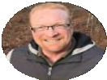**Leading Thoughts**

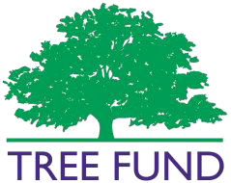

**TREE Fund Year-End Appeal**

**Appearing in Mailboxes Soon**

Please consider supporting TREE Fund’s Year-End Appeal before Dec. 31. As our new president, Russell King, begins his first full fiscal year with TREE Fund in January, your gifts will give him the freedom to move decisively on TREE Fund’s behalf from day one. We also note that J. Eric Smith and his wife, Marcia, have been among our largest individual donors in recent years, so we respectfully encourage gifts made in their honor as tokens of our g r a t i t u d e f o r t h e i r commitment to our work and cause. We appreciate your consideration and your gifts. They will be put to good use, and make a difference.

You can support TREE Fund’s Year-End Appeal anytime by visiting our website and clicking on the purple [**Donate Now**](https://app.etapestry.com/onlineforms/TREEFund/donationform.html) button.

Thank you.

*By Russell K. King, TREE Fund President and CEO*

As you read this edition of *TREE Press*, you may be looking for information about the new president and CEO, wondering “Who is this guy and what’s he going to do for TREE Fund?” You’ve enjoyed strong staff leadership that has built a solid organization supported by an engaged community serving a vital mission. You don’t want to see it messed up, so you’re right to ask. Let me attempt an answer.

After earning my Bachelor of Science degree, I worked as a freelance writer for a couple of years. Part of that freelance life was a weekly outdoor column that eventually morphed into my first book. I entered the nonprofit world as a writer and editor, spending eight years as editor of a peer-reviewed scientific journal. During that time, I attended the Institute of Organization Management, earned certification from the

American Society of Association Executives, and received an MBA. Nonprofit management is a specific discipline requiring certain skill sets, and these programs provided those skills.

In my first CEO post, we had a staff the same size as TREE Fund has. My mentor told me I’d stay a couple of years to “cut my teeth” and then move on. I stayed 17 years. I stayed because I believed in the mission. I did reach the point where the work had grown repetitive and stale, so I returned to freelancing.

This time, instead of freelance writing, I worked as a freelance nonprofit executive (aka a consultant). I took short-term “fix it” jobs. My years as a consultant were rich in experience, giving me the chance to work with an operating budget as large as $5 million and a staff as large as 120,

negotiate with a union, build fund-development programs from the ground up, teach the roles of boards and their members, create organizational voices, and more.

It may not be a coincidence that my predecessor, J. Eric Smith, was also a freelance writer and nonprofit consultant prior to arriving at TREE Fund. Perhaps such a life is an excellent preparation for serving TREE Fund’s mission.

Technical skills are essential, but they’re not the heart of it. The heart is the mission. Trees, you will learn in the coming months, have always been a big part of who I am, so TREE Fund’s mission resonates powerfully with me. As I told the search committee during the interview process, this is about what we love.

So what’s in store? During these first several months, most of my time will be spent learning the organization, its community, and its relationships. Long term, the best answer is “more and explore.” My intent is to build on what I’ve inherited, honoring and enhancing the work of the past, while seeking out new ways to serve our mission.

Serving this mission and being a member of this community are genuine honors. I’m grateful for the past, hopeful for today, and eager to see what we can make of tomorrow.

# Lead Donors

We are extremely grateful to the following people and organizations who contributed **$2,500 or more** to TREE Fund in October 2019:

## GREEN MANUFACTURING, INC.

**JOHN B. WARD & CO. PACIFICORP**

See the full list of Lead Donors who make our vital tree research and education work possible on our website, [**treefund.org**.](https://www.treefund.org/about/our-donors)

# Tour des Trees 2020

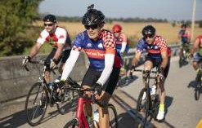Join us next year as we bike through the Rocky Mountain Front Range in the beautiful state of Colorado! We are excited to announce that Tour des Trees 2020 will kick-off in Denver for another five days of

riding, engagement, and comradery. Riders and volunteers will check-in and partake in an opening dinner on Saturday, Aug. 29. The ride will depart from Denver on Sunday, Aug. 30, and return to Denver on Thursday, Sept. 3. Finally, we will close out the week with a breakfast, top fundraiser recognition, and our “big check reveal” on Friday, Sept. 4. Stay tuned as route and event details become available. Registration for Tour des Trees 2020 opens on Jan. 15, 2020.

Interested in receiving all the latest 2020 Tour updates? Click

[**here**](https://lp.constantcontact.com/su/YoUwaWx?source_id=ff43e716-cc48-4206-b907-e19855aaa3a7&source_type=em&c) to sign up for our 2020 Tour des Trees emails.

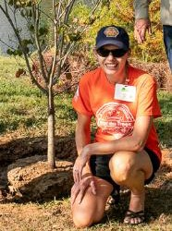

**Volunteer Spotlight**

***Laura Iles***

This month we are celebrating Laura Iles in our Volunteer Spotlight! Laura is an indispensable volunteer member of the TREE Fund Tour des Trees event staff, giving of her time and talents each year to make every aspect of Tour engagement as outstanding as can be. Not only does Laura act as primary support to Tour event management,

she also provides valuable feedback during the planning process as TREE Fund works to create solid engagement events with communities along the Tour des Trees route.

Laura’s upbeat humor shines through in all of her work to make the rider and community experience memorable, and she is always quick to step in and lend a hand, no matter the task. Laura has truly mastered the art of the cowbell cheer, a skill that every Tour rider would tell you is essential to the success of each ride.

Thank you for your endless support, Laura!

*To suggest someone for the Volunteer Spotlight, contact* [***Teresa Recchia****.*](mailto:trecchia@treefund.org)

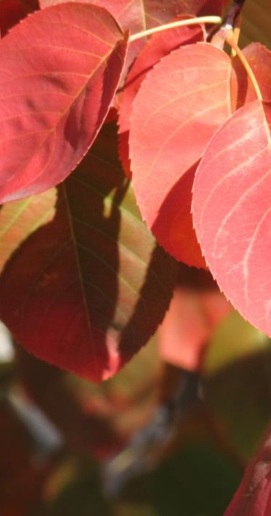

**WE ARE SO VERY**

**GRATEFUL FOR**

**YOU!**

**HAPPY THANKSGIVING**

**The Word on Webinars**

An ever-growing, international body of research points to many human health and wellness benefits that result from nearby nature experiences. But what about trees? Two recent reviews have explored, first, the studies that focus on the urban forest and health response, and second, on the economics of human health effects. Join Dr. Kathleen Wolf for her webinar next Tuesday, Nov. 19, 2019, where she will share the highlights of both reviews. Visit our [**website**](https://treefund.org/webinars) to register.

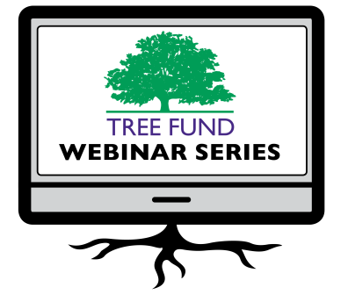

### Nov. 19, 2019 at 12 pm (Mountain)

Dr. Kathleen Wolf, University of Washington *Health Benefits of City Trees: Research Evidence and Economic Values*

**Jan. 14, 2020 at 12 pm (Mountain)** Dr. Bryant Scharenbroch, University of Wisconsin, Stevens Point

*Soil Assessment for Urban Trees*

**March 26, 2020 at 12 pm (Central)** Dr. Greg Dahle, West Virginia University *Why Do Tree Branches Fail?*

**June 16, 2020 at 12 pm (Mountain)** Dr. Rachael Antwis, University of Salford *Fighting Microbes with Microbes to Protect Our Native Trees*

### July 14, 2020 at 12 pm (Central)

Dr. Brandon Winfrey, Monash University *Enhancing Tree Health in Water Sensitive Urban Design: Role of Mycorrhizae*

TREE Fund’s one-hour webinars are **FREE** and offer **1.0 CEU** credit for live broadcast from the International Society of Arboriculture, the Society of American Foresters, the National Association of Landscape Professionals and sometimes the Landscape Architecture Continuing Education System. Registration and more detailed CEU credit information becomes available on our [**website**](https://treefund.org/webinars) approximately one month before webinar date. Missed a webinar? Watch it anytime on our website’s [**webinar archive**](https://treefund.org/webinar-archive) page.



**Connect with us online at** [**treefund.org**](https://treefund.org/) **and on social media:**

**#treefund**

@TREEFund @TREE_Fund

**Contact Us**

[**TREE Fund**](https://treefund.org/)

552 S. Washington Street Suite 109

Naperville, IL 60540

(630) 369-8300

[treefund@treefund.org](mailto:treefund@treefund.org)

TREE FUND IS A 501(C)3 NONPROFIT WHOSE MISSION IS TO SUPPORT SCIENTIFIC DISCOVERY AND DISSEMINATION OF NEW KNOWLEDGE IN THE FIELDS OF ARBORICULTURE AND URBAN FORESTRY