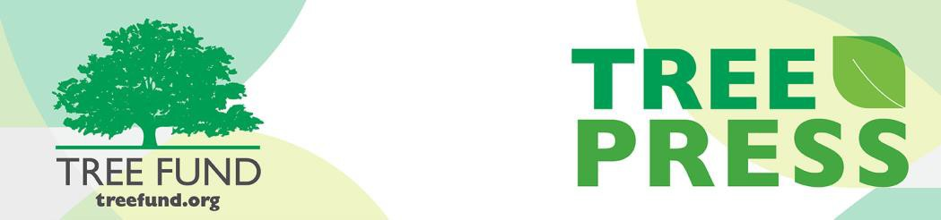

Tree Research and Education Endowment Fund Newsletter Vol. 2 No. 12 – December 2019

Crowning Achievements
Protecting Native Trees from Microbes, the Natural Way
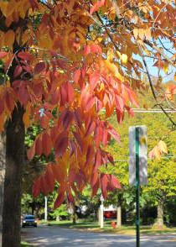
Native tree species have been in the news often as threats to their survival continue to increase. Among them, emerging pathogens are causing widespread tree population declines and a huge corresponding loss of biodiversity and natural capital in ecosystems across the globe. In one example, a fungus that arrived in the United Kingdom in 2012, chalara (Hymenoscyphus fraxineus), has now spread across the entire island and is expected to result in a 95% mortality rate for ash trees (Fraxineus excelsior).
To tackle this problem, Dr. Rachel Antwis, University of Salford, UK, and her co-investigator, Dr. Andrea Harper, University of York, UK, have chosen to focus on the microbiome, a symbiotic microbial community that includes fungi and bacteria and is found in all living organisms. The microbiome regulates host functioning and health, and its composition determines the ability of pathogens to infect hosts. Because the use and application of fungicides has become increasingly restricted by law in the UK, innovative, effective and natural approaches to disease mitigation must be developed quickly. Fortunately, unique opportunities exist in the microbiome to develop novel strategies that can promote host disease resistance. These include selecting individual trees with microbiota that protect their fellows from pathogens, and developing probiotics that may be used in the prevention or treatment of diseases.
Ash trees support more than 1,000 other associated species, and their extinction would force the co-extinction of up to 44 dependent species in the UK. Trees are the foundation of our natural ecosystem, and TREE Fund is committed to supporting the research and education they need to stay healthy. Visit our website, treefund.org, to learn more about Dr. Antwis’ research on the complex relationship between the chalara fungus and ash dieback disease in her study called, “Fighting Microbes with Microbes to Protect our Native Trees,” co-funded by TREE Fund’s Jack Kimmel International Grant. Dr. Antwis will also be presenting a webinar on June 16, 2020, so please join it to learn more about her work.

“Nature welcomes inquiry.
Nature does not hide its work.
Just seek,
and you will find.”

- Alex L. Shigo

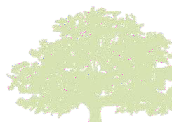
In This Issue
- Crowning Achievements
- Leading Thoughts
- Support TREE Fund
- Lead Donors
- Tour des Trees 2020
- Volunteer Spotlight
- The Word on Webinars

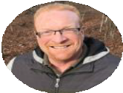
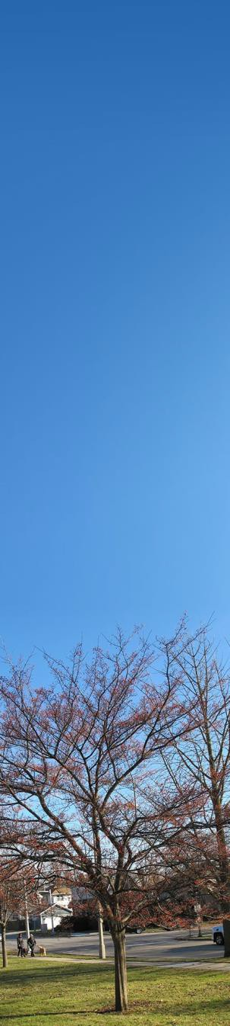Leading Thoughts

We Need Your
Help by Dec. 31
Giving to TREE Fund empowers tree research and education that keeps our urban forests growing strong. Your gift will make a d i f f e r e n c e t o y o u r community’s trees now, and for many years to come. Please consider visiting our website before Dec. 31 to make your donation.
We truly cannot thank you enough for your support.
By Russell K. King, TREE Fund President and CEO

“Something we were withholding made us weak
Until we found out that it was ourselves” - Robert Frost, The Gift Outright

The holidays we celebrate this time of year are rich in diversity and depth. They resonate with me the way the instruments of an orchestra, each playing its own part, compose a symphony. The song I hear them all playing is, at its heart, one of gratitude. I’d like to add a measure or two of my own.
I’d like to express my gratitude for the opportunity to serve TREE Fund. As Frost suggests above, the inner rewards of giving yourself fully are great, and here I find a cause that touches, inspires and fulfills me. There is an underlying profundity to our mission that makes this role much more than merely a professional engagement. I might dare call it sacred.
Some folks use “sacred” to mean something special, something set apart from our regular lives. Sometimes they speak of the sacred in strange language, using words that very few folks understand and concepts that are so wrapped up in their view of things or so dependent on their own jargon that they feel foreign, far away, and untouchable. I prefer to think we’re living in the sacred.
We can find the sacred in everything around us all the time. I once heard Carlos Nakai say “The only holy ground is the ground upon which you stand,” and I took it to mean that when we are open to the wonder, beauty and meaning of everyday things that relationship consecrates all of creation.
The fact that the nuclear fusion of the sun, just shy of 93 million miles away, has a byproduct of energy that radiates into space, reaches Earth where plants receive it through photosynthesis and begin the food chain that sustains us all inspires reverence and wonder. So does the fact that every calorie of energy, every BTU of heat, every hertz of vibration, and every wave of every particle of the people I love will exist forever. To me, the Earth and her flora and fauna are sacred, as are the many kinds of love we share. Our capacity to nurture and celebrate one another fills me with awe.
Which brings me to you: You have given of yourself to this mission, and I am grateful. Whether you have given time, treasure, or both, I am grateful. You have created and nurtured this sacred cause that I now take to heart, and I am grateful. You have expressed a love that starts with the trees but extends to the myriad life forms sustained buy those trees, and I am grateful.
My gratitude for the opportunity to join you in this cause is intense, but I need your help. As we build on a remarkable past to forge our future, I will look to you for support. Please consider closing 2019 with a donation or pledge of future support. Let’s discover, together, the strength of giving of ourselves.

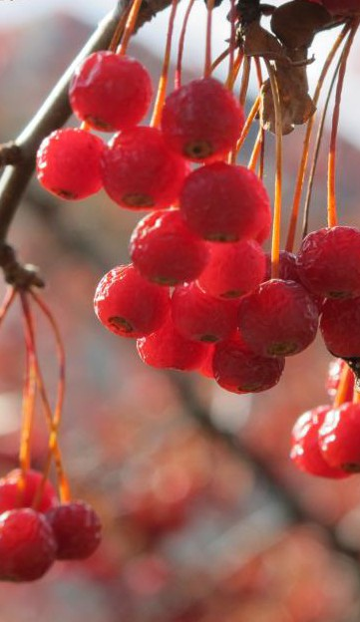Tour des Trees 2020
Lead Donors
We are extremely grateful to the following people and organizations who contributed $2,500 or more to TREE Fund in November 2019:
CN UTILITY CONSULTING, INC.
PAUL F. AND KRISTIN FLETCHER, JR.
STEVEN GEIST
ILLINOIS ARBORIST ASSOCIATION, INC.
See the full list of Lead Donors who make our vital tree research and education work possible on our
website, treefund.org.
HAPPY
HOLIDAYS!
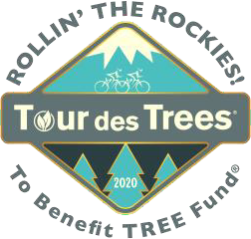
Registration and fundraising will open on Jan. 15 for TREE Fund’s annual long-distance cycling adventure and primary public outreach and community engagement event to benefit tree research and education, the Tour des Trees. 2020’s tour, Rollin’ the
Rockies, will depart Denver on
Aug. 30 for five days of riding, comradery and educating the public on the value of trees. Stay tuned as route and event details become available, and consider making this year’s event your New Year’s resolution. This is one you will want to keep!
Interested in receiving emails about the 29th Tour des Trees to Benefit TREE Fund? Please sign up here to get tour updates sent straight to your Inbox.
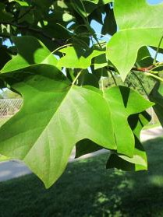
Volunteer Spotlight
TREE Fund Liaisons and ISA Chapters
We are excited to highlight all our TREE Fund Liaisons and ISA Chapters in this month's Volunteer Spotlight. This group of 21 ISA Chapters and their TREE Fund Liaison representatives has been supporting TREE Fund on an annual basis for many years. Although each ISA Chapter operates differently, they all fundraise and support TREE Fund with donations or support of
Tour des Trees riders who represent many if not all of the Chapters. Our Liaisons volunteer their time to communicate TREE Fund news with their Chapters, represent TREE Fund during Chapter conferences and organize and facilitate fundraising initiatives on TREE Fund's behalf. Several of the Chapters have spearheaded some of TREE Fund's endowment funds, ensuring the longevity of support for research and education grants and scholarships. We thank this devoted group of volunteers from around the country for their tireless support of TREE Fund.
To suggest someone for the Volunteer Spotlight, contact Teresa Recchia.

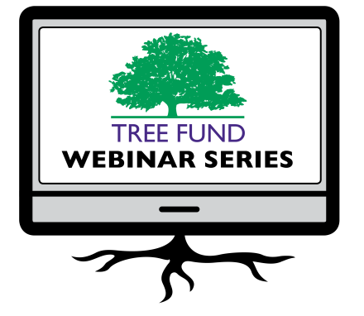The Word on Webinars

Jan. 14, 2020 at 12 pm (Mountain) Dr. Bryant Scharenbroch, University of Wisconsin, Stevens Point
Soil Assessment for Urban Trees

March 26, 2020 at 12 pm (Central) Dr. Greg Dahle, West Virginia University Why Do Tree Branches Fail?

June 16, 2020 at 12 pm (Mountain) Dr. Rachael Antwis, University of Salford Fighting Microbes with Microbes to Protect Our Native Trees

July 14, 2020 at 12 pm (Central)
Dr. Brandon Winfrey, Monash University Enhancing Tree Health in Water Sensitive Urban Design: Role of Mycorrhizae
Registration opens soon for Dr. Bryant Scharenbroch’s webinar, “Soil Assessment for Urban Trees.” In his webinar Dr. Scharenbroch will introduce soil quality, cover how it is assessed, and discuss how soil quality assessment is used for urban tree management. Dr. Scharenbroch will also include examples of how this information may be applied to real world situations for the arborist and urban forester.
In Dr. Kathleen Wolf’s November webinar, “Health Benefits of City Trees: Research Evidence & Economic Values,” she conducted an in-depth literature review of the ever-growing, international body of research on the many human health and wellness benefits of nature experiences. If you were unable to join it live, you will be pleased to know that her webinar and supporting materials are now available on the Webinar Archive page of our website.
TREE Fund’s one-hour webinars are FREE and offer 1.0 CEU credit for live broadcast from the International Society of Arboriculture, the Society of American Foresters, the National Association of Landscape Professionals and sometimes the Landscape Architecture Continuing Education System. Registration and more detailed CEU credit information becomes available on our website, treefund.org, approximately one month before webinar date.

Connect with us online at treefund.org and on social media:
#treefund

@TREEFund @TREE_Fund

Contact Us
TREE Fund
552 S. Washington Street Suite 109
Naperville, IL 60540
(630) 369-8300
treefund@treefund.org

TREE FUND IS A 501(C)3 NONPROFIT WHOSE MISSION IS TO SUPPORT SCIENTIFIC DISCOVERY AND DISSEMINATION OF NEW KNOWLEDGE IN THE FIELDS OF ARBORICULTURE AND URBAN FORESTRY

