Tree Research and Education Endowment Fund Newsletter Vol. 3 No. 1 – January 2020

Crowning Achievements
How to measure the DBH of a multi-stemmed tree
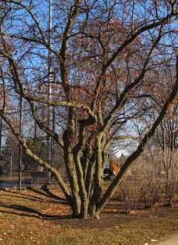
Diameter at breast height (DBH) measurements are a core element of forest inventories and monitoring. However, DBH—and, specifically, breast height above the ground—has notable shortcomings. The height at which this measurement is taken varies between continents, researchers and tree types. This is where the research of Mr. Yasha A. S. Magarik of the Yale School of Forestry and Environmental Studies and co- investigators, Dr. Lara Roman, USDA Forest Service, and Dr. Jason G. Henning, The
Davey Institute and USDA Forest Service, comes in. In his project, “Dendrometry of Multi-Stemmed Urban Trees,” partially funded by TREE Fund, Magarik specifically tackles the problem of applying traditional DBH (approximately 137 cm) measurements to small statured, multi-stemmed trees, which his research has shown are a growing population of trees in urban environments.
In this project, 25 urban forestry practitioners were surveyed in 12 cities across the northeastern United States on how they approach measuring the DBH of multi-stemmed trees in real-world situations. Among his findings were that practitioners employ alternatives to the current protocols for measuring at 137 cm, and that current measurement practices for multi-stemmed trees can be burdensome. In addition to conducting this survey, Magarik and his team measured the stem diameter of 569 trees of three frequently planted, commonly multi- stemmed genera: Malus, Prunus, and Zelkova. Several distances above the ground were recorded: (1) at the root collar, (2) at 30 cm, just below the fork (which occurred between 30 and 137 cm), and (3) at 137 cm (up to six stems following established protocols).
Access Magarik’s research on our website, treefund.org, to find out what insights this rich data revealed about measuring the diameter at breast height of multi-stemmed trees. And mark your calendar now for his and Roman’s webinar at 12:00 p.m. (CT) on Tues., Oct. 13, 2020.

“Nature welcomes inquiry.
Nature does not hide its work.
Just seek,
and you will find.”

- Alex L. Shigo

In This Issue
- Crowning Achievements
- Leading Thoughts
- Spring Cycle Grant and Scholarship Applications
- Lead Donors
- Board of Trustees Transitions
- Tour des Trees 2020
- Volunteer Spotlight
- The Word on Webinars

Leading Thoughts

Spring Cycle Grant Applications
Applications for the following TREE Fund grant and scholarship programs are open now through March 15, 2020:
$50,000
Utility Arborist Research Fund Grant*
$25,000
Hyland R. Johns Grant*

$5,000
Ohio Chapter ISA Education Grant
$5,000
All Scholarships

Get more application details and instructions by visiting TREE Fund’s website, treefund.org.
* An approved Letter of Inquiry (LOI) is required to submit an application for TREE Fund research grants. The deadline to submit an LOI is March 1, 2020.
By Russell K. King, TREE Fund President and CEO
The lifeblood of most nonprofit organizations is the strength of its volunteers, and this is true for TREE Fund, as well. From donors to corporate partners, local chapter members, affiliated organization members, task forces, standing committees, Tour des Trees riders and support, and trustees, our network of volunteers is as vital as it is varied.
A lot of good people help good causes. The question for most of us is “How can I be the most help?”
For TREE Fund, the first answer is: Give. Our mission is to support the research that enhances trees and the people who work among them, so financial support is the most effective way to help. Our most pressing need is for “unrestricted” gifts that pay our operating costs.
There are other ways to generate financial support for TREE Fund’s mission. Ride in the Tour des Trees. Support your local ISA chapter’s fundraising events. Encourage your employer to become a TREE Fund partner. Take advantage of your employer’s matching gifts program if one exists. Include TREE Fund in your estate planning. Talk to other organizations about raising
money for TREE Fund.
Perhaps your company provides services to a celebrity or others who have both an affinity for trees and extraordinary ability to support TREE Fund— opening those doors, facilitating those contacts, is a great way to help.
Spreading the word about TREE Fund through social media is helpful in both raising the level of awareness of TREE Fund’s work and generating financial support. For example, you can create your own fundraising event, in honor of your birthday, or share posts from TREE Fund’s social media platforms that include donation opportunities.
If you shop on Amazon Smile, you can designate TREE Fund as your preferred charity and every purchase generates support.
The second answer to how you can best help TREE Fund is: Share the news! Paying attention to our research and sharing it within the industry are important ways of supporting the mission. Research matters most when it has practical applications, and the more people who know about the research the more application it’s likely to have.
The third answer is: Volunteer. Some think that means serving on the Board of Trustees and feel uncomfortable with that level of responsibility. The good news is that serving on a committee is less intimidating and can actually be more effective.
Committees are where the proverbial rubber meets the road. It’s in committees that efforts, issues, and ideas get their most robust engagement. Boards meet less frequently and are focused on big-picture matters of broad policy, governance, and mission. The ideas, insights, inspirations, and opinions you may offer, as well as the local contacts you may make or doors you may open, are all valuable parts of the support on which TREE Fund depends.
You already know the importance of trees in our lives, communities, and environment. Make 2020 the year you put that knowledge into concrete action by either supporting or increasing your current support of TREE Fund’s work, message, and mission.

Lead Donors
We are extremely grateful to the following people and organizations who contributed $2,500 or more to TREE Fund in December 2019:

MICHAEL AND KAREN GRIMM
WILBUR NUTTER
MUNDY WILSON PIPER AND WINTHROP PIPER
JAMES URBAN

See the full list of Lead Donors who make our vital tree research and education work possible on our website, treefund.org.

Tour des Trees 2020
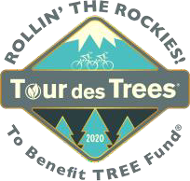
Registration and fundraising are now open for TREE Fund’s 28th Annual Tour des Trees 2020, Rollin’ the Rockies! Join us this August as we engage with communities and cycle through the Rocky Mountain Front Range of Colorado. The 2020 Tour will depart
Denver on Aug. 30 for five days of riding, engagement and comradery. Whether this will be your 20+ year supporting and riding with TREE Fund or you are considering making this your first experience with us, we can guarantee it will be a memorable one. Stay tuned as route and event details become available.
Interested in receiving emails about the 28th Tour des Trees to Benefit TREE Fund? Please sign up here to get tour updates sent straight to your Inbox.

TREE Fund Board of Trustees Transitions
Volunteer Spotlight
Steve Geist
Please join us in celebrating Steve Geist of SavATree as our outstanding volunteer. Steve has been a TREE Fund Trustee since 2014 and most recently served as TREE Fund’s chair of the Board. In addition, he has also participated on the Liaison Committee, Education Sub-Committee, Executive and
Governance Committee, Tour des Trees Planning Committee, and Tour des Trees Safety Task Force, with his insight and wit brightening each and every meeting. Steve is a true champion of TREE Fund, not only serving as a strong board leader and advocate for TREE Fund but also in his longtime involvement in the Tour des Trees. Steve has been a vital member of the Tour des Trees family for 22 years, more often than not securing a place on the fundraising leaderboard. This year’s tour will be his 23rd! After his many years as an outstanding spokesman and leader for our organization, we are eager to bring the Tour des Trees to his home state of Colorado this year. Thank you so much, Steve, for the many things you do for TREE Fund.

To suggest someone for the Volunteer Spotlight, contact Teresa Recchia.
At its December 2019 meeting, the TREE Fund Board of Trustees elected Arnold “Beau” Brodbeck as its chair, Sharon Jean-Philippe as chair elect, and David Krause as vice chair. Jeff Edgar, president and owner of Silver Creek Nurseries, Inc., in Manitowoc, WI, was elected to the board. Mundy Wilson Piper (having served two years) and Tom Wolf (having served four and one half years) stepped down from the board. Steve Geist, our immediate past chair, remains on the board. We offer all of these volunteers our heartfelt gratitude!

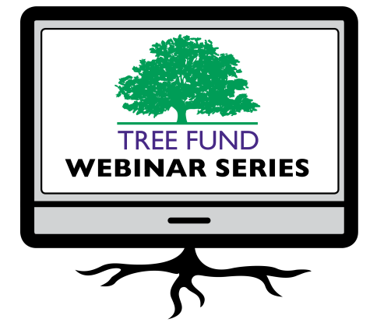The Word on Webinars
Thank you to everyone who joined us for Dr. Bryant Scharenbroch’s Jan. 14 webinar, “Soil Assessment for Urban Trees.” If you were unable to watch it live, it will be archived on our website, treefund.org, within one week of broadcast. Also, we’ve added a new webinar for 2020 to our schedule! Please mark your calendar for Yasha Magarik and Lara Roman’s webinar, “Measuring Multi-Stemmed Trees” on Oct. 13.

March 26, 2020 at 12 pm (Central) Dr. Greg Dahle, West Virginia University Why Do Tree Branches Fail?

June 16, 2020 at 12 pm (Mountain) Dr. Rachael Antwis, University of Salford Fighting Microbes with Microbes to Protect Our Native Trees

July 14, 2020 at 12 pm (Central)
Dr. Brandon Winfrey, Monash University Enhancing Tree Health in Water Sensitive Urban Design: Role of Mycorrhizae

Oct. 13, 2020 at 12 pm (Central)
Yasha Magarik, Yale School of Forestry and
Environmental Studies
Dr. Lara Roman, USDA Forest Service
Measuring Multi-Stemmed Trees

TREE Fund’s one-hour webinars are FREE and offer 1.0 CEU credit from the International Society of Arboriculture, the Society of American Foresters, the National Association of Landscape Professionals and sometimes the Landscape Architecture Continuing Education System. Registration information becomes available on our website approximately one month before webinar date. Missed a webinar? Watch it anytime on our website’s webinar archive page.

Connect with us online at treefund.org and on social media:
#treefund

@TREEFund @TREE_Fund

Contact Us
TREE Fund
552 S. Washington Street Suite 109
Naperville, IL 60540
(630) 369-8300
treefund@treefund.org

TREE FUND IS A 501(C)3 NONPROFIT WHOSE MISSION IS TO SUPPORT SCIENTIFIC DISCOVERY AND DISSEMINATION OF NEW KNOWLEDGE IN THE FIELDS OF ARBORICULTURE AND URBAN FORESTRY

