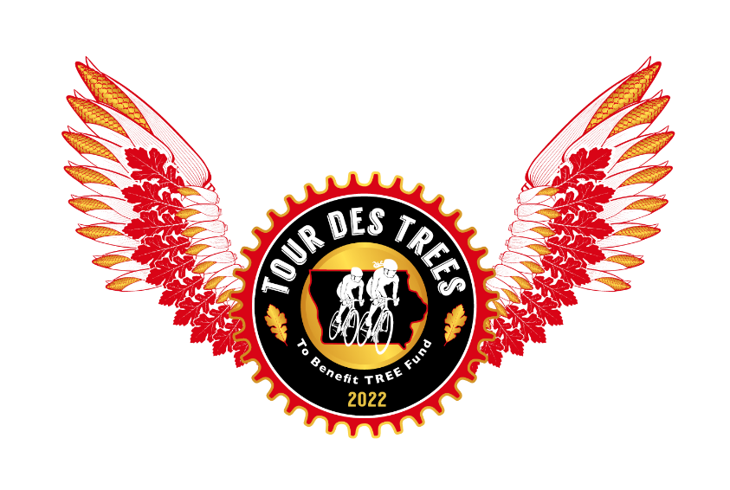

2022 Tour des Trees Itinerary
(Updated 3/21/22)

Sat 9/3 Des Moines, IA

12:00 - 4:00 p.m. Rider check-in and apparel pick-up
Embassy Suites Hotel

5:00 p.m. Rider Orientation Meeting
Embassy Suites Hotel

6:30 p.m. Reception/Welcome Dinner
Embassy Suites Hotel

Hotel: Embassy Suites Hotel
101 E. Locust Street, Des Moines, IA 50309

Sun 9/4 Des Moines to Pella, IA – 54 miles

6:00 - 7:15 a.m. Breakfast
Embassy Suites Hotel

8:00 a.m. Tour Launch

8:30 – 9:30 a.m. TBA
Mile XX TBA City, IA

2:45 - 4:30 p.m. Hotel- Country Inn and Suites
Mile 54 315 Roosevelt Rd, Pella, IA 50219

6:00 p.m. Reception / Dinner
Tamory Hall, 616 Franklin Street, Pella, IA 50219

Mon 9/5 Pella to Ames, IA – 86 miles

7:30 a.m. Breakfast
Tamory Hall, 616 Franklin Street, Pella, IA 50219

8:30 a.m. Riders Depart

8:30 – 9:30 a.m. TBA
Mile XX TBA City, IA

2:45 - 4:30 p.m. Hotel- Gateway Hotel and Conference Center at Iowa State
Mile 86 2100 Green Hills Drive, Ames, IA 50014

6:00 p.m. Dinner
Reiman Gardens

Tues 9/6 Ames to Des Moines, IA – 75 miles

6:00 - 7:15 a.m. Breakfast
Gateway Hotel

8:00 a.m. Riders Depart

8:30 – 9:30 a.m. TBA
Mile XX TBA City, IA

11:00a.m.–12:30 p.m.Lunch
Mile 45 Brenton Arboretum (Pavilion), 25141 260th Street, Dallas Center, IA

2:45 - 4:30 p.m. Hotel- Embassy Suites Hotel
Mile 75 101 E. Locust Street, Des Moines, IA 50309

6:00 p.m. Dinner
Greater Des Moines Botanical Gardens- DuPont West Room

Wed 9/7 Des Moines to Creston, IA – 73 miles

6:00 - 7:15 a.m. Breakfast
Embassy Suites Hotel

8:00 a.m. Riders Depart

8:30 – 9:30 a.m. Aid Station
Mile 34 John Wayne Birthplace Museum, Winterset, IA

2:45 - 4:30 p.m. Hotel- Quality Inn
Mile 73 900 S. Summer Ave, Creston, IA 50801

6:00 p.m. Dinner
Creston Family Restaurant

Thus 9/8 Creston, IA to Nebraska City, NE – 108 Miles

6:00 - 7:15 a.m. Breakfast
Creston Family Restaurant

8:00 a.m. Riders Depart

8:30 – 9:30 a.m. TBA
Mile XX TBA City, IA

2:45 - 4:30 p.m. Hotel- Lied Lodge
Mile 108 2700 Sylvan Rd, Nebraska City, NE 68410

6:00 p.m. Dinner
Historic Barn on Arbor Day Farm Campus

Fri 9/9 Nebraska City (Lied Lodge out and back) – 41 Miles

6:00 - 7:15 a.m. Breakfast
Steinhart Lodge on Arbor Day Farm campus

9:00 a.m. Riders Depart

8:30 – 9:30 a.m. TBA
Mile XX TBA City, IA

2:45 - 4:30 p.m. Hotel- Lied Lodge
Mile 41 2700 Sylvan Rd, Nebraska City, NE 68410

Noon – 1:30 p.m. Lunch
Steinhart Lodge on Arbor Day Farm campus

2:00 – 5:00 p.m. Afternoon activities at Arbor Day Farm

5:00 – 6:00 p.m. Mixer Reception
Treetop Village at Arbor Day Farm campus

6:00 p.m. Reception/Dinner
Steinhart Lodge on Arbor Day Farm campus

Sat 9/10 Nebraska City, NE

8:00 - 9:00 a.m. Breakfast
Steinhart Lodge on Arbor Day Farm campus
8:00 - 9:00 a.m. Closing Ceremony – Steinhart Lodge on Arbor Day Farm campus

10:00 a.m. Shuttles Depart
Omaha’s Eppley Airfield or return to Des Moines Embassy Suites

