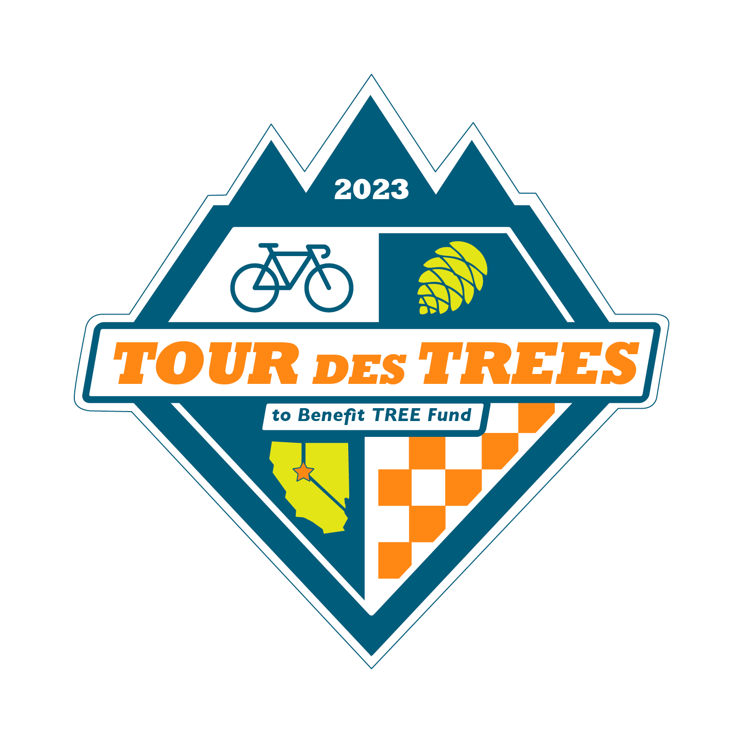
Who wants to ride ~380 miles on a bike
to raise money for tree research and education?

I do, actually. In September, my bike and I will travel to Nevada and California to ride the 2023 Tour des Trees to benefit TREE Fund. I’ve signed up to ride ~380 miles in five days and raise $3,500 for TREE Fund because I believe that the tree research and environmental education this ride supports are critical to the well-being of our communities and all of us who inhabit them.

Urban trees are vital to our survival. They reduce air pollution, sequester carbon, control erosion, shelter us from heat and wind, and add beauty to our lives. Trees give us respite from the stressors of our daily lives, but did you know that living in cities is stressful for trees? Pests, diseases, construction, pollution and neglect put the trees in our communities at risk every day. The research and education funded by TREE Fund via the Tour des Trees helps to ensure that tree care professionals are well equipped with best practices and the latest techniques to keep the trees we live with healthy and thriving.

So, do you want to cycle ~380 miles with me to support this important cause?

If not, here’s another option: would you donate $100 (or whatever you can afford) to my campaign and I’ll do the riding? I would really appreciate your support! Since TREE Fund Partners defray event costs, you can rest assured that 100% of your donation to my campaign will support tree research and education.

Here’s a link to my fundraising page:

Or you can write a check and mail it to the address on this form. Please note my name in the memo section.

For more information about TREE Fund visit: treefund.org
Learn more about the Tour des Trees at: treefund.org/tourdestrees

Thank you!

