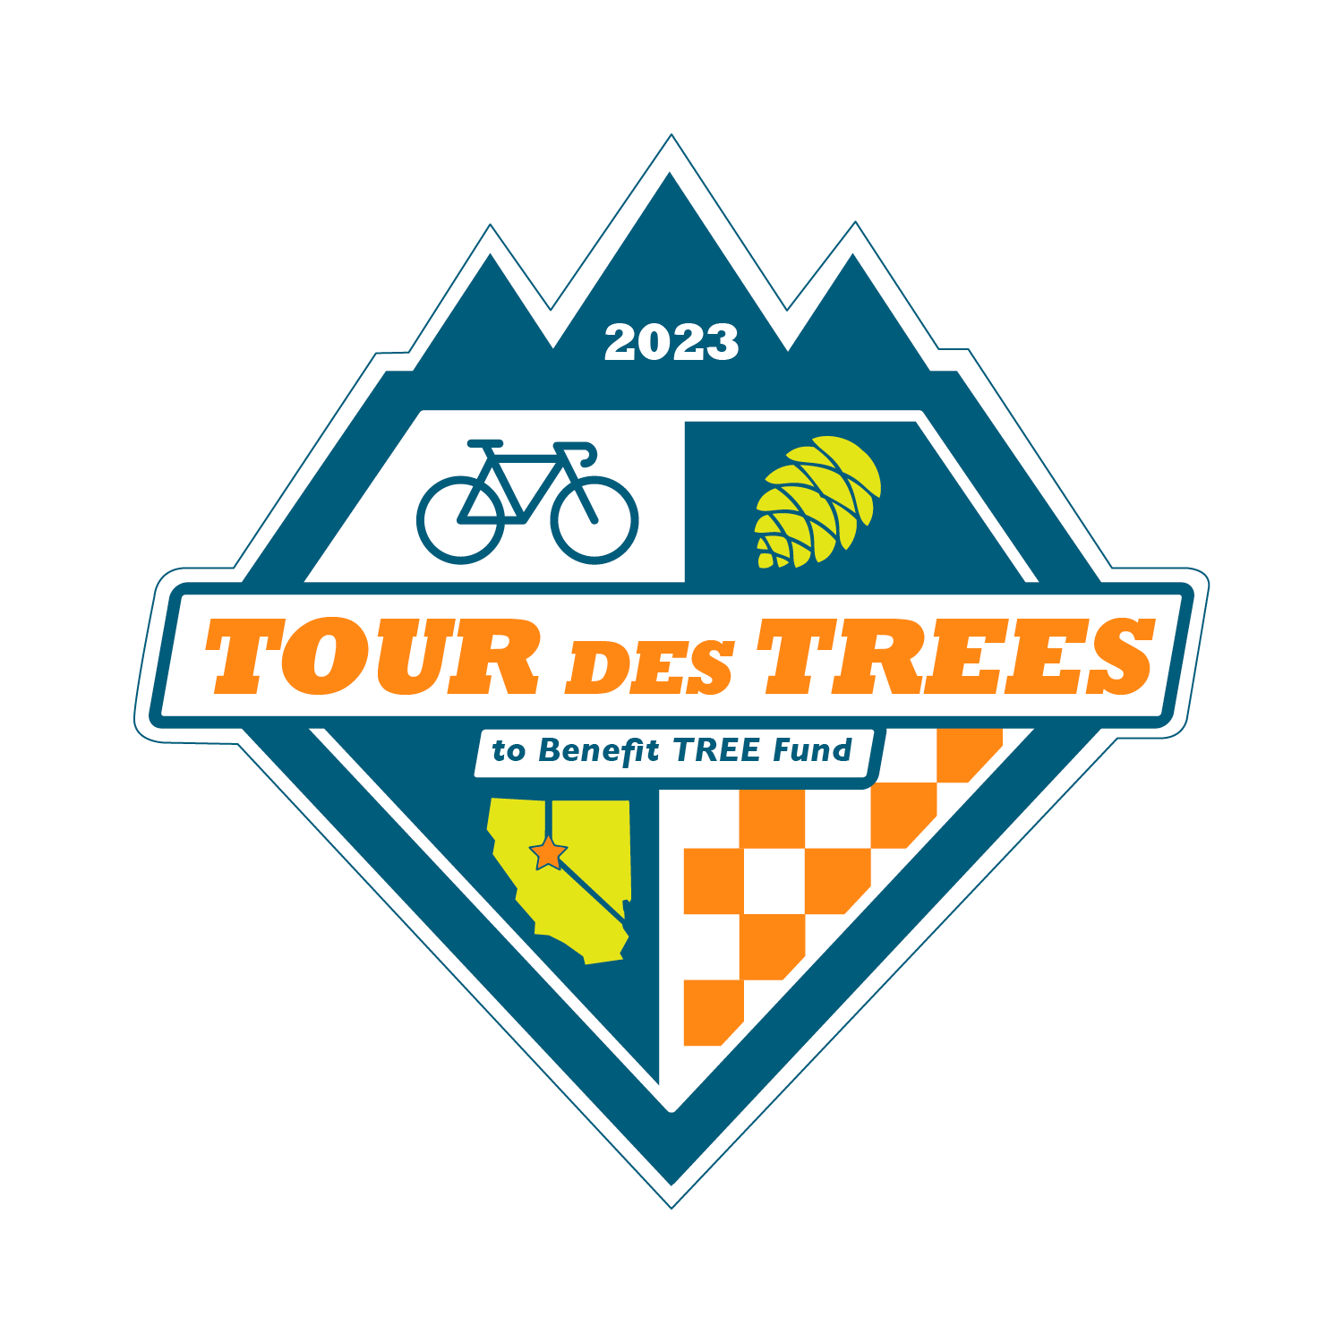

2023 Tour des Trees Itinerary
(Updated 2/13/23)

Tues 9/26 Reno, NV

12:00 - 4:00 p.m. Rider check-in and apparel pick-up
Hotel- Whitney Peak Hotel, 255 N Virginia St, Reno, NV 89501

5:00 p.m. Rider Orientation Meeting
Hotel- Whitney Peak Hotel, 255 N Virginia St, Reno, NV 89501

6:30 p.m. Reception/Welcome Dinner
Hotel- Whitney Peak Hotel, 255 N Virginia St, Reno, NV 89501

Hotel: Hotel- Whitney Peak Hotel, 255 N Virginia St, Reno, NV 89501
Hotel website: www.whitneypeakhotel.com

Wed 9/27 Reno, NV to South Lake Tahoe, CA – 61 Miles

6:00 - 7:15 a.m. Breakfast
TBA

8:00 a.m. Tour Launch

TBA a.m. Aid Station Location
Mile TBA Location

TBA p.m. Hotel: TBA
Mile 63 Location

Thurs 9/28 South Lake Tahoe, CA to Murphys, CA – 106 Miles

6:00 - 7:15 a.m. Breakfast
TBA

8:00 a.m. Ride depart

TBA a.m. Aid Station Location
Mile TBA Location

TBA p.m. Hotel: Murphys Suites
Mile 104 134 CA-4, Murphys, CA 95247

Fri 9/29 Murphys, CA to Modesto, CA – 66 Miles

6:00 - 7:15 a.m. Breakfast
TBA

8:00 a.m. Ride depart

TBA a.m. Aid Station Location
Mile TBA Location

TBA p.m. Hotel: TBA
Mile 66 Location

Sat 9/30 Modesto, CA to San Jose, CA – 88 Miles

6:00 - 7:15 a.m. Breakfast
TBA

8:00 a.m. Ride depart

TBA a.m. Aid Station
Mile 63 Lick Observatory, 7281 Mt. Hamilton Rd, Mt. Hamilton, CA

TBA p.m. Hotel: TBA
Mile 88 Location

Sun 10/1 San Jose, CA to Half Moon Bay, CA– 66 Miles

6:00 - 7:15 a.m. Breakfast
TBA

8:00 a.m. Ride depart

TBA a.m. Aid Station Location
Mile TBA Location

TBA p.m. Hotel: TBA
Mile 60 Location

Mon 10/2 Half Moon Bay, CA

8:00 - 9:00 a.m. Breakfast
Hotel TBA
8:00 - 9:00 a.m. Closing Ceremony – Hotel TBA

TBA a.m. Depart for airport (San Francisco Airport)

