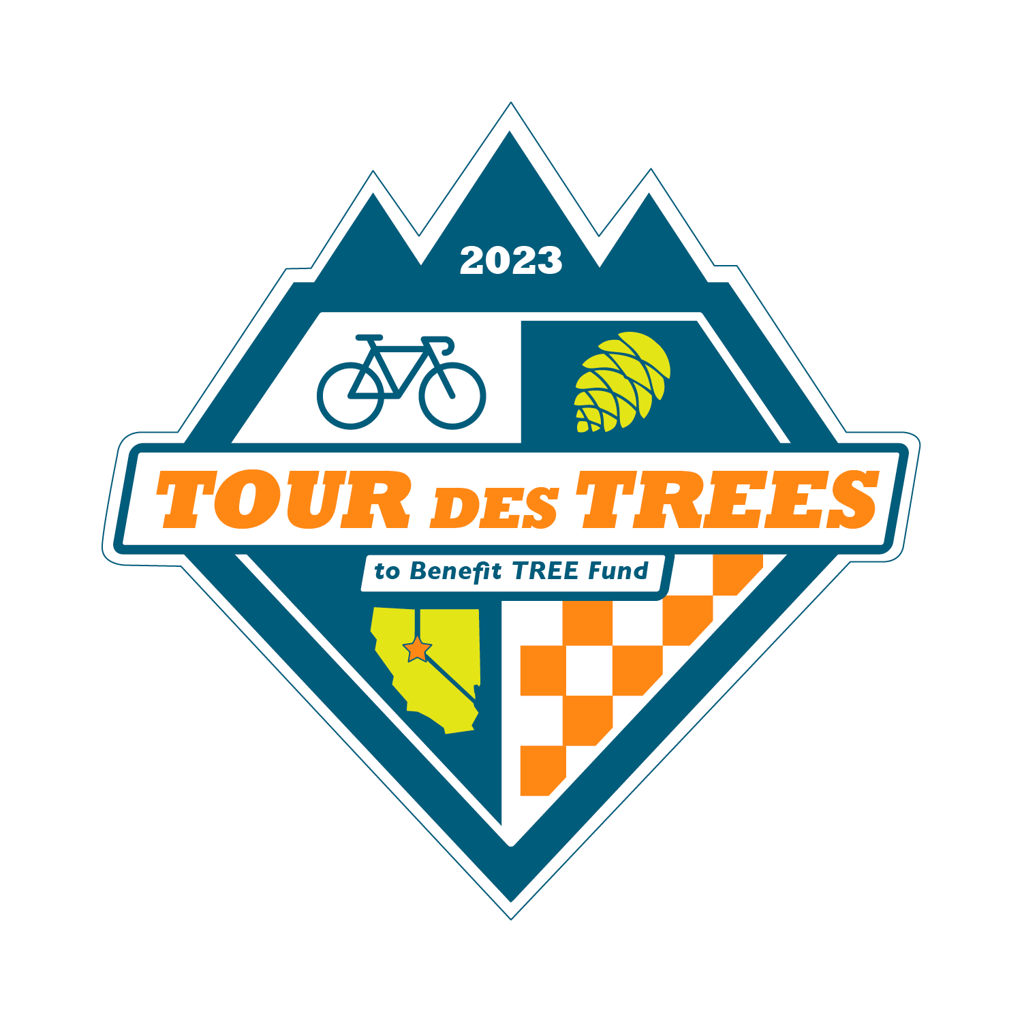

2023 Tour des Trees Itinerary
(Updated 3/9/23)

Tues 9/26 Reno, NV

12:00 - 4:00 p.m. Rider check-in and apparel pick-up
Hotel- Whitney Peak Hotel, 255 N Virginia St, Reno, NV 89501

2:00 – 3:00 p.m. Pre-ride Activity: Self-guided tour and staff meet-and-greet
May Arboretum, 1595 N Sierra St., Reno, NV 89503

2:00 – 3:00 p.m. Pre-ride Activity: Professor Pricklethorn Presentation
St. Albert the Great Catholic School, 1255 St. Alberts Drive, Reno, NV 89503

5:00 p.m. Rider Orientation Meeting
Hotel- Whitney Peak Hotel, 255 N Virginia St, Reno, NV 89501

6:30 p.m. Reception/Welcome Dinner
Hotel- Whitney Peak Hotel, 255 N Virginia St, Reno, NV 89501

Hotel: Hotel- Whitney Peak Hotel, 255 N Virginia St, Reno, NV 89501
Hotel website: www.whitneypeakhotel.com

Wed 9/27 Reno, NV to South Lake Tahoe – 61 Miles

6:00 - 7:15 a.m. Breakfast
Whitney Peak Hotel

8:00 a.m. Tour Launch

TBA a.m. Aid Station Location
Mile TBA Location

TBA p.m. Hotel: Hard Rock Hotel
Mile 61 50 Hwy 50, Stateline, NV 89449

6:00 p.m. Dinner
Hard Rock Hotel

Thurs 9/28 South Lake Tahoe to Murphys, CA – 106 Miles

6:00 - 7:15 a.m. Breakfast
Hard Rock Hotel

8:00 a.m. Ride depart

TBA a.m. Aid Station Location
Mile TBA Location

TBA p.m. Hotel: Murphys Suites
Mile 106 134 CA-4, Murphys, CA 95247

6:00 p.m. Dinner
Murphys Suites

7:00 p.m. Vermeer Olympics Night
Sponsored by Vermeer

Fri 9/29 Murphys, CA to Modesto, CA – 66 Miles

6:00 - 7:15 a.m. Breakfast
Murphys Suites

8:00 a.m. Ride depart

TBA a.m. Aid Station Location and Tree Planting
Mile 39 Knights Ferry Rec Area, 17968 Covered Bridge Rd, Oakdale, CA, 95361

TBA p.m. Hotel: DoubleTree Hotel
Mile 66 1150 9th St, Modesto, CA 95354

6:00 p.m. Wrap-up Evening Meeting
DoubleTree lobby area

Anytime “On Your Own” Night
Please enjoy one of the local restaurants Modesto has to offer

Sat 9/30 Modesto, CA to San Jose, CA – 88 Miles

6:00 - 7:15 a.m. Breakfast
DoubleTree Hotel

8:00 a.m. Ride depart

TBA a.m. Aid Station
Mile 63 Lick Observatory, 7281 Mt. Hamilton Rd, Mt. Hamilton, CA

TBA p.m. Hotel: Holiday Inn Silicon Valley/ Airport
Mile 88 1350 N. 1st Street, San Jose, CA 95112

6:00 p.m. Dinner
Holiday Inn Silicon Valley/ Airport

Sun 10/1 San Jose, CA to Half Moon Bay, CA– 66 Miles

6:00 - 7:15 a.m. Breakfast
Holiday Inn Silicon Valley/ Airport

8:00 a.m. Ride depart

9:00 – 10:00 a.m. Aid Station
Mile 10 Bartlett Tree Experts, 882 Camden Ave, Campbell, CA 95008

Noon – 2:00 p.m. Lunch
Mile 43 Loma Mar Store and Kitchen, 8150 Pescadero Creek Rd, Loma Mar, CA 94021

TBA p.m. Hotels: Quality Inn & Best Western
Mile 66 Quality Inn, 2930 N Cabrillo Hwy, Half Moon Bay, CA 94019
Best Western Hotel, 1400 Cabrillo Hwy S, Half Moon Bay, CA 94019

6:00 p.m. Dinner
TBA

Mon 10/2 Half Moon Bay, CA

8:00 - 9:00 a.m. Breakfast
At hotels: Quality Inn & Best Western
TBA a.m. Depart for airport (San Francisco Airport)

