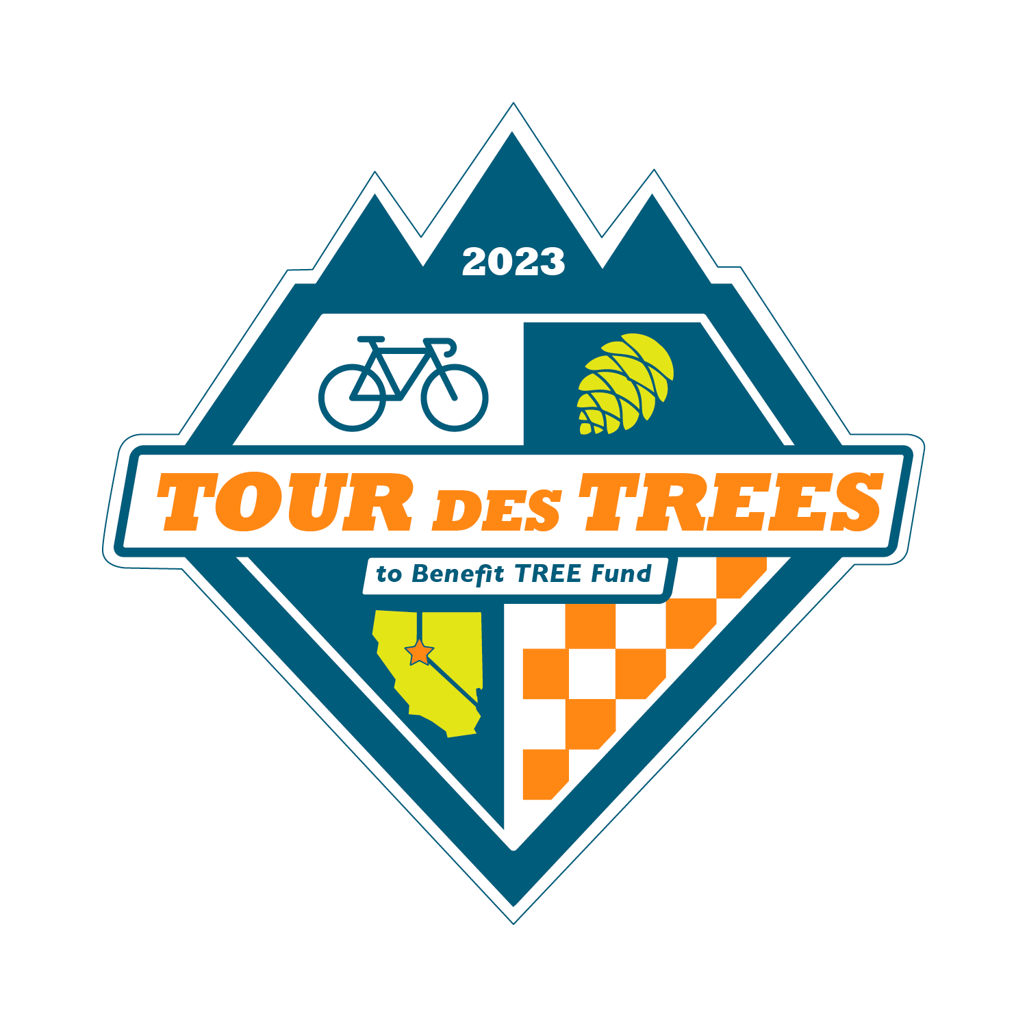

2023 Tour des Trees Itinerary
(Updated 6/21/23)

Tues 9/26 Reno, NV

12:00 - 4:00 p.m. Rider check-in and apparel pick-up
Hotel- Whitney Peak Hotel, 255 N Virginia St, Reno, NV 89501

2:00 – 3:00 p.m. Pre-ride Activity: Self-guided tour and staff meet-and-greet
May Arboretum, 1595 N Sierra St., Reno, NV 89503

2:00 – 3:00 p.m. Pre-ride Activity: Professor Pricklethorn Presentation
St. Albert the Great Catholic School, 1255 St. Alberts Drive, Reno, NV 89503

5:00 p.m. Rider Orientation Meeting
Hotel- Whitney Peak Hotel, 255 N Virginia St, Reno, NV 89501

6:30 p.m. Reception/Welcome Dinner
Hotel- Whitney Peak Hotel, 255 N Virginia St, Reno, NV 89501

Hotel: Hotel- Whitney Peak Hotel, 255 N Virginia St, Reno, NV 89501
Hotel website: www.whitneypeakhotel.com

Wed 9/27 Reno, NV to South Lake Tahoe – 61 Miles

6:00 - 7:15 a.m. Breakfast
Whitney Peak Hotel

9:00 a.m. Tour Kickoff Event, tree planting, and departure
Reno, NV

TBA a.m. Lunch Stop Location
Mile 48 Spooner Lake State Park, Hwy 28, Incline Village, NV

TBA p.m. Tree planting
Mile 63 Van Sickle Bi-State Park, 30 Lake Parkway, South Lake Tahoe, CA

TBA p.m. Hotel: Hard Rock Hotel
Mile 65 50 Hwy 50, Stateline, NV 89449

6:00 p.m. Dinner
Hard Rock Hotel

Thurs 9/28 South Lake Tahoe to Murphys, CA – 107 Miles

6:00 - 7:15 a.m. Breakfast
Hard Rock Hotel

8:00 a.m. Ride depart

8:45 a.m.- 9:30am Tree plantings with the Sugar Pine Foundation
Mile 9 Meyers, CA- Location TBD

TBA a.m. Aid Station and presentation from Alpine Watershed Group
Mile 34 Turtle Rock Park, 17300 CA-89, Markleeville, CA 96120

TBA a.m. Aid Station Location
Mile 89 Calaveras Big Trees State Park, 1170 CA-4, Arnold, CA 95223

TBA p.m. Hotel: Murphys Suites
Mile 107 134 CA-4, Murphys, CA 95247

6:00 p.m. Dinner- Sponsored by Vermeer
Outer Aisle Catering, 164 CA-4, Murphys, CA 95247

7:00 p.m. Vermeer Olympics Night
Sponsored by Vermeer

Fri 9/29 Murphys, CA to Modesto, CA – 77 Miles

6:00 - 7:15 a.m. Breakfast
Outer Aisle Catering, 164 CA-4, Murphys, CA 95247

8:00 a.m. Ride depart- Team Jersey Day!

TBA a.m. Aid Station Location and Tree Planting
Mile 42 Knights Ferry Rec Area, 17968 Covered Bridge Rd, Oakdale, CA, 95361

3:00 – 5:00 p.m. Tree Care Industry Job Fair
Modesto Junior College- East Campus Ag Dept, College Ave & Coldwell Ave, Modesto, CA 95350

TBA p.m. Hotel: DoubleTree Hotel
Mile 77 1150 9th St, Modesto, CA 95354

6:00 p.m. Wrap-up Evening Meeting
DoubleTree lobby area

Anytime “On Your Own” Night
Please enjoy one of the local restaurants Modesto has to offer

Sat 9/30 Modesto, CA to San Jose, CA – 97 Miles

6:00 - 7:15 a.m. Breakfast
DoubleTree Hotel

8:00 a.m. Ride depart

TBA a.m. Aid Station
Mile 63 Lick Observatory, 7281 Mt. Hamilton Rd, Mt. Hamilton, CA

TBA a.m. Get together, tour, and Prof. Pricklethorn presentation
Mile 90 California Native Gardens, 76 Race Street, San Jose, CA

TBA p.m. Hotel: Holiday Inn Silicon Valley/ Airport
Mile 97 1350 N. 1st Street, San Jose, CA 95112

6:00 p.m. Dinner
Holiday Inn Silicon Valley/ Airport

Sun 10/1 San Jose, CA to Half Moon Bay, CA– 65 Miles

6:00 - 7:15 a.m. Breakfast
Holiday Inn Silicon Valley/ Airport

8:00 a.m. Ride depart

9:00 – 10:00 a.m. Aid Station
Mile 10 Bartlett Tree Experts, 882 Camden Ave, Campbell, CA 95008

Noon – 2:00 p.m. Lunch- Sponsored by Bartlett Tree Experts
Mile TBA TBA

TBA p.m. Hotel: Half Moon Bay Lodge
Mile 65 2400 Cabrillo Hwy S, Half Moon Bay, CA 94019

6:00 p.m. Dinner
Half Moon Bay Lodge

Mon 10/2 Half Moon Bay, CA

8:00 - 9:00 a.m. Breakfast
At hotel: Half Moon Bay Lodge
TBA a.m. Depart for airport (San Francisco Airport)

TBA a.m. Depart in shuttles back to Reno

