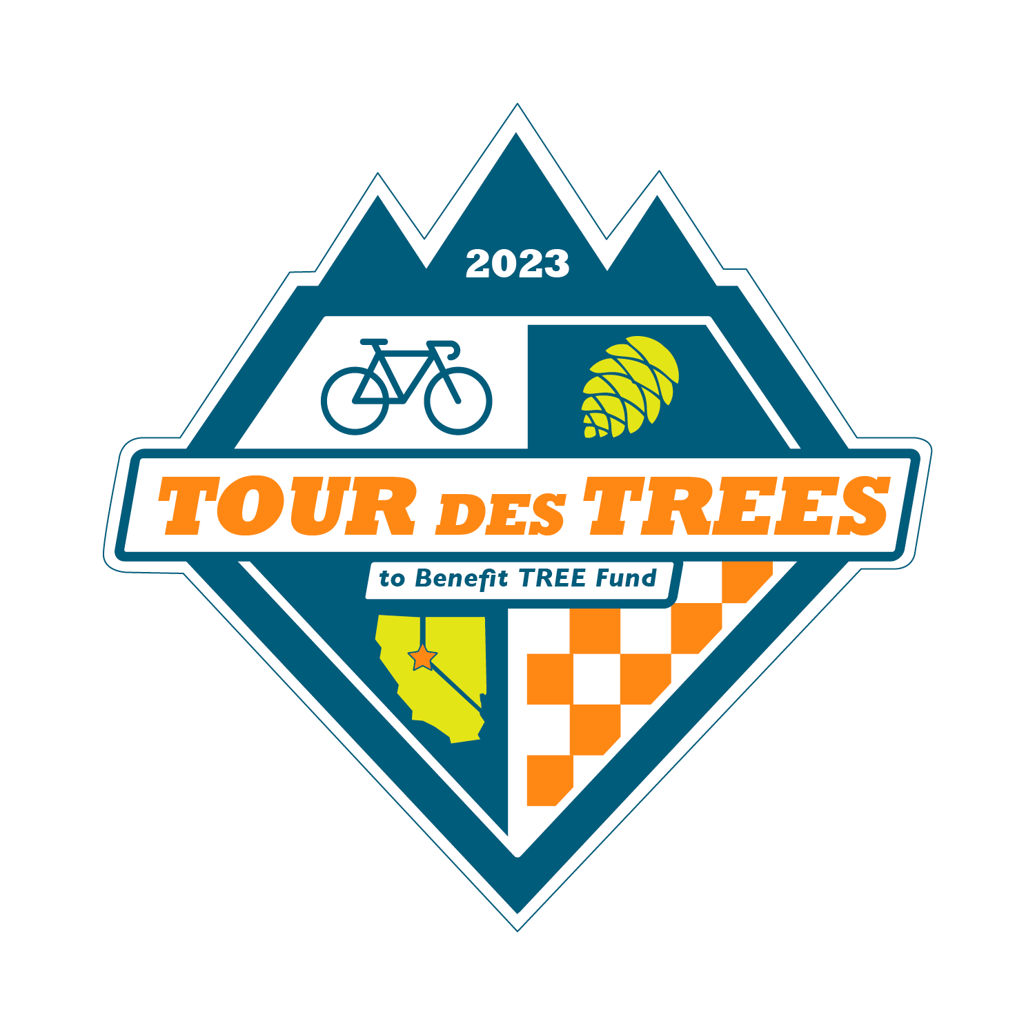

2023 Tour des Trees Itinerary
(Updated 8/16/23)

Tues 9/26 Reno, NV

12:00 - 4:00 p.m. Rider check-in and apparel pick-up
Hotel- Whitney Peak Hotel, 255 N Virginia St, Reno, NV 89501

2:00 – 3:00 p.m. Pre-ride Activity: Self-guided tour and staff meet-and-greet
May Arboretum, 1595 N Sierra St., Reno, NV 89503

2:00 – 3:00 p.m. Pre-ride Activity: Professor Pricklethorn Presentation
St. Albert the Great Catholic School, 1255 St. Alberts Drive, Reno, NV 89503

5:00 p.m. Rider Orientation Meeting
Hotel- Whitney Peak Hotel, 255 N Virginia St, Reno, NV 89501

6:30 p.m. Reception/Welcome Dinner
Hotel- Whitney Peak Hotel, 255 N Virginia St, Reno, NV 89501

Hotel: Hotel- Whitney Peak Hotel, 255 N Virginia St, Reno, NV 89501
Hotel website: www.whitneypeakhotel.com

Wed 9/27 Reno, NV to South Lake Tahoe – 61 Miles

6:00 - 7:15 a.m. Breakfast
Whitney Peak Hotel

9:00 a.m. Tour Kickoff Event, tree planting, and departure
Reno, NV

TBA a.m. Aid Station Location
Mile 22 Sky Tavern Ski Area, 21130 Sky Tavern Rd, Reno, NV 89511

TBA a.m. Lunch Stop Location
Mile 48 Spooner Lake State Park, Hwy 28, Incline Village, NV

TBA a.m. Aid Station & Information Stop with Society of American Foresters
Mile 57 Zephyr Cove, 880 Hwy 50, Zephyr Cove, NV

TBA p.m. Hotel: Hard Rock Hotel
Mile 61 50 Hwy 50, Stateline, NV 89449

4:45 p.m. Walk to tree planting, hosted by Liberty Utilities
Van Sickle Bi-State Park, 30 Lake Parkway, South Lake Tahoe, CA

6:00 p.m. Dinner
Hard Rock Hotel

Thurs 9/28 South Lake Tahoe to Murphys, CA – 107 Miles

6:00 - 7:15 a.m. Breakfast
Hard Rock Hotel

8:00 a.m. Ride depart

8:45 a.m.- 9:30am Tree plantings with the Sugar Pine Foundation
Mile 9 Meyers, CA- Location TBD

TBA a.m. Aid Station and presentation from Alpine Watershed Group
Mile 34 Turtle Rock Park, 17300 CA-89, Markleeville, CA 96120

TBA a.m. Aid Station (roadside)
Mile 57 Hermit Valley area, Arnold, CA (Across from Hermit Valley Monument sign)

TBA a.m. Lunch Stop
Mile 66 Lake Alpine Lodge, 4000 CA-4, Bear Valley, CA 95223

TBA a.m. Aid Station Location
Mile 89 Calaveras Big Trees State Park, 1170 CA-4, Arnold, CA 95223

TBA p.m. Hotel: Murphys Suites
Mile 107 134 CA-4, Murphys, CA 95247

6:00 p.m. Dinner- Sponsored by Vermeer
Outer Aisle Catering, 164 CA-4, Murphys, CA 95247

7:00 p.m. Vermeer Olympics Night
Sponsored by Vermeer

Fri 9/29 Murphys, CA to Modesto, CA – 77 Miles

6:00 - 7:15 a.m. Breakfast
Outer Aisle Catering, 164 CA-4, Murphys, CA 95247

8:00 a.m. Ride depart- Team Jersey Day!

TBA a.m. Lunch Location and Tree Planting- Sponsored by SavATree
Mile 39 Knights Ferry Rec Area, 17968 Covered Bridge Rd, Oakdale, CA, 95361

TBA a.m. Aid Station
Mile 62 Jacob Myers Park, 23655 S Santa Fe Rd, Riverbank, CA, 95367

3:00 – 5:00 p.m. Tree Care Industry Job Fair
Modesto Junior College- East Campus Ag Dept, College Ave & Coldwell Ave, Modesto, CA 95350

TBA p.m. Hotel: DoubleTree Hotel
Mile 77 1150 9th St, Modesto, CA 95354

6:00 p.m. Wrap-up Evening Meeting
DoubleTree lobby area

Anytime “On Your Own” Night
Please enjoy one of the local restaurants Modesto has to offer

Sat 9/30 Modesto, CA to San Jose, CA – 97 Miles

6:00 - 7:15 a.m. Breakfast
DoubleTree Hotel

8:00 a.m. Ride depart

TBA p.m. Aid Station and Prof. Pricklethorn presentation (10:30)
Mile 25 Patterson Public Library, 46 N. Salado Ave, Patterson, CA 95363

TBA p.m. Aid Station
Mile 44 Frank Raines Regional Park, Del Puerto Canyon Rd, Patterson, CA

TBA p.m. Lunch- Sponsored by The Davey Tree Expert Company
Mile 53 The Junction, 47300 Mines Rd, Livermore, CA 94550

TBA a.m. Aid Station
Mile 63 Lick Observatory, 7281 Mt. Hamilton Rd, Mt. Hamilton, CA

TBA a.m. Get together, tour, and Prof. Pricklethorn presentation
Mile 90 California Native Gardens, 76 Race Street, San Jose, CA

TBA p.m. Hotel: Holiday Inn Silicon Valley/ Airport
Mile 97 1350 N. 1st Street, San Jose, CA 95112

6:00 p.m. Dinner- Sponsored by Western Chapter ISA
Holiday Inn Silicon Valley/ Airport

Sun 10/1 San Jose, CA to Half Moon Bay, CA– 65 Miles

6:00 - 7:15 a.m. Breakfast
Holiday Inn Silicon Valley/ Airport

8:00 a.m. Ride depart

9:00 – 10:00 a.m. Aid Station
Mile 10 Bartlett Tree Experts, 882 Camden Ave, Campbell, CA 95008

TBA Aid Station
Mile 29 Russian Ridge parking lot, 3901 Alpine Rd, La Honda, CA

Noon – 2:00 p.m. Lunch- Sponsored by Bartlett Tree Experts
Mile 47 Arcangeli Grocery, 287 Stage Road, Pescadero, CA 94060

TBA p.m. Hotel: Half Moon Bay Lodge
Mile 65 2400 Cabrillo Hwy S, Half Moon Bay, CA 94019

6:00 p.m. Dinner
Half Moon Bay Lodge

Mon 10/2 Half Moon Bay, CA

8:00 - 9:00 a.m. Breakfast
At hotel: Half Moon Bay Lodge
TBA a.m. Depart for airport (San Francisco Airport)

TBA a.m. Depart in shuttles back to Reno

