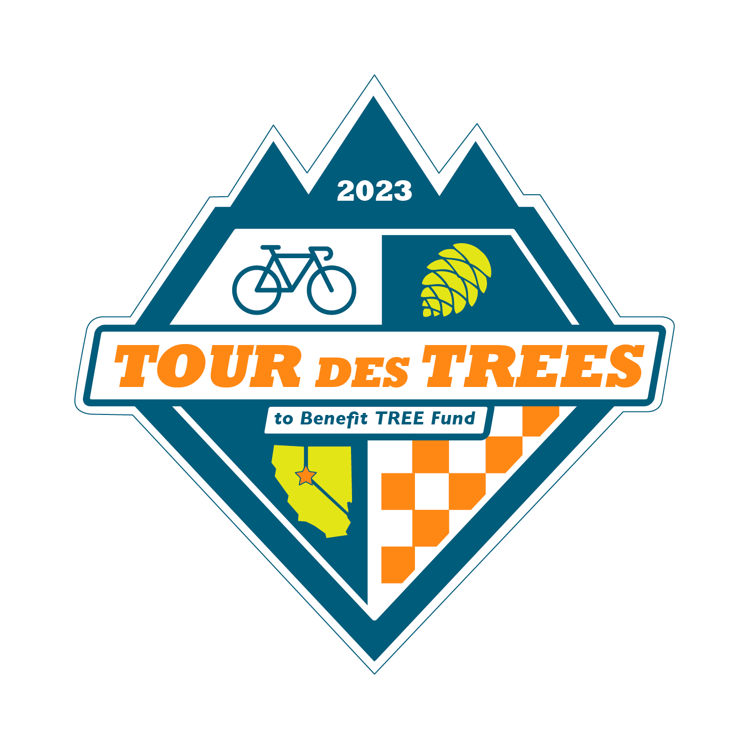

2023 Tour des Trees Itinerary
(Updated 9/20/23)

Tues 9/26 Reno, NV

12:00 - 4:00 p.m. Rider check-in and apparel pick-up
Hotel- Whitney Peak Hotel, 255 N Virginia St, Reno, NV 89501

2:00 – 3:00 p.m. Pre-ride Activity: Self-guided tour and staff meet-and-greet
May Arboretum, 1595 N Sierra St., Reno, NV 89503

2:00 – 3:00 p.m. Pre-ride Activity: Professor Pricklethorn Presentation
St. Albert the Great Catholic School, 1255 St. Alberts Drive, Reno, NV 89503

5:00 p.m. Rider Orientation Meeting
Hotel- Whitney Peak Hotel, 255 N Virginia St, Reno, NV 89501

6:30 p.m. Reception/Welcome Dinner
Hotel- Whitney Peak Hotel, 255 N Virginia St, Reno, NV 89501

Hotel: Hotel- Whitney Peak Hotel, 255 N Virginia St, Reno, NV 89501
Hotel website: www.whitneypeakhotel.com

Wed 9/27 Reno, NV to South Lake Tahoe – 61 Miles

6:00 - 7:15 a.m. Breakfast
Whitney Peak Hotel

9:00 a.m. Tour Kickoff Event, tree planting, and departure
Reno, NV

10:55- 11:45 a.m. Aid Station Location
Mile 22 Sky Tavern Ski Area, 21130 Sky Tavern Rd, Reno, NV 89511

12:35- 2:05 p.m. Lunch Stop Location
Mile 48 Spooner Lake State Park, Hwy 28, Incline Village, NV

1:30- 3:10 p.m. Aid Station & Information Stop with Society of American Foresters
Mile 55 Zephyr Cove, 880 Hwy 50, Zephyr Cove, NV

2:00-3:30 p.m. Hotel: Hard Rock Hotel
Mile 61 50 Hwy 50, Stateline, NV 89449

4:45 p.m. Walk to tree planting, hosted by Liberty Utilities
Van Sickle Bi-State Park, 30 Lake Parkway, South Lake Tahoe, CA

6:00 p.m. Dinner
Hard Rock Hotel

Thurs 9/28 South Lake Tahoe to Murphys, CA – 107 Miles

6:00 - 7:15 a.m. Breakfast
Hard Rock Hotel

8:00 a.m. Ride depart

8:20- 8:30 a.m. Tree plantings with the Sugar Pine Foundation
Mile 6 Pullout on Pioneer Trail, Meyers, CA

10:00 – 10:35 a.m. Aid Station and presentation from Alpine Watershed Group
Mile 31 Turtle Rock Park, 17300 CA-89, Markleeville, CA 96120

12:20- 1:55 p.m. Aid Station (roadside)
Mile 60 Hermit Valley area, Arnold, CA (Across from Hermit Valley Monument sign)

1:10 – 3:10 p.m. Lunch Stop
Mile 68 Lake Alpine Lodge, 4000 CA-4, Bear Valley, CA 95223

2:55- 4:45 p.m. Aid Station Location
Mile 92 Calaveras Big Trees State Park, 1170 CA-4, Arnold, CA 95223

3:25- 5:30 p.m. Hotel: Murphys Suites
Mile 107 134 CA-4, Murphys, CA 95247

6:00 p.m. Dinner- Sponsored by Vermeer
Outer Aisle Catering, 164 CA-4, Murphys, CA 95247

7:00 p.m. Vermeer Olympics Night
Sponsored by Vermeer

Fri 9/29 Murphys, CA to Modesto, CA – 77 Miles

6:00 - 7:15 a.m. Breakfast
Outer Aisle Catering, 164 CA-4, Murphys, CA 95247

8:30 a.m. Ride depart- Team Jersey Day!

9:30- 9:50 p.m. Aid Station
Mile 15 Alley Tree & Landscaping, 31265 Shaws Flat Rd., Sonora, CA 95370

11:10- 11:55 a.m. Lunch Location and Tree Planting- Sponsored by SavATree
Mile 42 Knights Ferry Rec Area, 17968 Covered Bridge Rd, Oakdale, CA, 95361

12:45- 1:50 p.m. Aid Station
Mile 63 Jacob Myers Park, 23655 S Santa Fe Rd, Riverbank, CA, 95367

3:00- 5:00 p.m. Tree Care Industry Job Fair (1.1 mile walk from hotel)
Modesto Junior College- East Campus Ag Dept, College Ave & Coldwell Ave, Modesto, CA 95350

1:50- 3:05 p.m. Hotel: DoubleTree Hotel
Mile 77 1150 9th St, Modesto, CA 95354

6:00 p.m. Wrap-up Evening Meeting
DoubleTree lobby area

Anytime “On Your Own” Night
Please enjoy one of the local restaurants Modesto has to offer

Sat 9/30 Modesto, CA to San Jose, CA – 99 Miles

6:00 - 7:15 a.m. Breakfast
DoubleTree Hotel

8:00 a.m. Ride depart

9:25- 9:45 p.m. Aid Station and Prof. Pricklethorn presentation (10:30)
Mile 25 Patterson Public Library, 46 N. Salado Ave, Patterson, CA 95363

11:00- 11:50 a.m. Aid Station
Mile 45 Frank Raines Regional Park, Del Puerto Canyon Rd, Patterson, CA

Noon- 1:20 p.m. Lunch- Sponsored by The Davey Tree Expert Company
Mile 53 The Junction, 47300 Mines Rd, Livermore, CA 94550

2:15- 4:40 p.m. Aid Station
Mile 71 Lick Observatory, 7281 Mt. Hamilton Rd, Mt. Hamilton, CA

3:50- 5:35 p.m. Hotel: Holiday Inn Silicon Valley/ Airport
Mile 99 1350 N. 1st Street, San Jose, CA 95112

6:00 p.m. Dinner- Sponsored by Western Chapter ISA
Holiday Inn Silicon Valley/ Airport

Sun 10/1 San Jose, CA to Half Moon Bay, CA– 65 Miles

6:00 - 7:15 a.m. Breakfast
Holiday Inn Silicon Valley/ Airport

8:00 a.m. Tree Planting Ceremony
Holiday Inn Silicon Valley/ Airport

8:30 a.m. Ride depart

9:00 – 9:15 a.m. Aid Station
Mile 9 Bartlett Tree Experts, 882 Camden Ave, Campbell, CA 95008

11:05- 11:55 Aid Station
Mile 30 Russian Ridge parking lot, 3901 Alpine Rd, La Honda, CA

Noon – 1:15 p.m. Lunch- Sponsored by Bartlett Tree Experts
Mile 49 Arcangeli Grocery, 287 Stage Road, Pescadero, CA 94060

1:20- 2:50 p.m. Hotel: Half Moon Bay Lodge
Mile 65 2400 Cabrillo Hwy S, Half Moon Bay, CA 94019

6:00 p.m. Dinner
Half Moon Bay Lodge

Mon 10/2 Half Moon Bay, CA

7:00 a.m. Breakfast
At hotel: Half Moon Bay Lodge
7:00 a.m. Depart for airport (San Francisco Airport)
(*or earlier)

8:00 a.m. Depart in shuttles back to Reno
(*or earlier)

