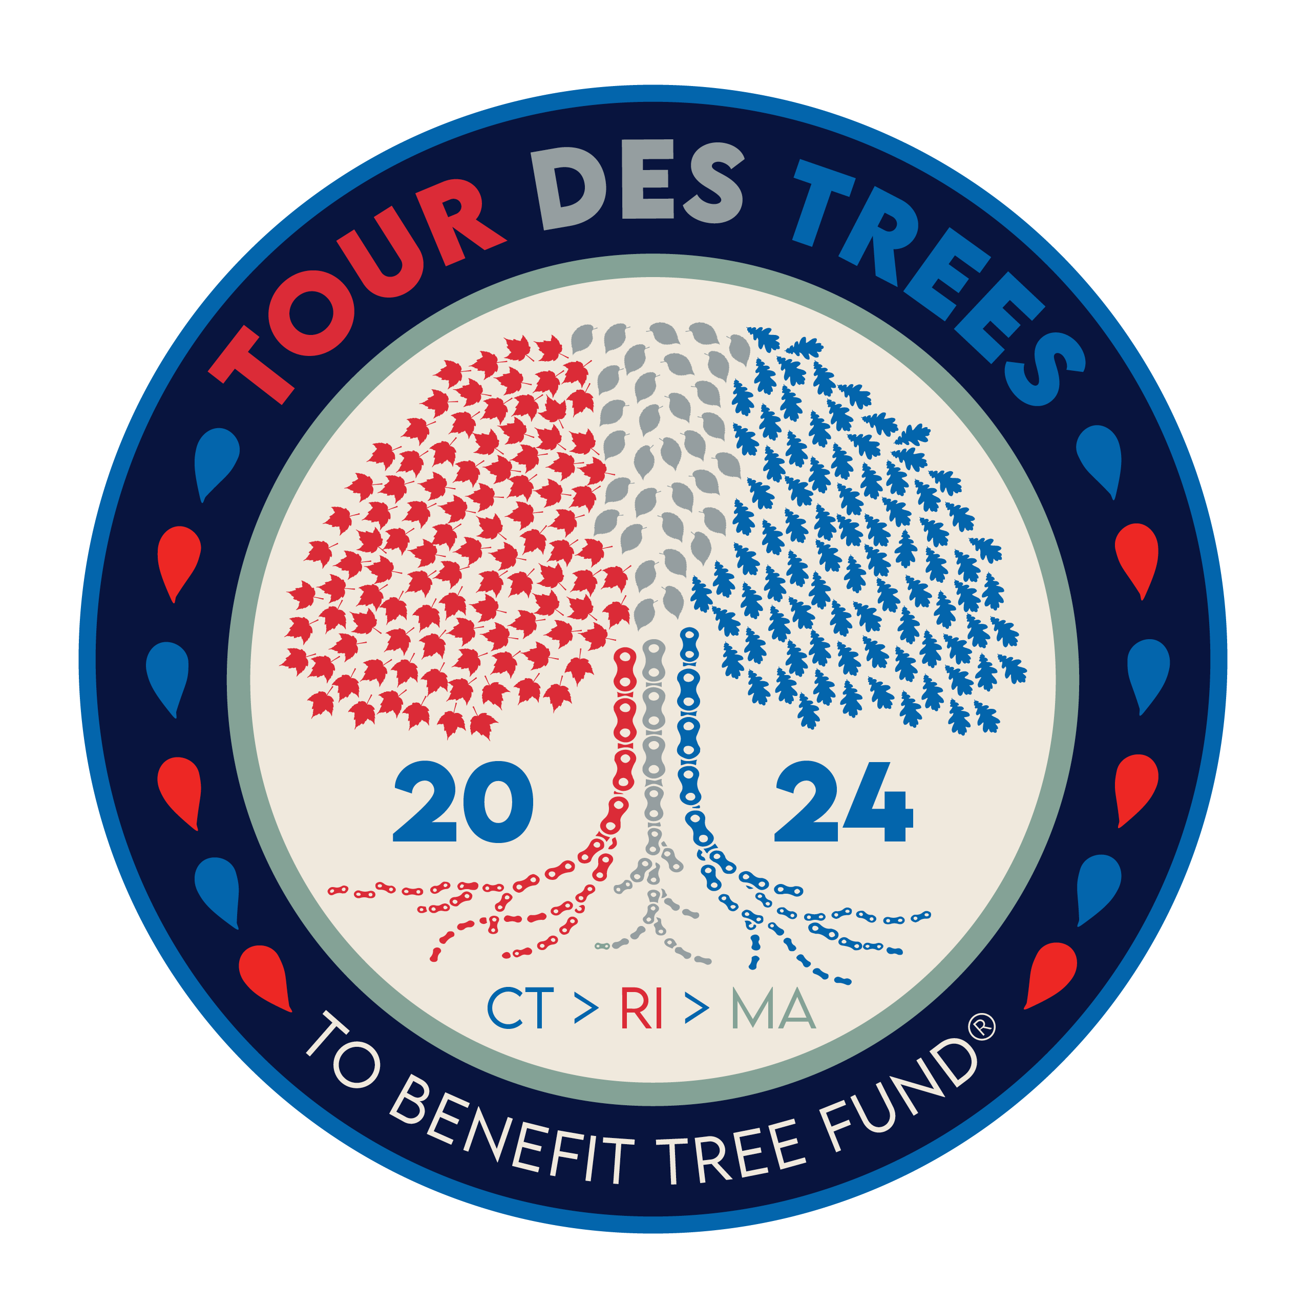

2024 Tour des Trees Itinerary
(Updated 1/29/24)

Sun 9/22 Stamford, CT

12:00 - 4:00 p.m. Rider check-in and apparel pick-up
Hotel- TBA

5:00 p.m. Rider Orientation Meeting
TBA

6:30 p.m. Reception/Welcome Dinner
Bartlett Arboretum and Gardens, 151 Brookdale Rd, Stamford, CT 06903

Hotel: Hotel- TBA

Mon 9/23 Stamford, CT to Middletown, CT – 82 miles

6:00 - 7:15 a.m. Breakfast
Hotel

8:00 a.m. Ride Depart
Stamford, CT

TBD p.m. Hotel: TBA
Mile 82 Middletown, CT

6:00 p.m. Dinner
TBA

Tues 9/24 Middletown, CT to Smithfield, RI – 82 miles

6:00 - 7:15 a.m. Breakfast
Hotel

8:00 a.m. Ride depart
TBD p.m. Hotel: TBA
Mile 82 Smithfield, RI

6:00 p.m. Dinner
TBA

Wed 9/25 Smithfield, RI to Falmouth, MA – 78 Miles

6:00 - 7:15 a.m. Breakfast
Hotel

8:00 a.m. Ride depart

TBD p.m. Hotel: TBA
Mile 78 Falmouth, MA

6:00 p.m. Dinner
TBA

Thurs 9/26 Martha’s Vineyard loop – 73 miles

6:00 - 7:15 a.m. Breakfast
Hotel

8:00 a.m. Ride depart/ Depart for ferries

TBD p.m. Back to ferries
Mile 73

TBA p.m. Hotel: TBA
Mile 99 Falmouth, MA

6:00 p.m. Dinner
TBA

Fri 9/27 Falmouth, MA to Providence, RI – 103 Miles

6:00 - 7:15 a.m. Breakfast
TBA

8:00 a.m. Ride depart

TBD p.m. Hotel: Half Moon Bay Lodge
Mile 103 Providence, RI

6:00 p.m. Dinner and Closing Ceremonies
TBA

Sat 9/28 Providence, RI

6:00 -7:00 a.m. Breakfast
Hotel
TBA a.m. Depart in shuttles back to Stamford, CT

