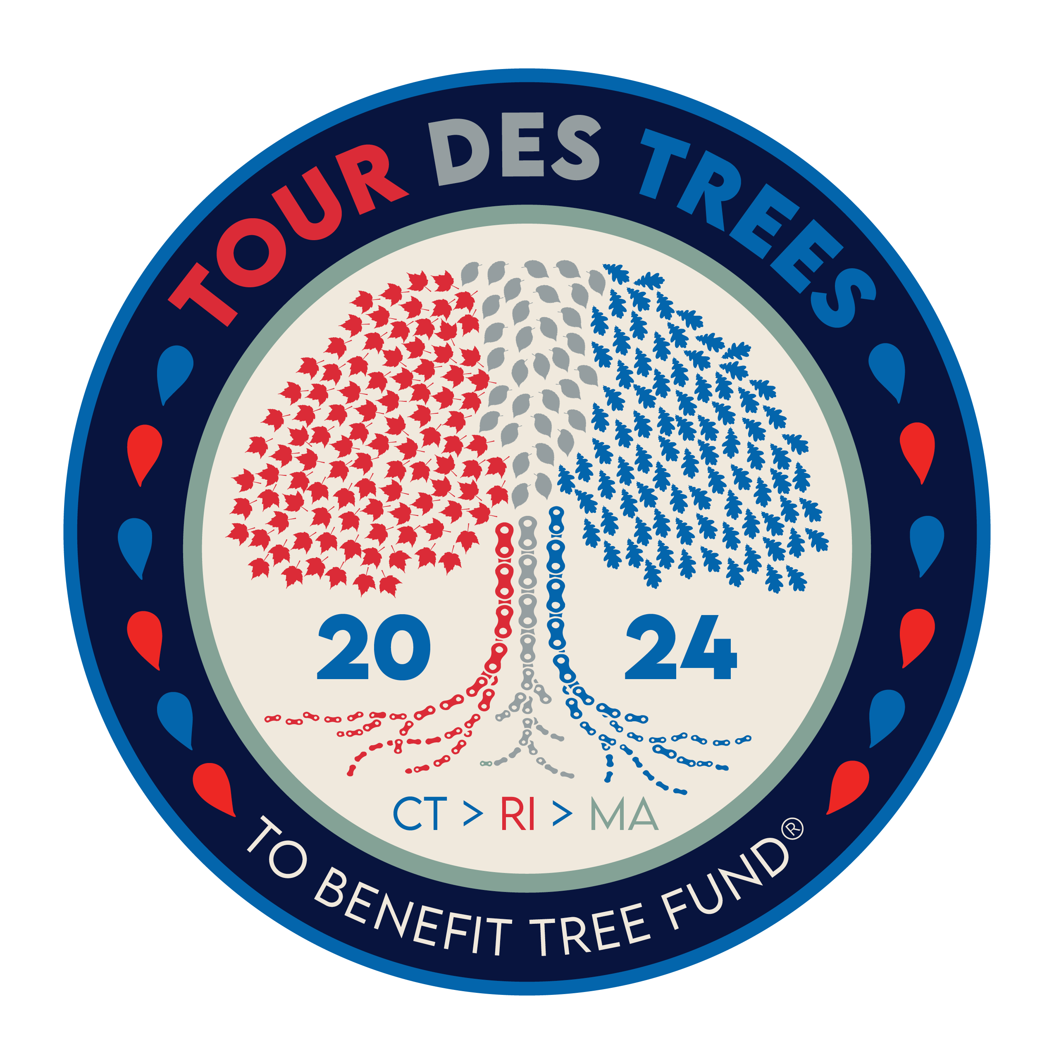

2024 Tour des Trees Itinerary
(Updated 3/15/24)

Sun 9/22 Stamford, CT

10:30 a.m.- 3:30 p.m. Rider check-in and apparel pick-up
Hotel- Marriott Stamford, 243 Tresser Blvd, Stamford, CT 06901

Noon- 4:00 p.m. Tours and activities at Bartlett Arboretum and Gardens
151 Brookdale, Rd, Stamford, CT 06903

4:30 p.m. Shuttle bus departs hotel for Arboretum.
* All riders must take bus to Arboretum.

5:00 p.m. Rider Orientation meeting
Bartlett Arboretum

6:00 p.m. Tree planting and presentations

6:30 p.m. Reception/Welcome Dinner
Bartlett Arboretum and Gardens, 151 Brookdale Rd, Stamford, CT 06903

8:00 p.m. Shuttle bus back to hotel

Hotel: Hotel- Marriott Stamford, 243 Tresser Blvd, Stamford, CT 06901

Mon 9/23 Stamford, CT to Middletown, CT – 82 miles

6:00 - 7:15 a.m. Breakfast
Hotel

8:00 a.m. Ride Depart
Stamford, CT

TBD p.m. Hotel: TBA
Mile 82 Middletown, CT

6:00 p.m. Dinner
TBA

Tues 9/24 Middletown, CT to Smithfield, RI – 82 miles

6:00 - 7:15 a.m. Breakfast
Hotel

8:00 a.m. Ride depart
TBD p.m. Hotel: TBA
Mile 82 Smithfield, RI

6:00 p.m. Dinner
TBA

Wed 9/25 Smithfield, RI to Falmouth, MA – 78 Miles

6:00 - 7:15 a.m. Breakfast
Hotel

8:00 a.m. Ride depart

TBD p.m. Lunch: UMass Cranberry Station
Mile 60 1 State Bog Rd, East Wareham, MA 02538

TBD p.m. Hotel: TBA
Mile 78 Falmouth, MA

6:00 p.m. Dinner
TBA

Thurs 9/26 Martha’s Vineyard loop – 73 miles

6:00 - 7:15 a.m. Breakfast
Hotel

8:00 a.m. Ride depart/ Depart for ferries

TBD a.m. Aid station/ Tour
Mile 18 Poly Hill Arboretum, 809 State Rd, West Tisbury, MA 02575

TBD p.m. Back to ferries
Mile 73

TBA p.m. Hotel: TBA
Mile 99 Falmouth, MA

6:00 p.m. Dinner
TBA

Fri 9/27 Falmouth, MA to Providence, RI – 103 Miles

6:00 - 7:15 a.m. Breakfast
TBA

8:00 a.m. Ride depart

TBD p.m. Lunch
Mile 60 Apponagansett Park, 75 Gulf Rd, Dartmouth, MA 02748

TBD p.m. Hotel: Half Moon Bay Lodge
Mile 103 Providence, RI

6:00 p.m. Dinner and Closing Ceremonies
TBA

Sat 9/28 Providence, RI

6:00 -7:00 a.m. Breakfast
Hotel
TBA a.m. Depart in shuttles back to Stamford, CT

