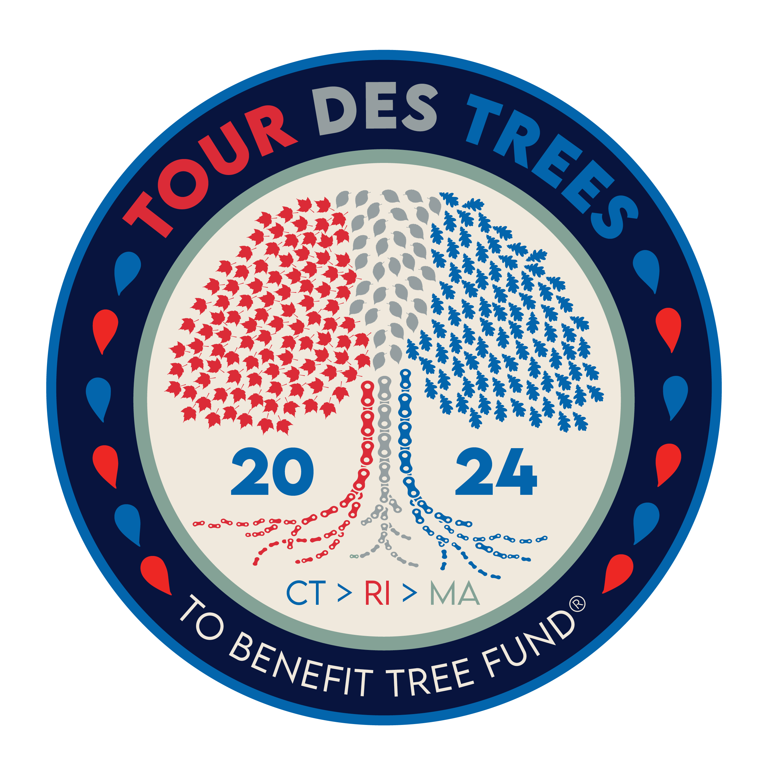

2024 Tour des Trees Itinerary
(Updated 8/29/24)

Sun 9/22 Stamford, CT

10:30 a.m.- 3:30 p.m. Rider check-in and apparel pick-up
Hotel- Marriott Stamford, 243 Tresser Blvd, Stamford, CT 06901

Noon- 4:00 p.m. Tours and activities at Bartlett Arboretum and Gardens
151 Brookdale, Rd, Stamford, CT 06903
- Tours are on rolling basis of grounds and farmhouse

4:30 p.m. Shuttle bus departs hotel for Arboretum.
* All riders must take bus to Arboretum.

5:00 p.m. Rider Orientation meeting
Bartlett Arboretum

6:00 p.m. Tree planting and presentations

6:30 p.m. Reception/Welcome Dinner
Bartlett Arboretum and Gardens, 151 Brookdale Rd, Stamford, CT 06903

8:00 p.m. Shuttle bus back to hotel

Hotel: Hotel- Marriott Stamford, 243 Tresser Blvd, Stamford, CT 06901

Mon 9/23 Stamford, CT to Middletown, CT – 82 miles

6:00 - 7:15 a.m. Breakfast
Hotel

8:00 a.m. Tree planting and dedication for Dick Maloney and Group Photo
St. John’s Park, corner of Elm Street and Main Street, Stamford, CT

8:15 a.m. Ride Depart
Stamford, CT

TBD a.m. Aid station
Mile 25 Mark Twain Library, 439 Redding Rd, Redding, CT 06896

10:00 a.m. Professor Pricklethorn Presentation
Redding Elementary School, 33 Lonetown Rd., Redding, CT 06896

TBD a.m. Lunch
Mile 51 Cornerstone Church, 656 Oxford Rd, Oxford, CT 06478

TBD a.m. Aid station
Mile 74 Kohler Environmental Center (Choate Rosemary Hall Boarding School), 889 Old Durham Rd, Wallingford, CT 06492

2:00 p.m. Educational Event: Panel on Utility Forestry
CT Forest and Parks Association building, 16 Meriden Rd, Rockfall, CT 06481

TBD p.m. Hotel: Inn at Middletown
Mile 82 70 Main Street, Middletown, CT 06457

6:00 p.m. Dinner- Sponsored by Vermeer
Inn at Middletown, 70 Main Street, Middletown, CT 06457

7:45 p.m. Meditation Class
Lead by Dr. Hallie Dozier

Tues 9/24 Middletown, CT to Smithfield, RI – 82 miles

6:00 - 7:15 a.m. Breakfast
Hotel

8:00 a.m. Ride depart

9:30 a.m. Professor Pricklethorn Rally
MacDonough Elementary School, 66 Spring Street, Middletown, CT 06457

9:15 – 10:00 a.m. Aid Station
Mile 21 Church Street lot on Air Line Trail, south of Church Street & North Pond Rd intersection, Hebron, CT

Noon- 1:30 p.m. Lunch
Mile 52 Killingly Community Center, 185 Broad Street, Killingly, CT 06239

1:30 p.m. Professor Pricklethorn Rally
Horace W Porter School, 3 Schoolhouse Rd, Columbia, CT 06237

4:30 p.m. Aid Station and Professor Pricklethorn Rally
Mile 80 Greenville Public Library, 573 Putnam Pike, Greenville, RI 02828

TBD p.m. Hotel: Two sites
Mile 82 Hampton Inn & Suites, 945 Douglas Pike, Smithfield, RI 02917
Home2 Suites, 944 Douglas Pike, Smithfield, RI 02917

6:00 p.m. Dinner- Sponsored by Stanley Tree Service
Tavolo Wine Bar, 970 Douglas Pike, Smithfield, RI 02917

Wed 9/25 Smithfield, RI to Falmouth, MA – 78 Miles

6:00 - 7:15 a.m. Breakfast
Hotel

8:00 a.m. Ride depart

TBD p.m. Aid Station
Mile 20 Shelter Tree, 195 John L Dietsch Square, North Attleborough, MA 02763

TBD p.m. Aid Station and Tree Planting
Mile 31 Bristol County Agricultural HS, 135 Center St, Dighton, MA 02715

TBD p.m. Lunch: UMass Cranberry Station sponsored by Jeffrey Hamilton, MASS ISA Certified Arborist (retired)
Mile 60 1 State Bog Rd, East Wareham, MA 02538

TBD p.m. Aid Station and community event with Saluting Branches
Mile 73 Bourne Community Center, 239 Main St., Buzzards Bay, MA 02532

TBD p.m. “Aid Station” Rider Get-together
Mile 85 Paul Sellers’s house

TBD p.m. Hotel: Holiday Inn
Mile 90 291 Jones Rd., Falmouth, MA 02540

Evening Dinner- “On Your Own” Night

Thurs 9/26 Martha’s Vineyard loop – 73 miles

6:00 - 7:15 a.m. Breakfast Sponsored by SavATree
Hotel

8:00 a.m. Ride depart/ Depart for ferries- Ferry ride sponsored by SavATree

TBD a.m. Aid station/ Tour
Mile 18 Poly Hill Arboretum, 809 State Rd, West Tisbury, MA 02575

11:30a.m.- 1:30pm Lunch Sponsored by SavATree
Mile 51 West Tisbury Public Library, 1042 State Rd, West Tisbury, MA 02575

TBD p.m. Back to ferries
Mile 73

TBA p.m. Hotel: Holiday Inn
Mile 73 291 Jones Rd., Falmouth, MA 02540

6:00 p.m. Dinner Sponsored by SavATree
Holiday Inn, 291 Jones Rd, Falmouth, MA 02540

Fri 9/27 Falmouth, MA to Providence, RI – 103 Miles

6:00 - 7:15 a.m. Breakfast
TBA

8:00 a.m. Ride depart

TBD p.m. Aid Station
Mile 18 Buzzards Bay Park, 33 Canal Service Rd, Buzzards Bay, MA 02532

TBD p.m. Lunch
Mile 47 Apponagansett Park, 75 Gulf Rd, Dartmouth, MA 02748

TBD p.m. Aid Station and Tours
Mile 52 Lloyd Center for the Environment, 430 Potomska Rd, South Dartmouth, MA 02748

TBD p.m. Closing Tree Planting
Mile 103 60 Cogdon Street, Providence, RI

TBD p.m. Hotel: Providence Marriott Downtown
Mile 103 1 Orms Street, Providence, RI, 02904

6:00 p.m. Dinner and Closing Ceremonies- Sponsored by New England ISA
Providence Marriott Downtown, 1 Orms Street, Providence, RI 02904

Sat 9/28 Providence, RI

6:00 -7:00 a.m. Breakfast
Hotel
TBA a.m. Depart in shuttles back to Stamford, CT

