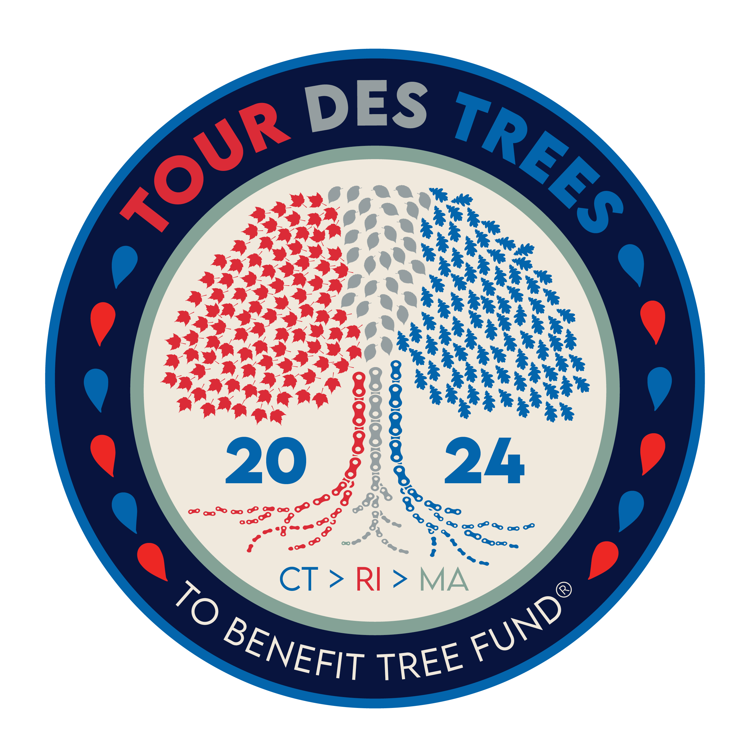

2024 Tour des Trees Itinerary
(Updated 9/18/24)

Sun 9/22 Stamford, CT

10:30 a.m.- 3:30 p.m. Rider check-in and apparel pick-up
Hotel- Marriott Stamford, 243 Tresser Blvd, Stamford, CT 06901

Noon- 4:00 p.m. Tours and activities at Bartlett Arboretum and Gardens
151 Brookdale, Rd, Stamford, CT 06903
- Tours are at 12:30 and 2:30
- Pricklethorn presentation at 1:30

4:30 p.m. Shuttle bus departs hotel for Arboretum.
* All riders must take bus to Arboretum.

5:00 p.m. Rider Orientation meeting
Bartlett Arboretum

6:00 p.m. Tree planting and presentations

6:30 p.m. Reception/Welcome Dinner
Bartlett Arboretum and Gardens, 151 Brookdale Rd, Stamford, CT 06903

8:00 p.m. Shuttle bus back to hotel

Hotel: Hotel- Marriott Stamford, 243 Tresser Blvd, Stamford, CT 06901

Mon 9/23 Stamford, CT to Middletown, CT – 91 miles

6:00 - 7:15 a.m. Breakfast
Hotel

8:00 a.m. Tree planting and dedication for Dick Maloney and Group Photo
St. John’s Park, corner of Elm Street and Main Street, Stamford, CT

8:15 a.m. Ride Depart
Stamford, CT

10:00-10:45 a.m. Aid station
Mile 27 Mark Twain Library, 439 Redding Rd, Redding, CT 06896

10:00 a.m. Professor Pricklethorn Presentation
Redding Elementary School, 33 Lonetown Rd., Redding, CT 06896

Noon.- 1:20p.m. Lunch
Mile 58 Our Lady of Assumption Church, 81 Center Rd, Woodbridge, CT 06525

1:30-3:30 p.m. Aid station
Mile 77 Kohler Environmental Center (Choate Rosemary Hall Boarding School), 889 Old Durham Rd, Wallingford, CT 06492

2:00 p.m. Educational Event: Panel on Utility Forestry
CT Forest and Parks Association building, 16 Meriden Rd, Rockfall, CT 06481

2:30-4:45 p.m. Hotel: Inn at Middletown
Mile 91 70 Main Street, Middletown, CT 06457

6:00 p.m. Dinner- Sponsored by Vermeer
Inn at Middletown, 70 Main Street, Middletown, CT 06457

7:45 p.m. Meditation Class
Lead by Dr. Hallie Dozier

Tues 9/24 Middletown, CT to Smithfield, RI – 82 miles

6:00 - 7:15 a.m. Breakfast
Hotel

8:00 a.m. Ride depart

9:30 a.m. Professor Pricklethorn Rally
MacDonough Elementary School, 66 Spring Street, Middletown, CT 06457

9:00 – 9:30 a.m. Aid Station
Mile 17 Church Street lot on Air Line Trail, south of Church Street & North Pond Rd intersection, Hebron, CT

10:00- 11:00 a.m. Aid Station
Mile 30 Whitewater Park, 28 Bridge Street, Willimantic, CT

11:30am- 1:00 p.m. Lunch
Mile 53 Killingly Community Center, 185 Broad Street, Killingly, CT 06239

1:30 p.m. Professor Pricklethorn Rally
Horace W Porter School, 3 Schoolhouse Rd, Columbia, CT 06237

1:30- 3:30 p.m. Aid Station and Professor Pricklethorn Rally
Mile 77 Greenville Public Library, 573 Putnam Pike, Greenville, RI 02828

2:00- 4:10 p.m. Hotel: Two sites
Mile 82 Hampton Inn & Suites, 945 Douglas Pike, Smithfield, RI 02917
Home2 Suites, 944 Douglas Pike, Smithfield, RI 02917

6:00 p.m. Dinner- Sponsored by Stanley Tree Service
Tavolo Wine Bar, 970 Douglas Pike, Smithfield, RI 02917

Wed 9/25 Smithfield, RI to Falmouth, MA – 91 Miles

6:00 - 7:15 a.m. Breakfast
Hotel

8:00 a.m. Ride depart

9:10-9:35 a.m. Aid Station
Mile 19 Shelter Tree, 195 John L Dietsch Square, North Attleborough, MA 02763

10:30- 11:10 a.m. Aid Station and Tree Planting
Mile 37 Bristol County Agricultural HS, 135 Center St, Dighton, MA 02715

12:30- 2:15 p.m. Lunch and tree planting: UMass Cranberry Station sponsored by Jeffrey Hamilton, MASS ISA Certified Arborist (retired)
Mile 67 1 State Bog Rd, East Wareham, MA 02538

1:20- 3:00 p.m. Aid Station and community event with Saluting Branches
Mile 73 Bourne Community Center, 239 Main St., Buzzards Bay, MA 02532

2:40- 4:30 p.m. “Aid Station” Rider Get-together
Mile 87 Paul Sellers’s house

3:15- 5:15 p.m. Hotel: Holiday Inn
Mile 91 291 Jones Rd., Falmouth, MA 02540

Evening Dinner- “On Your Own” Night

Thurs 9/26 Martha’s Vineyard loop – 73 miles

6:45 a.m. Ride depart/ Depart for ferries
Breakfast at Ferry Terminal- Breakfast sponsored by SavATree

8:15 a.m. Ferry departs (8:15 ferry)- Ferry ride sponsored by SavATree
Mile 5 Woods Hole Ferry Terminal, 1 Cowdry Rd, Woods Hole, MA

9:00 a.m. Arrive at Vineyard Haven Ferry Terminal
Mile 13

9:50- 10:15 a.m. Aid station/ Tour
Mile 25 Poly Hill Arboretum, 809 State Rd, West Tisbury, MA 02575

11:45a.m.- 1:00pm Lunch Sponsored by SavATree
Mile 51 West Tisbury Public Library, 1042 State Rd, West Tisbury, MA 02575

1:30-3:00 p.m. Back to ferries (return ferry at 3:45pm)
Mile 71 Oak Bluff Ferry Terminal, 1 Water St, Vineyard Haven, MA

4:30 p.m. Arrive at Woods Hole Ferry Terminal
Mile 79

5:15-5:30 p.m. Hotel: Holiday Inn
Mile 88 291 Jones Rd., Falmouth, MA 02540

6:00 p.m. Dinner Sponsored by SavATree
Holiday Inn, 291 Jones Rd, Falmouth, MA 02540

Fri 9/27 Falmouth, MA to Providence, RI – 102 Miles

6:00 - 7:15 a.m. Breakfast
TBA

8:00 a.m. Ride depart

9:00- 9:10 a.m. Aid Station
Mile 18 Buzzards Bay Park, 33 Canal Service Rd, Buzzards Bay, MA 02532

10:15- 11:00 a.m. Aid Station
Mile 37 Roseland Nursery, 247 Main Street, Acushnet, MA 02743

11:00am- Noon Lunch and tree planting
Mile 47 Apponagansett Park, 75 Gulf Rd, Dartmouth, MA 02748

11:50am- 1:00p.m. Aid Station and Tours
Mile 52 Lloyd Center for the Environment, 430 Potomska Rd, South Dartmouth, MA 02748

1:20-3:15 p.m. Aid Station and tree planting (2:45pm)
Mile 79 Lafayette Park, 475 County Street, Fall River, MA 02723.

3:00- 5:20 p.m. Closing Tree Planting (4:30pm, Gather in hotel lobby at 4pm)
Mile 102 60 Cogdon Street, Providence, RI

TBD p.m. Hotel: Providence Marriott Downtown
Mile 102 1 Orms Street, Providence, RI, 02904

6:00 p.m. Dinner and Closing Ceremonies- Sponsored by New England ISA
Providence Marriott Downtown, 1 Orms Street, Providence, RI 02904

Sat 9/28 Providence, RI

7:00 a.m. Breakfast
Hotel
TBA a.m. Depart in shuttles back to Stamford, CT

