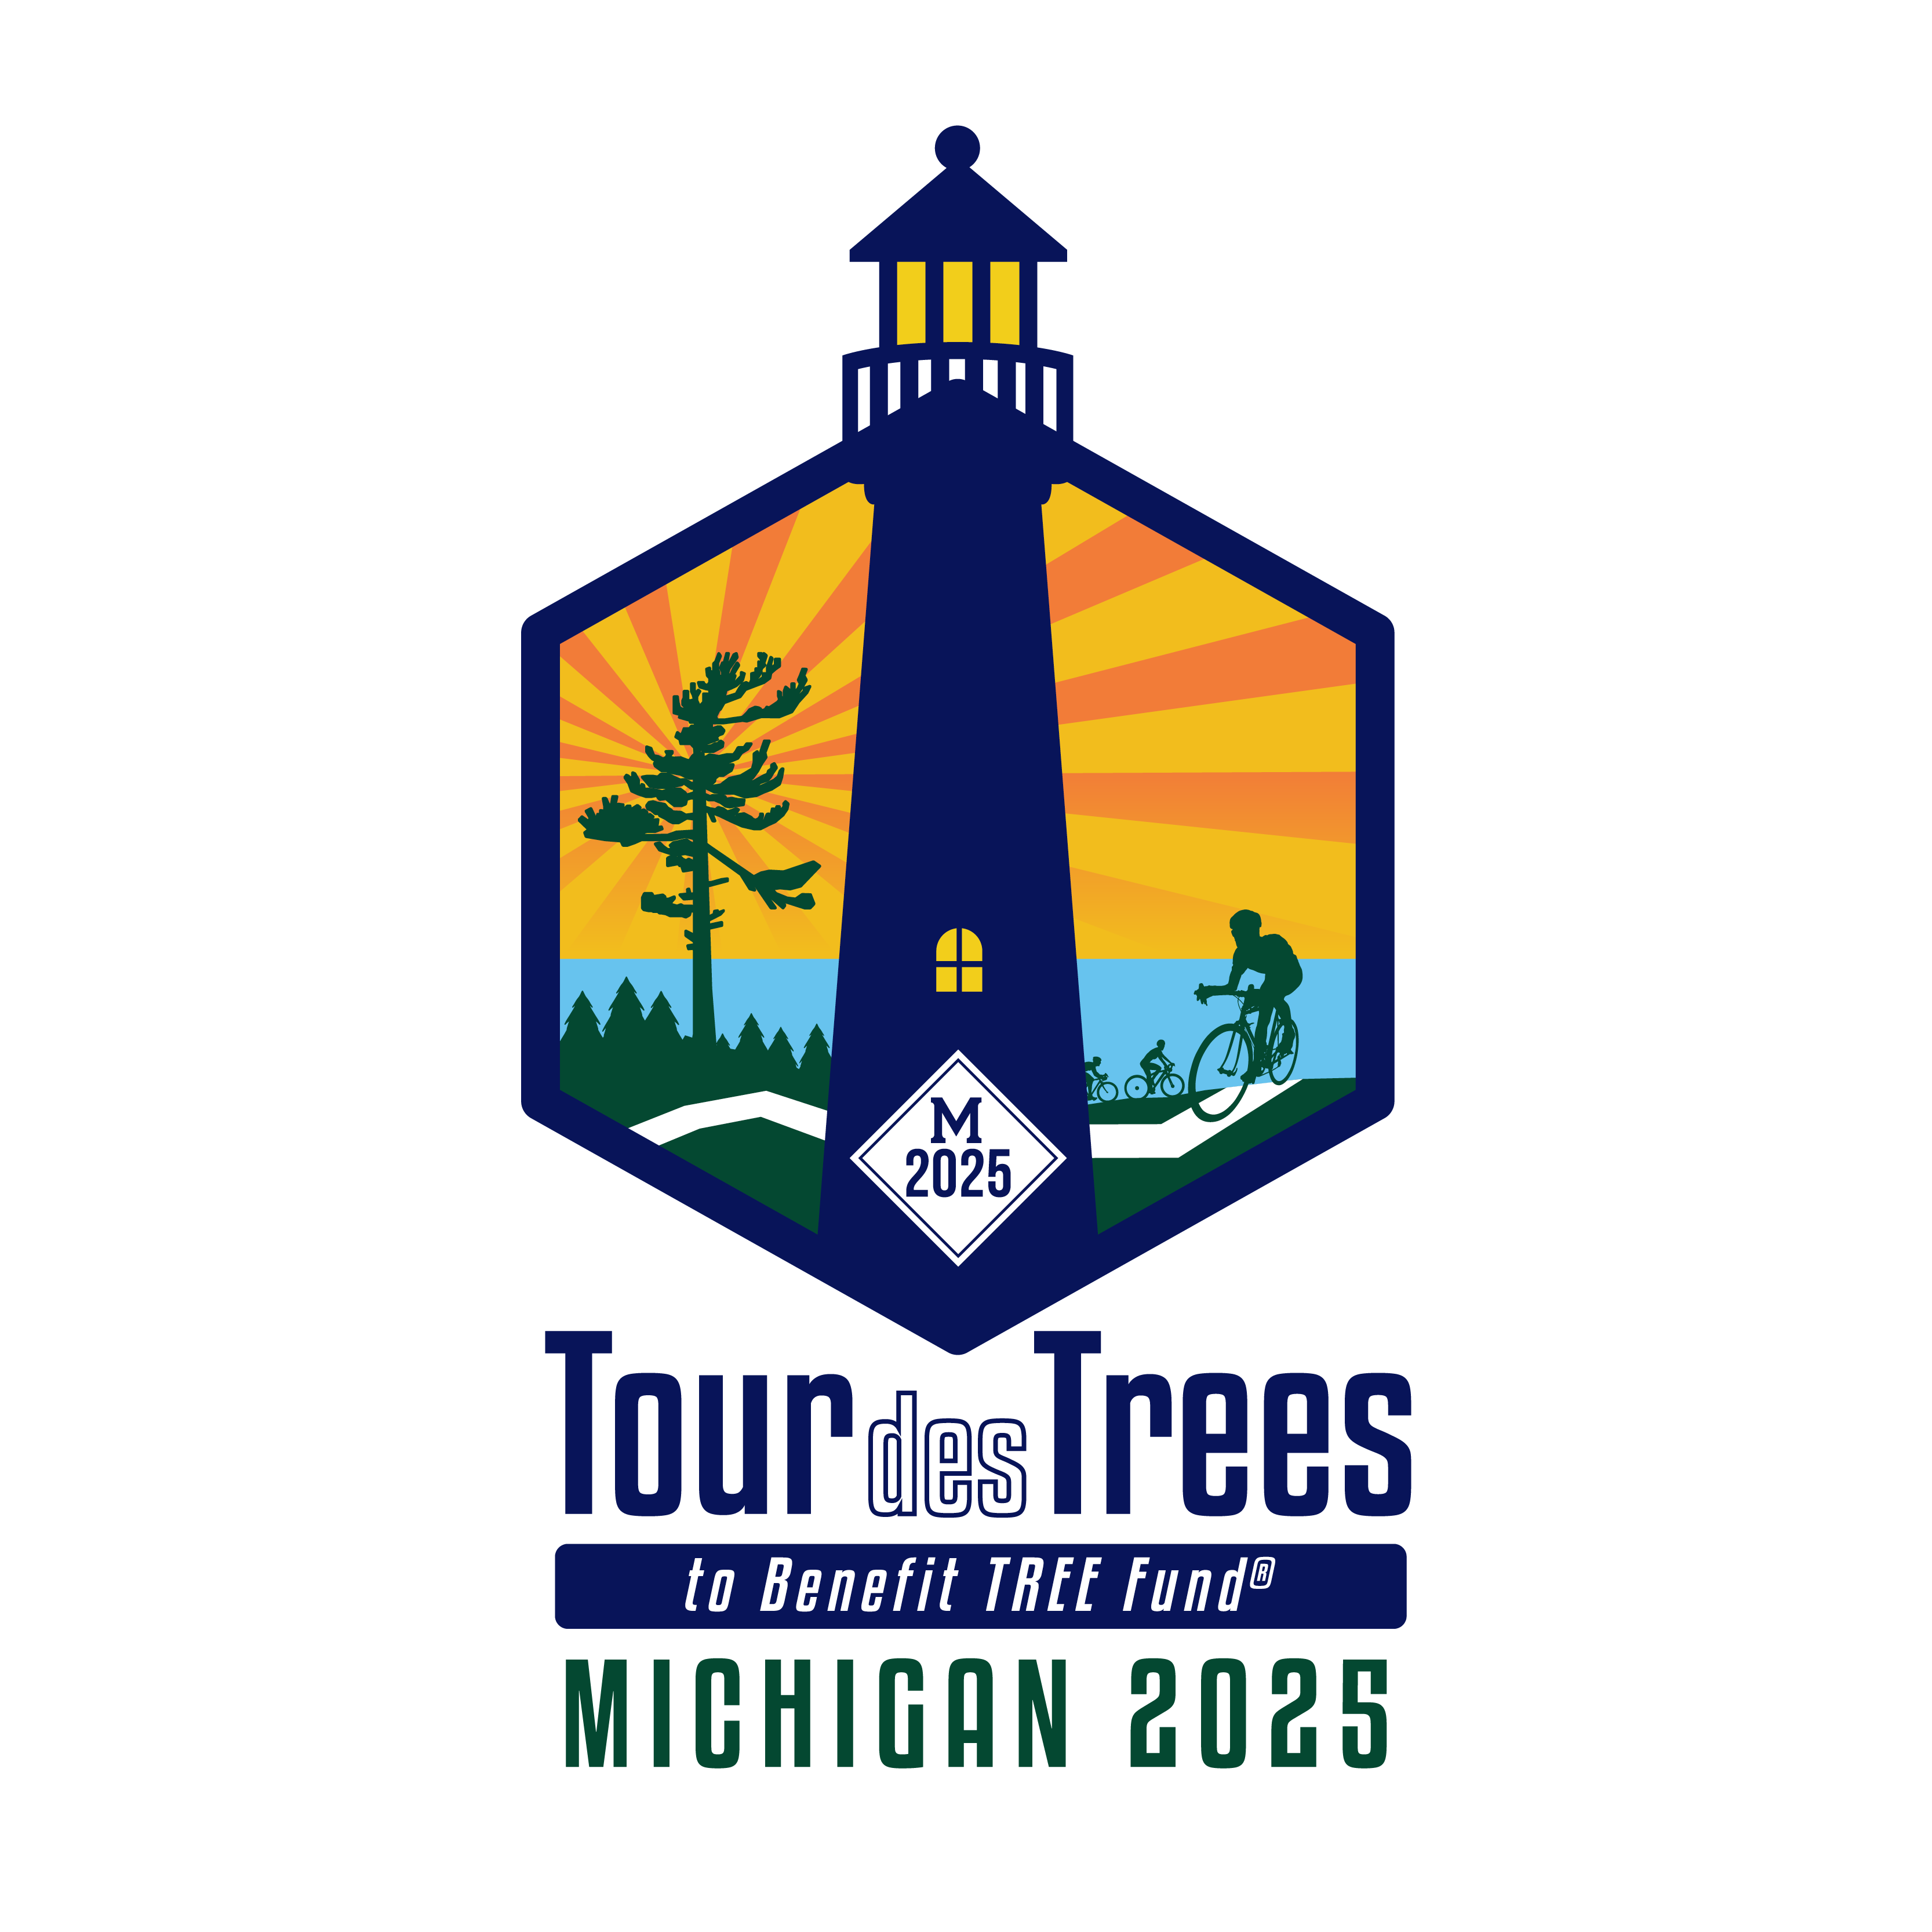

Tour des Trees New Rider FAQs

Q: What is included with Tour des Trees registration?
A: See FAQs: Registration

Q: What is a typical day/week on the Tour like? Will there be rest stops along the way? Will lunch be provided during the ride? Who am I rooming with? How do I know where and how far we’re going each day? Is it possible for me to ride only a portion of the route on any given day?
A: See FAQ Page

Q: What is a Ride Buddy?
A: Generally, this will be someone you find yourself riding with for most of the day’s route – someone who rides at a similar speed as you. It’s a natural sorting process.

Q: What do we do if it rains or is cold?
A: There are no scheduled days off, so yes, we ride in the weather we are presented with. Bring a rain vest and/or jacket to help keep you dry and warm in case it rains or is cold in the morning. You should also think about bringing arm and leg warmers to help with layering.

Q: What type of roads and road surfaces will we be riding on?
A: Because the Tour emphasizes and promotes the value of urban and community forests, many of our destinations and connecting routes lead us to and through urban centers.
To safely navigate our way through these urban centers, we enlist the assistance of the local cycling community, our hosting chapter liaisons, and utilize the best available mapping tools. This ensures that we can move in and through communities of size as efficiently and safely as possible, but this also means there are times when we are sharing the road with significant traffic, so be vigilant and use the practices to keep yourself safe. Between these urban centers, you can expect beautiful ribbons of road through rural countryside that the locals seek for their club rides and events.
Regarding the road surface, as we all know, the quality of the pavement is influenced by a number of factors; environmental stress, county budgets, as well as traffic types and volume, so expect the full gambit, from pristine blacktop to roads that should have been repaved decades ago. Oh, and you never know when Paul may include a connecting “dirt” road, to add to the sense of adventure.

Q: What if my bike breaks?
A: If your bike breaks, we have excellent mechanics who will get you going quickly. If it’s beyond the scope of their in-field services, then they will do their best to get you rolling before the next day’s ride. You will be responsible for the cost of items needed to repair your bike – cables, tubes, tires, chain. We recommend that you are capable of repairing a flat (How to fix flat), but our support team will be there to lend a hand if you are not comfortable completing that task.

Q: What wheels and/or tires do you recommend?
A: We don’t make any specific recommendations, but it's safe to say this isn’t the event for your lightest, low spoke count, wonderwheels or tires. We recommend equipping your bike with a good sturdy high spoke count rim and the widest tire it and your bike frame can accommodate.

Q: Do you have suggestions on what to pack?
A: See below

Cycling apparel:
• 2 - 3 pairs of cycling shorts
• 3 - 4 pairs of cycling socks
• 1 pair of cycling shoes
• 2 pairs cycling gloves
• 1 pair of cycling glasses
• 2 - 3 wicking cycling undershirts
• 1 wind/rain cycling jacket
• Jerseys: 3 to 5-day riders are able to order two TdT cycling jerseys and 1 to 2-day riders are able to order one, so you can wear these and proudly display the TDT colors each day!
• Helmet: Full-Tour riders receive one KASK helmet and Partial-Tour riders will receive a helmet, subject to availability.

After ride apparel:
• Shorts (2 pairs)
• Jeans or other casual long pants.
• T-shirts. You will be given a TdT t-shirt for the current year, however, feel free to bring along tees from previous Tours, other rides you've done, or from your home cycling community.
• Lightweight jacket
• Shoes (sneakers, sandals, casual footwear)
• Socks
• Bathing suit (always prepare for that random pool or hot tub)
• Reading glasses (for most of us)
• Hat

Miscellaneous:
• Sunblock and lip balm
• Personal medications
• Camera
• Chamois cream
• Laundry detergent (a clean jersey is a happy jersey)
• Copy of your ID and insurance card
• Cash for adult beverages and incidentals like ice cream

For your bike:
• A few tubes (make sure they are the correct size and have sufficient length stem)
• Patch kit
• Tire levers
• Inflator head
• 3 or 4 CO2 canisters (we’ll have some to purchase for those of you flying in)
• Multi-tool

Helpful list: What to pack in your saddle bag

Q: Is there a limit to how many bags I can bring?
A: We don't charge extra for bags but we do ask that you be considerate of the fact that our limited support team consists of volunteers who will be moving everyone’s bags to/from our hotels. We suggest no more than two bags and please keep them under 50 lbs. per bag.

Q: How do I wash my cycling clothes at the end of the day?
A: We will alert you ahead of time which hotels have laundry facilities or you can hand wash them in the sink or shower. Once washed and rinsed you can accelerate drying by wringing them out and rolling them in a towel before hanging them to dry further.

Q: Do you recommend Road I.D.?
A: It’s always good to have identification on you while riding, especially if you have medical issues or directives. Visit https://www.roadid.com/to learn more and order yours today!
Hint: We will be posting a coupon code for Road I.D. as the tour approaches, so keep your eyes open!

Q: Can I bring a guest to dinner?
A: Yes, we are happy to have guests join us! Please let Paul and Jonathan know in advance if you’re planning to bring one (or more), so we will have enough food. The cost per guest (age 12 and older) for breakfast or lunch is $25 and for dinner it’s $50, payable by credit card to Jonathan the day of the meal. Please note that we do NOT make any money off guest meals; we are simply covering our costs so we can keep Tour expenses in line.

Q: What are the fundraising details for riders?
A: Click these links for questions about Tour donations and Tour fundraising

Q: What else?
A: Hydration: Since it is typically a warm weather Tour, managing your hydration will be critical. Our stops are spaced from 1 - 2.5 hours apart, so plan accordingly.

Click on this link for basic info and guidance: Hydration Myths and Suggestions

