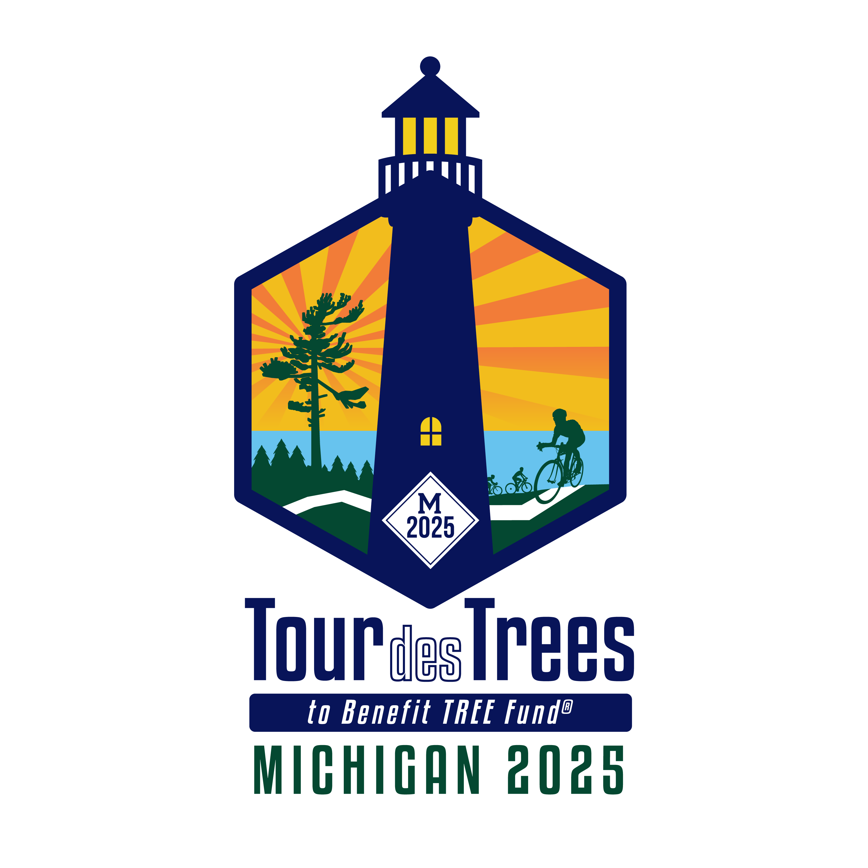
BIKE RULES & CYCLING BEST PRACTICES

What the law requires
- Bicycles must obey all traffic laws including all traffic signals and signs (a bicycle is a vehicle with the same rights and rules as a car).
- Ride with traffic, NOT against it.
- Use hand signals to indicate your intentions for turning and stopping.
- Do not pass cars on the right, and do not weave your way through traffic.

Ride Defensively
- Assume that drivers can't see you.
- Always stop and look "Left-Right-Left" before entering or crossing traffic.
- Watch out for:
  - Cars turning left in front of you (left hook).
  - Cars that pass you then cut in front of you to make a right turn (right cross).
  - Parked cars (drivers may be opening doors into traffic.)
  - Railroad tracks- they can grab your front wheel and cause you to fall. When safe and possible cross RR Tracks perpendicular.
- Be careful of making sudden turns or movements that drivers or riders may not be anticipating.

Riding in a Group
- Be aware of the cyclists around you at all times and do not weave back and forth across the lane.
- Be a predictable cyclist!
- When passing other riders, make sure the traffic is clear and always pass on the left. Let them know you are there by calling out "On your LEFT!" before you pass. Never pass on the right.
- When a car is approaching from the rear, call out, "Car BACK!" When a car is approaching from the front, call out, "Car UP!" When a car is approaching from the side, call out, "Car LEFT!" or, "Car RIGHT!"
- Use hand signals to indicate your intentions to other riders and drivers for turning and stopping.
- When stopping suddenly, you may not be able to take one hand off the handlebars. In this case, call out "Stopping!" or "Slowing!"
- Look for hazards in the road and call out anything unexpected like speed bumps, potholes, gravel, sand, branches, broken glass, or "road kill" so the riders behind will be aware of it.

Other Points
- You must wear a helmet at all times while you are riding.
- Make sure your bike is road-ready and safe.
- Pay attention to the ride staff and directors during the ride.
- Dispose of your trash properly.
- Please be respectful in attending to “personal” matters; relieving oneself “in public” can be both legally risky and embarrassing. But if an emergency arises, please use discretion.

Summation
- BE SAFE
- STAY LEGAL
- PAY ATTENTION
- BE COURTEOUS
- BE CONSCIENTIOUS
- WEAR YOUR HELMET
- SIGNAL YOUR INTENTIONS
- CALL OUT CONDITIONS
- BE AWARE OF CARS AND CYCLISTS
- DISPOSE OF TRASH PROPERLY

TOUR DES TREES SAFETY PRINCIPLES & POLICIES

We want the Tour des Trees to be the safest event of its kind. In order for us to accomplish this with all the participants and support crew, there are some basic principles and policies which will enable us to enjoy a safe event. Remember, we all are now a part of the Tour des Trees community; we should look out for one another, lend a helping hand, and always remain alert!

Ride Principles
The spirit of the Tour des Trees is about us moving beyond our limits, both as individuals and as a group. This not only applies to the challenge of training, fundraising and pedaling, but to the way we treat one another and interact with one another throughout the Ride. The Tour des Trees is not a race. It is a supportive, community-oriented ride open to people from all walks of life. Because of this, we will learn to expect the unexpected. Expect people to offer you help. Expect people to ask how you are doing. Expect people to support you, to cheer you on in a way you've never experienced. Expect to give that back. Afterwards, expect to experience a sense of pride in your achievements.

Safety Policies
The following are principles and policies you should adopt and follow, not only as a Tour des Trees Rider, but wherever and whenever you ride a bicycle.
STAY ALERT - STAY ALIVE
We're serious. Safety is a serious issue with us. It must be with you, too. We will repeat safety messages throughout the Ride, and you'll hear safety talks before the ride - you'll become accustomed to it. That's the goal. This repetition will help you to not have to think about what safety is. Safe riding will become second nature to you.
- Helmets are required. You must properly wear an ANSI, Snell or ASTM approved helmet while on the Tour des Trees.
- Riding in a group is very different from riding by yourself. Your riding behavior affects not only your life, but others' lives as well. Your actions on your bike will affect others. Remember: there will be riders of all skills and abilities on the TDT.
- Riding unsafe. Unsafe riding is foolish. You should never ride in such a way as to endanger the lives of others. The TDT is not only non-competitive; it is a context of community and support that does not tolerate unsafe riding behavior.
Ask questions. If you are at all unsure about what is safe or unsafe riding, ask us. When it comes to your life, there is no such thing as a dumb question.

