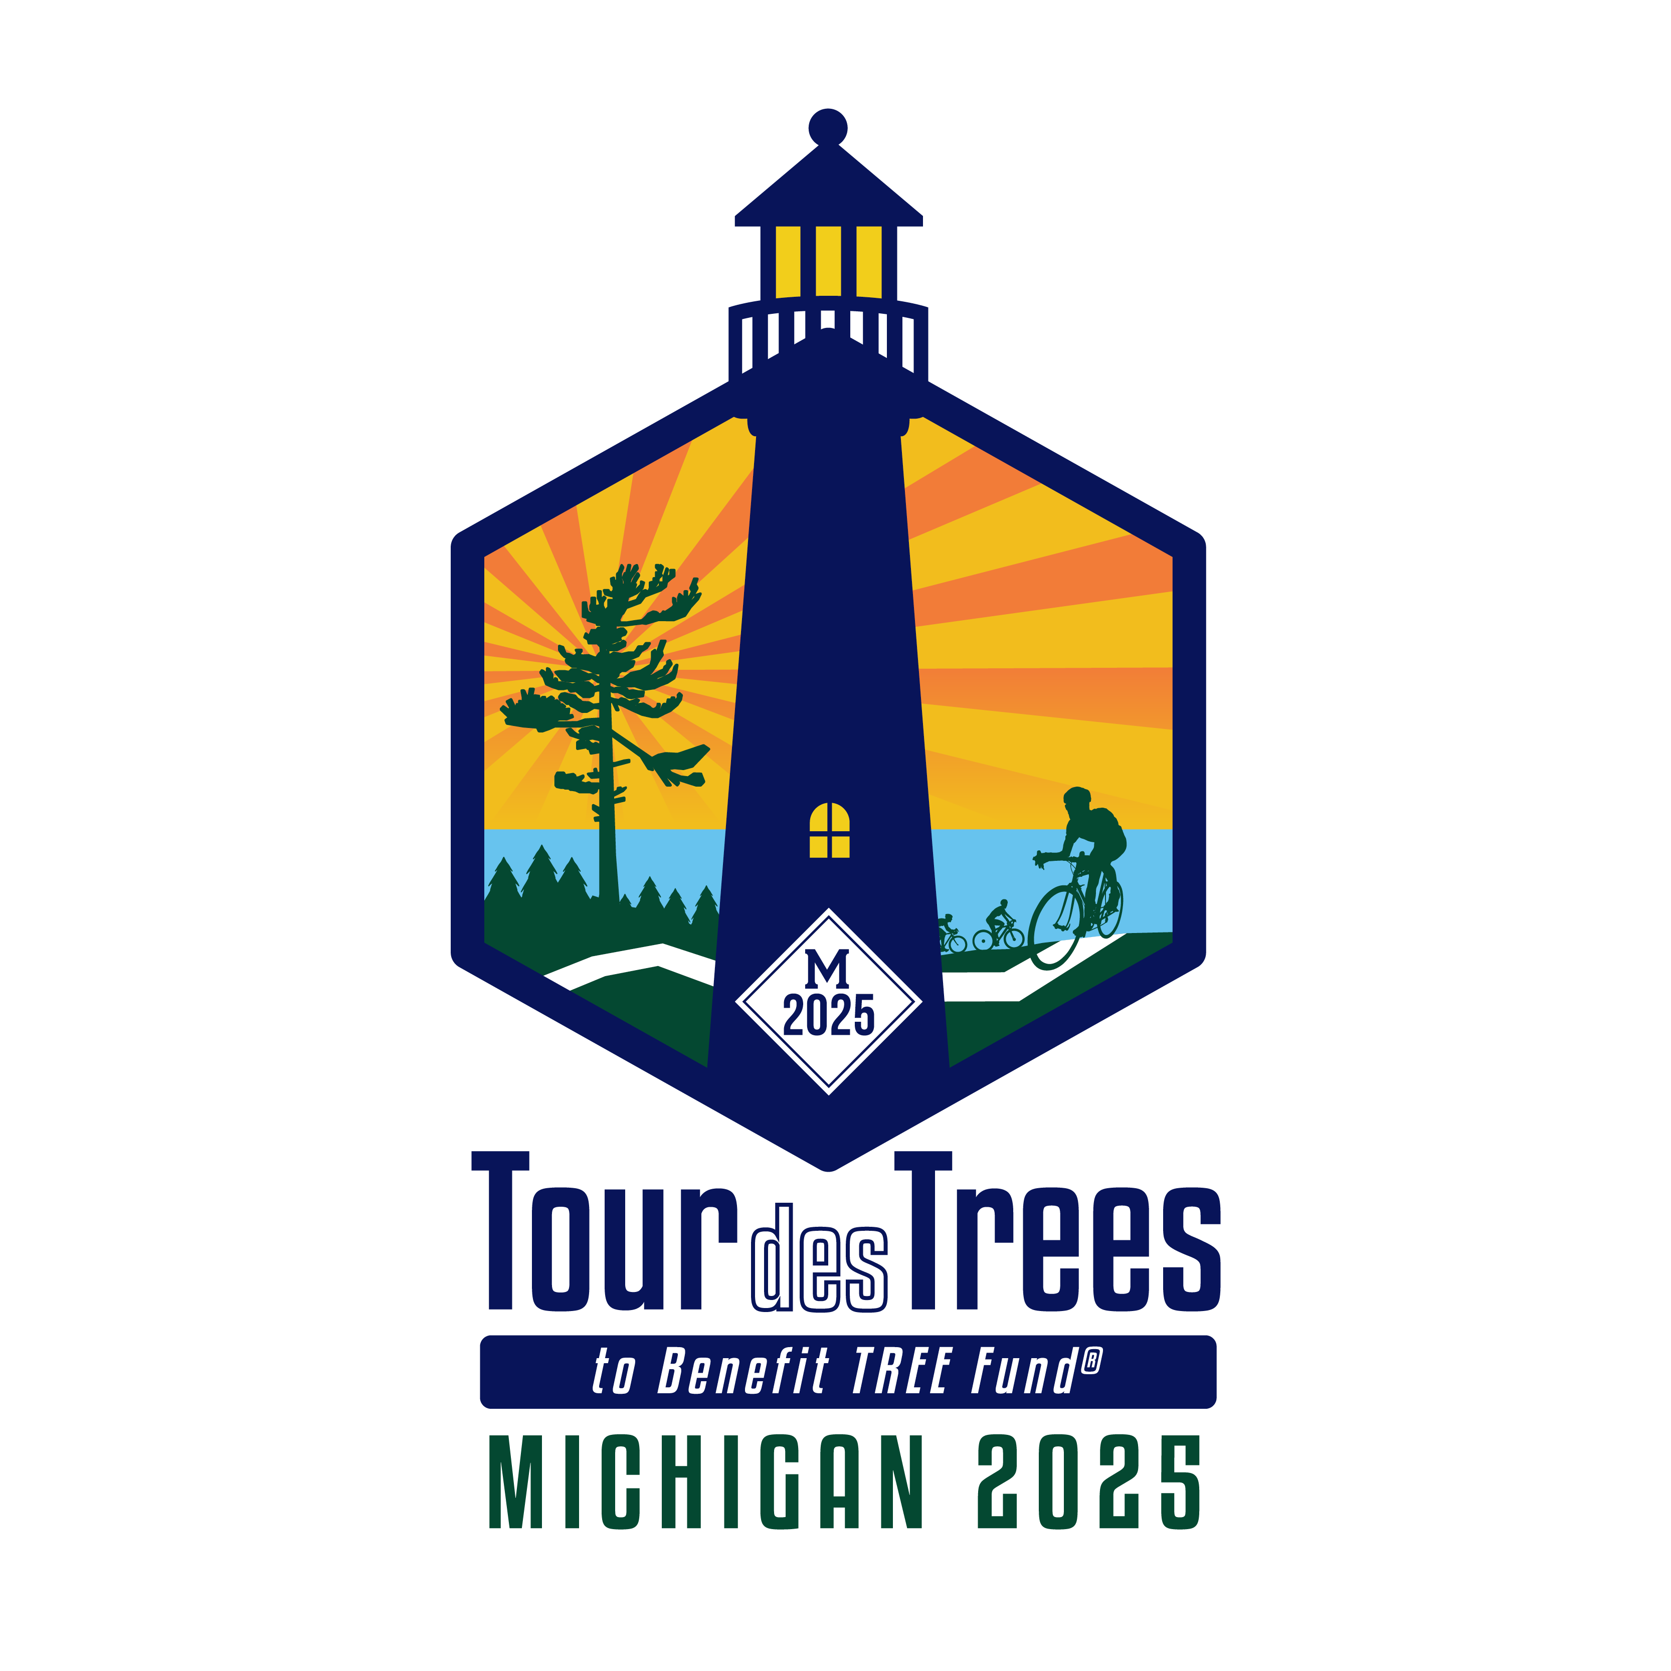
Tour des Trees riders: See below for an example email that you can send out to friends, family, and other contacts to help you with your fundraising goals for this year’s ride. Copy and paste the text below into an email and add your fundraising page link where directed. Please feel free to add in your own personal information or stories to help make more of a connection.
EXAMPLE TEXT:
I am excited to announce that I will be participating in the 2025 Tour des Trees bike ride to benefit TREE Fund! This year’s ride will be in New England, covering 435 miles over five days. I believe that the tree research and environmental education this ride supports are critical to the well-being of our communities and all of us who inhabit them, which is why I am fundraising for this event, with a goal of raising over $3,700.
You have heard me talk about the importance of trees. Urban trees are vital to our survival. They reduce air pollution, sequester carbon, control erosion, shelter us from heat and wind, and add beauty to our lives. Did you know that living in cities is stressful for trees? Pests, diseases, construction, pollution, and neglect put the trees in our communities at risk every day. The research and education funded by TREE Fund via the Tour des Trees helps to ensure that tree care professionals are well equipped with best practices and the latest techniques to keep the trees we live with healthy and thriving.
This is why I am asking you to please support my ride this year and help me support TREE Fund.
My fundraising page can be found below or by going to www.tourdestrees.org.
<INSERT YOUR FUNDRAISING PAGE URL HERE>
For more information about TREE Fund visit: www.treefund.org. You can also learn more about the Tour des Trees at: www.treefund.org/tourdestrees.
Thank you for your support and your willingness to help tree research!

