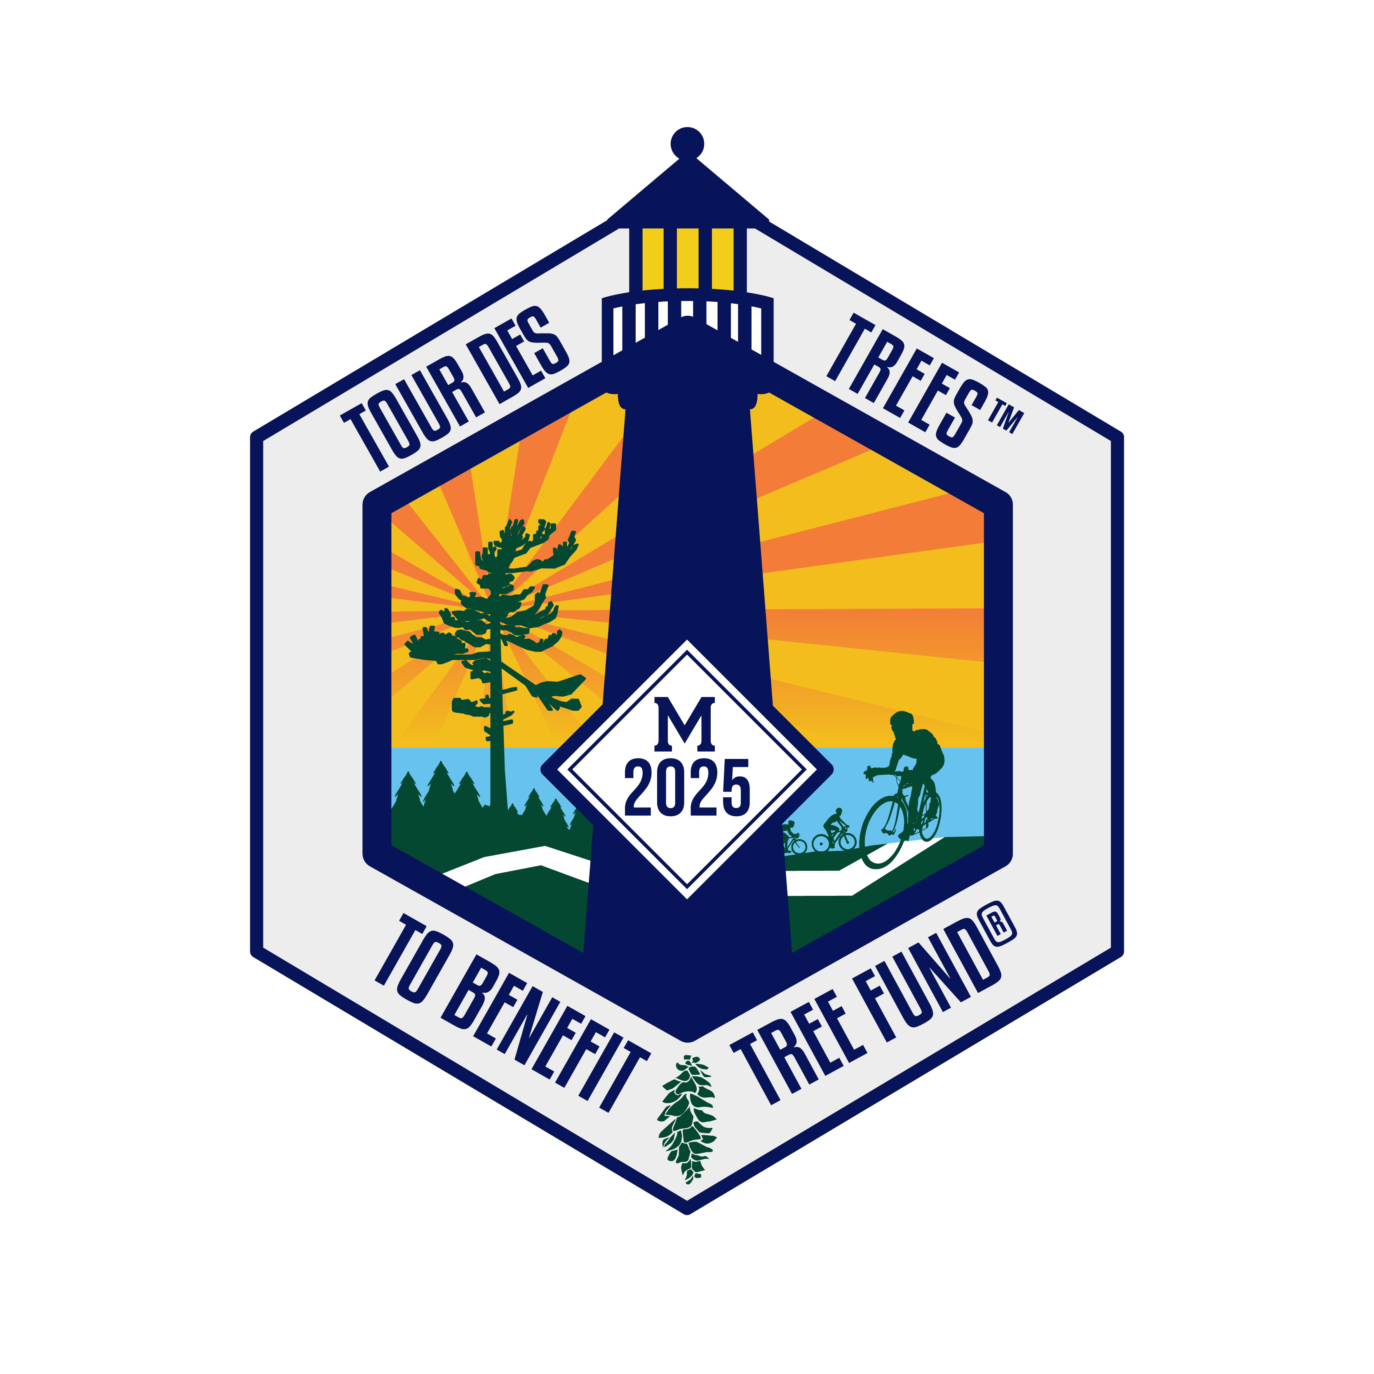

2025 Tour des Trees Itinerary
(Updated 5/13/25)

Sun 8/10 Grand Rapids, MI

11:00 a.m.- 4:30 p.m. Rider check-in and apparel pick-up
Hotel- Amway Grand Plaza by Hilton, 187 Monroe Ave NW, Grand Rapids, MI 49503

5:00 p.m. Rider Orientation meeting
Hotel Conference Room

6:30 p.m. Reception/Welcome Dinner
Hotel Dining Room- Anway Grand Plaza by Hilton

Hotel: Hotel- Amway Grand Plaza by Hilton, 187 Monroe Ave, NW Grand Rapids, MI 49503

Mon 8/11 Grand Rapids, MI to Big Rapids, MI – 59 miles (optional Morbark Challenge add-on for 124 miles/ 200k)

6:00 - 7:15 a.m. Breakfast- Sponsored by Bandit Industries, Inc.
Hotel

8:00 a.m. Ride Depart
Grand Rapids, MI

TBD a.m. Aid stations
Mile TBD TBD

TBD a.m. Lunch and Community Presentations- Sponsored by Morbark, Inc.
Mile 42 Morley Community Center, 151 7th St, Morley, MI 49336

TBD a.m. Morbark Challenge: Optional Add-on Route Aid station and Facility Tour- Sponsored by Morbark, Inc.
Mile 75 Morbark facility, 8705 S. Winn Rd, Winn, MI 48896

3-5:00 p.m. Educational Event with Mecosta Conservation District
Mile 56/121 Hemlock Park Pavillion, PG2C+F45 Hemlock St., Big Rapids, MI 49307

TBD p.m. Hotel: Holiday Inn Express
Mile 59/124 1005 Perry Ave, Big Rapids, MI 49307

6:00 p.m. Dinner
Off-site TBA

Tues 8/12 Big Rapids, MI to Traverse City, MI – 91 miles

6:00 - 7:15 a.m. Breakfast
Hotel

8:00 a.m. Ride depart

TBD a.m. Aid Stations
Mile TBD TBD

TBD a.m. Lunch
Mile 44 City Park and Pavillion, 131-199 W Harris St, Cadillac, MI 49601

1:00 p.m. Professor Pricklethorn Rally
Human Nature School, GT Commons, adjacent to 1580 Red Drive Traverse City, MI

3:00 p.m. Tours and Educational Presentation
SEEDS Ecology and Education Centers, 1500 Red Dr, Traverse City, MI 49684
* Will need names of riders beforehand; will be transported via caravan from lunch/ rest stop.

TBD p.m. Hotel: Bayshore Resort
Mile 91 833 E Front St, Traverse City, MI 49686

6:00 p.m. Pre-dinner meeting/ Dinner- On Your Own Night
Downtown Traverse City

Wed 8/13 Traverse City, MI to Manistee, MI – 98 Miles

6:00 - 7:15 a.m. Breakfast
Hotel

8:00 a.m. Ride depart

TBD a.m. Aid Stations
Mile TBD TBD

11:00 a.m. Professor Pricklethorn Rally
Traverse Area District Library, 610 Woodmere Ave, Traverse City, MI 49686
With North Youth Cycling Club

TBD a.m. Lunch
Mile 63 Mineral Springs Park, 630 Main St, Frankfort, MI 49635

TBD p.m. Aid Station and Activities
Mile 83 Glen Park/ Onekama Springs, 8460 4th Ave, Onekama, MI 49675

TBD p.m. Aid Station and Tour
Mile 93 Lake Bluff Farms, 2890 Lakeshore Rd, Manistee, MI 49660
* State Champion Sequoia and arboretum

TBD p.m. Hotel: Baymont by Wyndham Manistee
Mile 98 1462 US-31, Manistee, MI 49660

6:00 p.m. Dinner
Off site- Elks Lodge

Thurs 8/14 Manistee, MI to Whitehall, MI – 90 miles

6:00 - 7:15 a.m. Breakfast
Hotel

8:00 a.m. Ride depart

TBD a.m. Aid Stations
Mile TBD TBD

TBD a.m. Lunch
Mile 45 First Baptist Church, 101 S Rush St, Pentwater, MI 49449

TBD p.m. Hotel: Econo Lodge Whitehall
Mile 90 2865 E Colby St, Whitehall, MI 49461

6:00 p.m. Dinner
Off site- American Legion Hall

Fri 8/15 Whitehall, MI to Grand Rapids, MI – 78 Miles

6:00 - 7:15 a.m. Breakfast
Off site- TBA

8:00 a.m. Ride depart

TBD a.m. Aid Station
Mile 27 Hackley Park, 350 W Webster Ave, Muskegon, MI 49440

10:00 a.m. Professor Pricklethorn Rally
Muskegon YMCA Summer Camp, McGraft Park, 2204 Wickham Dr, Muskegon MI 49441

TBD a.m. Lunch
Mile 47 Outpouring Worship Center, 11811 Heights Ravenna Rd, Ravenna, MI 49451

TBD p.m. Hotel: Amway Grand Plaza by Hilton
Mile 78 187 Monroe Ave NW, Grand Rapids, MI 49503

6:00 p.m. Dinner and Closing Ceremonies
Anway Grand Plaza Dining Room

Sat 8/16 Grand Rapids, MI

7:00 a.m. Breakfast
Hotel
10:30 a.m. Professor Pricklethorn Rally
Meijer Gardens, 1000 E Beltline Ave NE, Grand Rapids, MI 49525

All Morning Hugs and Depart

